ERINBANK SECONDARY COLLEGE

YEAR 11 VCE UNIT 2 EXAM

SEMESTER 2, 2006

PHYSICAL EDUCATION

WEDNESDAY th November 2006
11am-12.39pm

Reading time: 5 minutes
Writing time: minutes

BREAKDOWN OF MARKS:
Section A: Multiple choice 25 marks
Section B: Short answers 55 marks
Section C: Labelling activities 20 marks
/100%

Name:

* Please note that students must score minimum of 30% in this Exam to pass the Unit
SECTION A Multiple-choice questions (25 marks)

1. A muscle’s origin is the point where

a) It attaches to the bone closest to the midline of the body
b) It attaches to the bone furthest from the midline of the body
c) It inserts to the bone furthest from the midline of the body
d) It forms ligament

2. The action of lowering to a squat involves what action at the knee joint?

a) Adduction
b) Abduction
c) Flexion
d) Extension

3. Air moves from the atmosphere into the body, through the structures of the respiratory system, in the following order:

a) Nose/mouth – trachea – pharynx – bronchioles – bronchus – alveoli
b) Alveoli – bronchioles – bronchus – trachea – pharynx – nose/mouth
c) Nose/mouth – pharynx – trachea – bronchus – bronchioles – alveoli
d) Nose/mouth – bronchus – bronchioles – trachea – pharynx – alveoli

4. The function of the skeleton is to

a) Provide support and protection for the body
b) Store minerals and manufacture red blood cells
c) Provide a structure for muscle attachment enabling movement to occur
d) All of the above

5. Tendons

a) Attach bone to bone
b) Attach muscle to bone
c) Attach muscle to muscle
d) Attach bone to cartilage

6. Gripping a racquet or playing stick is an example of an

a) Isotonic concentric contraction
b) Isotonic eccentric contraction
c) Isometric contraction
d) Isokinetic contraction

7. The paired action of muscles, where one muscle contracts while the opposing muscle relaxes, (for example the biceps and triceps) is referred to as

a) Flexion and extension
b) Agonist and antagonist
c) Reciprocal inhibition
d) Proprioceptive Neuromuscular Facilitation

8. Gaseous exchange in the lungs involves the movement of

a) CO₂ from the alveoli into the capillaries and O₂ from the capillaries into the alveoli
b) Air from the bronchioles via the pharynx and larynx to the alveoli
c) H₂O from the capillaries to the alveoli and O₂ alveoli to the capillaries
d) O₂ from the alveoli to the capillaries and CO₂ from the capillaries to the alveoli

9. A motor unit is

a) Controlled by the brain
b) The neuron and all the muscle fibres controlled by that neuron
c) Aided in the process of contraction by the enzyme acetylcholine
d) All of the above

10. The human heart consists of

a) One pump, four chambers and three valves
b) Two pumps, four chambers and four valves
c) Three pumps, two chambers and two valves
d) Four pumps, two chambers and four valves

11. A person’s Lactate Threshold is the point where lactic acid begins to rapidly accumulate in the blood and begins to affect ones performance. For an untrained athlete it is around____%max HR, and a trained athlete around _____%max HR

a) 50, 70
b) 60, 90
c) 80, 100
d) 50, 60

12. The insertion of a muscle is

a) The closest point of attachment of the muscle to the body’s midline
b) The furthest point of attachment of the muscle to the body’s midline
c) Where the muscle attaches to the bone
d) The point where the muscle sheath becomes tendon

13. The chemical compound that provides the energy that allows muscular effort is called

a) Carbohydrate
b) Fat
c) Adenosine triphosphate
d) Protein

14. When muscular activity is needed, one of the phosphate molecules breaks off, releasing energy, this creates

a) Adenosine diphosphate
b) Lactic Acid
c) ADP
d) both A & C

15. Energy substrates that the body can use to create more ATP include

a) water, Glucose, phosphocreatine, lactic acid
b) glucose, fat, protein, oxygen
c) glucose, carbon dioxide, lactic acid, protein
d) protein, adenosine diphosphate, fats, glycogen

16. A cathartic experience in physical activity would most likely involve

a) Activities that provide a physical and emotional release
b) Activities that improve one’s health or level of fitness
c) Activities characterised by excitement and thrills
d) Activities that provide for expression of ideas and emotion through graceful and artistic movement

17. The group in society with the most positive attitude towards participation in physical activity are

a) Young children
b) Teenagers
c) Adults 21–35 years of age
d) Older retired people

18. A vertiginous experience in physical activity is characterised by

a) Activities that involve rapid or frequent changes in direction and body orientation
b) Activities that are upright and competitive
c) Activities that are social and cooperative
d) Activities that require the use of a weapon against an opponent

19. At Rest the body is not under physical stress and has an abundant oxygen supply, so it produces

a) 1/3 of ATP from Fat stores
b) ½ of ATP from Fat stores
c) 2/3 of ATP from Fat stores
d) All of its ATP from Fat stores

20. Physical activity is an umbrella term, which encompasses various elements that can be arranged on a continuum in the following order:

a) Recreation Games Sport Play

b) Games Sport Play Recreation

c) Play Recreation Games Sport

d) Sport Play Recreation Games

21. The body produces ATP via ______ energy pathways, the ________energy system, the ________ glycloysis system and the _________system

a) two, lactic, anaerobic, ATP-PC
b) three, phosphate, anaerobic, arcenic
c) two, phosphate, anaerobic, aerobic
d) three, phosphate, anaerobic, aerobic

22. The blood vessels that take blood away from the heart are

a) Arteries
b) Veins
c) Capillaries
d) Ventricles

23. Normal diastolic blood pressure for a 20 year old is

a) 80 mmHg
b) 160 mmHg
c) 120 mmHg
d) 60 mmHg

24. When the body starts physical activity there is an immediate __________ in demand for __________to muscles

a) decrease, oxygen
b) increase, ATP
c) increase, oxygen
d) increase, ATP-PC

25. Activity means a state where the body is more exertive than at rest. The level of Activity is determined by

a) duration, intensity, heart rate, breathing
b) duration, intensity, fitness level, recovery rate
c) heart rate, speed, rest period, perspiration
d) aerobic exercise, anaerobic exercise, heart rate, lactic acid
SECTION B Short Answer questions (55 marks)
Question 1:

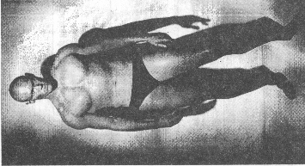

Michael Klim is an Australian Olympic Swimmer (pictured) who competes in the 100m Butterfly event (2 laps of a 50m pool). Fill in the missing words. (5 marks)
- At the Start he would use the _________energy system, which is stored in his __________. After _______seconds of maximal effort this store would be depleted. The Energy system that would become the dominant provider of ______ after his tumble turn at the ½ way mark would be the_____________, this would power him to the finish line. At the end of the race, approximately 45 seconds, Michael is able to breath in more __________ via puffing, this allows his body to create more _________from ADP and to reconstitute phosphocreatine from the broken Phosphate and creatine molecules remaining after this sprint. He performs an ____________recovery to remove _________acid and in about _____minutes he has replenished his energy.

Question 2:
- List 3 Physical, Social, Emotional benefits of being Physically active. ( 3 marks)

Physical | Social | Emotional
1 | 1
2 | 2
3 | 3

Question 3:
Write in your own words a definition for the following terms give an example of an activity you have performed.
(3 marks)
Personal example
Physical Activity:
Physical Fitness:
Exercise:
Sport:
Games:
Play

Question 4:
- Complete the table of the 3 Energy Systems and outline how they are different from each other ( 5 marks)
Name of System
Duration of System | seconds | seconds | minute
Intensity of System | % max HR | % max HR | % max HR
What can limit performance
Fuel for System | phosphocreatine | Carbohydrate, glycogen | Carbohydrate, Fat, Protein
Example of a Physical Activity that uses this system
Question 5:
What is the difference between intrinsic and extrinsic motivations for participation in physical activity; give an example for each (2 marks)

Question 6:
Label left atrium, right atrium, superior vena cava, and inferior vena cava on the Heart Diagram below (4 marks)

Draw the pathway of the blood on its journey through the Heart, to the Lungs, back to the heart and finally to the body. Use a blue pen for the deoxygenated blood and red pen for the oxygenated blood.
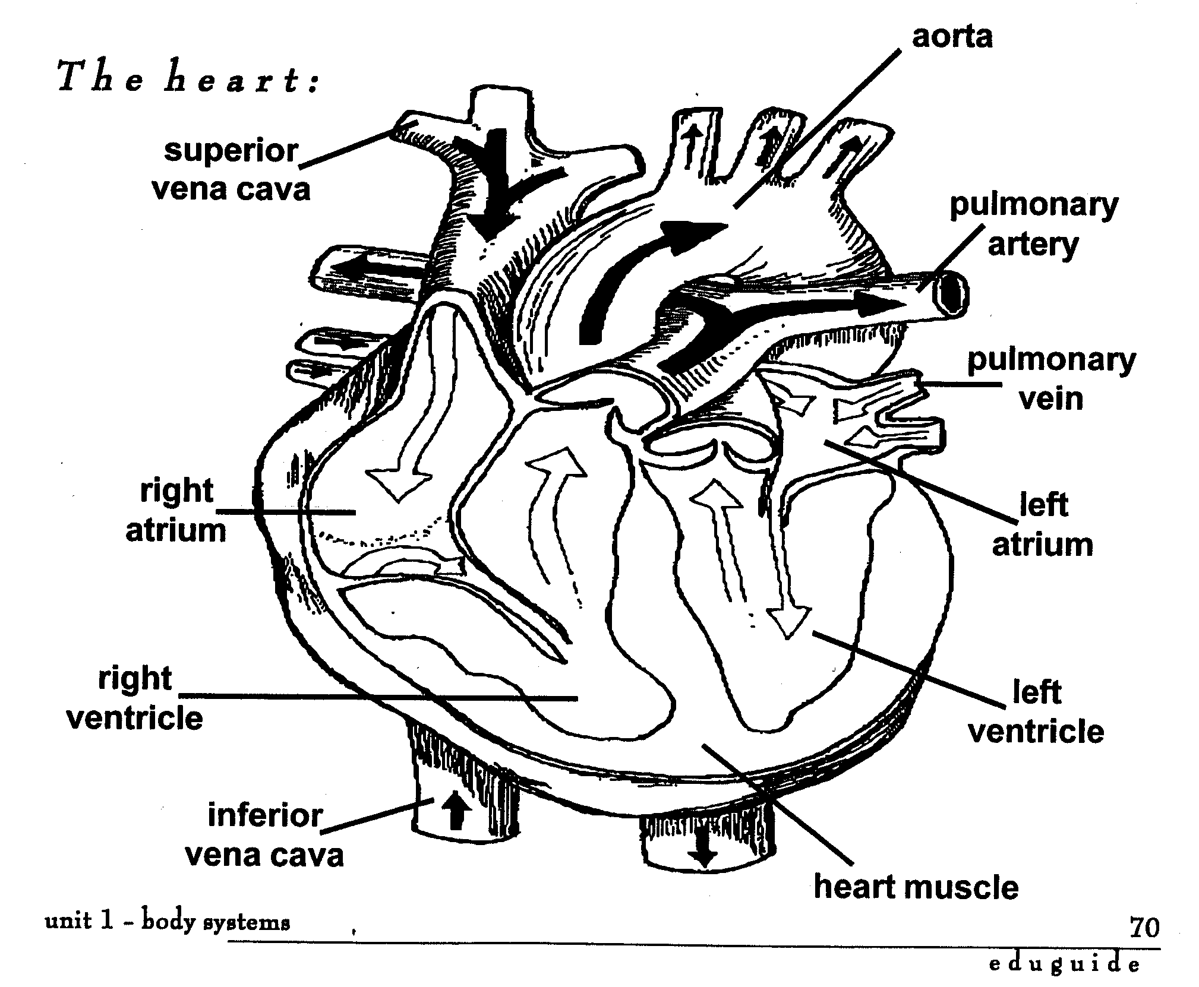

Question 7: (3 marks)

Physical Activity can be also classified according to one’s level of involvement in it, what do the following mean?
Frequency:
Intensity:
Duration:
How would/could you tell the difference between a person performing physical activity at:
Low Intensity:
Moderate Intensity:
Vigorous Intensity:

Question 8:
Physical Activity can provide a number of different experiences.
Match the type with a definition and give an example (4 marks)
Health &Fitness enhancing, social, aesthetic, competitive, recreational, vertiginous, cathartic, ascetic
Experience provided | Definition | Example
 | Provides an opportunity to meet and interact with people
 | Allows one to compare against others, oneself or environment
 | To release pent up emotions, tension, provides personal relaxation
 | Has potential to improve health and fitness
 | Provides an adrenalin rush, risk taking, loss of balance/control
 | Non competitive and used to refresh mind and body
 | Involves prolonged deeds of stamina, endurance
 | An appreciation of beauty

Question 9:
Refer to the following graph of Participation in activity by age and Frequency of participation by
sex.

a. What general patterns are revealed in the graphs? (1 mark)

b. Suggest reasons why fewer females than males in 18-24 age group are participating in physical activity. (1 marks)

c. Can you suggest reasons why the number of males participating dropped between 18-24 and 25-34 (1 marks)

Question 9: Provide an example for each of the following types of Joints found on the body (3 marks)
GLIDING:
HINGE:
BALL and SOCKET:

Question 10:
Physical Inactivity is a major contributor to diseases in males and females. It causes 8000 deaths annually. List 4 health related conditions directly linked to Physical Inactivity. (2 marks)

Question 11: Complete the following activity with the following words (5 marks)

regular, 30, 30, most, moderate, vigorous, two, most, moderate, several, 60

Adults should participate in at least ____minutes of _____________, ______________intensity physical activity on _______ days of the week.
Children and adolescents should participate in at least ____minutes, and up to __________hours, of

___________to ______________intensity physical activity every day. They should not spend more than ______hours using electronic media.
Older people should spend at least _____minutes of regular moderate intensity activity on ______days of the week. This will assist them to deal with the effects of Arthritis.

Question 12: There are a number of Factors that influence a person’s participation in physical activity.
Individual reasons( different phases of development), Social Reasons ( significant people groups in your life now or in past), Physical/Environmental reasons ( where they live/access to facilities).

Using your own personal experiences, comment in 200 words, on the significant reasons/factors why you have remained involved in, or have not taken up regular Physical Activity/Sport.
____________________________________________________________________________________________________________________________________________________________________________________________________________________________________________________________________________________________________________________________________________________________________________________________________________________________________________________________________________________________________________________________________________________________________________________________________________________________________________________________________________________________________________________________________________________________________________________________________________________________________________________________________________________________________________________________________________________________________________________________________________________________________________________________________________________________________________________________________________________________________________________________________________________________________________________________________________________________________________________________________________________________________________________________________________________________________________________________________________________________________________________________________________________________________________________________________________________________________________________________________________________________________________________________________________________________________________________________________________________________________________________________________________________________________________(5 marks)

Question 13: Think of 4 reasons commonly given by people who do not exercise or participate in physical activity. List 1 strategy that could be used to overcome this barrier. (4 marks)
Barriers/to participation | Strategies/solutions

Question 14: The Stages of Change is a path that people follow to adopt regular physical activity into their lives. Match the Stage with the correct definition (3 marks)
Maintenance Contemplation Pre contemplation Termination Preparation/Determination Action

STAGE
You start thinking positively about incorporating activity in life.
You are now implementing a plan with a plan of action.
Physical activity has now become part of you and are benefiting from your involvement
People are committed and develop a plan to follow.
You have permanently adopted regular exercise, no temptation to stop.
Start considering Pros and cons
Where they would place yourself and why? (1 mark)

SECTION C Labelling exercise (20 marks)

Label the following muscles of the Muscular System Tibialis anterior, Trapezius, quadriceps, Latissimus Dorsi, Deltoid, Pectorals, Triceps, Rectus Abdominals, gastrocnemius (5 marks)

Label the Respiratory System below with the following Left Bronchus, Bronchioles, Diaphragm, Trachea, Larynx (5 marks)
Label the following bones mandible, scapula, humerus, clavicle, radius, sacrum, ulna, femur, tibia, sternum of the Skeletal System (5 marks)

Label the five regions of the Vertebral column below (5 marks)

