Student Name: ______________________________

House: ______________________________

VCE PHYSICAL EDUCATION
UNIT 1
MID YEAR EXAMINATION

QUESTION BOOKLET

Number of Questions:

Answer all parts of all Questions in the spaces provided. Extra paper is supplied if needed.

Marks allotted to each part of each question are indicted at the end of the question.

READING TIME: 10 Minutes
WRITING TIME: 90 Minutes

Please Note:

Mrs McCallum’s Class: Complete all questions EXCEPT Question 15
There is a Total of 89 Marks

Mr Lindsay’s Class: Complete all questions EXCEPT Question 9

There is a Total of 96 Marks

Question 1

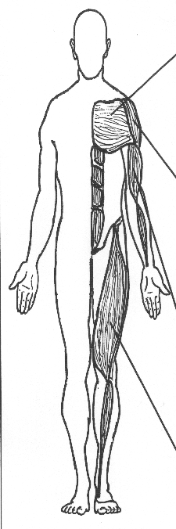
Muscle:

Action:

Muscle:

Action:

Muscle:

Action:

Muscle:

Action:

Muscle:

Action:
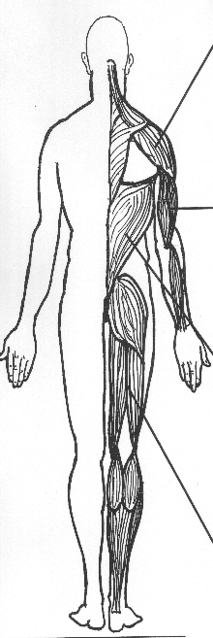

Muscle:

Action:

Muscle:

Action:

Muscle:

Action:

2+2+2+2=8 Marks

Question 2

Michael Klim is an Australian Olympic Swimmer (pictured below)

Studies show that body type can be an excellent indicator of which sports you are likely to excel at.

- Olympic male swimmers are more likely to have a certain somatotype. What is it?

- Identify one skeletal advantage that many elite swimmers like Michael Klim possess.

- How does this skeletal advantage help the swimmer?

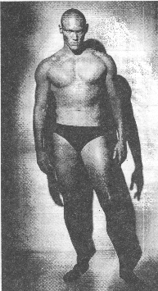

1+1+1=3 Marks

Question 3

When an athlete begins to exercise, the oxygen demands of the body increase.

- List and outline two cardiovascular responses that will help to increase the oxygen supply to the working muscles.

- List and outline two respiratory responses that will help to increase the oxygen supply to the working muscles.

Cardiovascular Responses | Respiratory Responses
1. | 1.
2. | 2.

4+4=8 Marks

Question 4
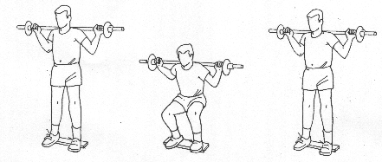

- In performing the above exercise, identify the major muscle group which the performer is exercising and through what types of contraction.

  - Quadriceps: concentric contractions and hamstrings: eccentric contractions
  - Hamstrings: concentric and eccentric contractions
  - Hamstrings: Concentric contractions and quadriceps: concentric contractions
  - Quadriceps: concentric and eccentric contractions

- Which of the following muscle pairs best demonstrates the agonist/antagonist relationship?

      - Gastrocnemius/Soleus
      - Biceps Brachii/Biceps Femoris
      - Trapezius/Pectoralis
      - Rectus abdominus/Erector Spinae

  - The biceps brachii muscle is able to develop greater force than the triceps brachii muscle because:

- The biceps is longer than the triceps
- Of the greater cross sectional area of the biceps muscle
- The biceps has greater attachment sites than the triceps
- The biceps has more actin/myosin crossbridges than the triceps

a)
b)
c)

1+1+1=3 Marks

Question 5

Following a skiing mishap, a VCE Physical Education student is brought to the first aid center. A doctor conducts a thorough examination where she first demonstrates the type of movement herself and then checks to see if the injured skier can do the same. She:

A= Points her toe away from the tibia
B= rotates her hand on the table, finishing with palm downwards
C= decreases the angle between her femur and tibia
D= moves her arm away from the body’s midline
E= rolls the sole of the foot so that the little toe moves towards the midline of the body.
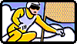

Match each of these demonstrated movements to their corresponding muscle action/movement.

Muscle Action/Movement | Corresponding Letter
Flexion
Abduction
Pronation
Inversion
Plantar Flexion
5 marks

Question 6

- What is the only form of energy the body can use for muscular contraction?

The body has 3 Energy Systems that are responsible for making the above energy compound.

- What are the names of each of the 3 Energy Systems and outline how they are different from each other by filing in the accompanying table.
Name of System
Duration of System
Intensity of System
Fuel for System
Physical Activity that uses this system

1+3+6=10 Marks

Question 7

What is Asthma, what causes it, what triggers it.

What effect does Asthma have on Exercise.

5 Marks

Question 8

- Name each of the structures (A, B, C and D) in the relaxed myofibril in the table below:

Name
A
B
C
D

- The diagram above shows a relaxed and contracted myofibril. Explain what occurs in the contracting myofibril as it shortens. Be very specific and follow the logical order of events!

4+2=6 Marks

Question 9
(Mrs McCallum’s class only)

The following diagram shows the protective
equipment/clothing that is worn by a typical
gridiron (American Football) player.

- Choose two pieces of protective equipment
shown in the diagram. For each, state a different
injury that the piece of equipment is designed to
prevent.

Protective Equipment 1
Possible Injury 1

Protective Equipment 2
Possible Injury 2

 | Protective Equipment 1 | Protective Equipment 2
Possible Injury 1
Possible Injury 2

- From a sport of your choice, outline two practices designed to avoid injuries (other than protective clothing).

Sport:

- Outline an Internal Factor that could be corrected to reduce the risk of injury.

1+1+2+2=6 Marks

Question 10

- Beside each Synovial Joint, list the type of Joint represented and the names of the bones that make up that joint.

 | Knee Joint | Shoulder Joint | Intervertebral Joint
Type of Joint
Bones that make up Joint

- Name 3 structures found in Synovial Joints and outline their function to the joint.

Structure | Function within Joint
1
2
3
6+3=9 Marks

Question 11

- List and explain 2 Psychological and 2 Physiological benefits of being Physically active.

Psychological Benefits of Physical Activity | Physiological Benefits of Physical Activity
1 | 1
2 | 2

- The government has recognised the importance of physical activity for a healthy body by implementing a number of initiatives designed to increase the number of people involved in physical activity on a regular basis.

Outline a specific Government or Private sector initiative by including the name of the initiative, the target group and examples of programs offered.

Name of Initiative:
Details of the Initiative:
4+3=7 Marks

Question 12

Label the Heart Diagram below

Draw the pathway of the blood on its journey through the Heart, to the Lungs, back to the heart and finally to the body. Use a blue pen for the deoxygenated blood and red pen for the oxygenated blood.

What process allows the blood to pick up oxygen in the lungs? Explain how this process works.

What component of the blood is responsible for transporting oxygen around the bloodstream?

4+2+3+1=10 Marks

Question 13

What are the two types of Cardiovascular Disease?

Outline 2 modifiable risk factors than can reduce CV Disease.

Risk Factor 1
Risk Factor 2

2+4=6 Marks

Question 14
- What common postural problem is associated with
Adolescence?

- What causes this problem and what corrective exercises
can be used to help?

1+3=4 Marks

Question 15

- The volume of air breathed in and out per breath is called your ___________

- How does the body increase this amount of air in each breath when you exercise?

Use the lung tracing below to help explain your answer.

Residual Volume

1+2=3 Marks

Question 15
(Mr Lindsay’s Class only)

- List 3 criteria used to make a distinction between sport, games, play and recreation.

1
2
3

- List and outline 3 types of experiences that physical education can provide for participants.

1
2
3

3+6=9 Marks

