Informatics Unit 3 Outcome 1 Information Sheet
Area of Study 1
Organisations and data management
In this area of study students investigate why organisations acquire data online for transaction processing and how they structure their data-gathering processes to support these transactions. Students also develop and apply skills in using a relational database management system (RDBMS) to manipulate data typically sourced through interactive online solutions, such as websites and applications (apps). Students examine how value can be added to this data through the careful structuring of data and the application of functions, such as queries, searches and reports that identify patterns and relationships between data sets.

Students investigate interactive online solutions to ascertain the types of data being acquired, how it is obtained and protected and how transactions are completed. They design a user flow diagram that traces different ways in which users interact with online solutions when initiating and completing transactions, acknowledging that there can be multiple entry points and multiple interactions. Students diagrammatically represent the user interface of the page on which the user commences an online transaction.

Students examine how organisations fulfil their legal requirements to protect the rights of those who provide data and why organisations want the data organised in particular ways. Students consider the fundamentals of an RDBMS; that is, fields and data types, data structures and the relationships between data sets. Students learn to describe data types and data structures, and apply functions, techniques, formats and conventions to store, validate and manipulate data, and to present suitable solutions.

When tracing user interactions and developing a solution, students respond to two teacher-provided design briefs: one relates to how users interact with an online solution when conducting a transaction; the other provides details of why an RDBMS solution is needed, and includes data. The contexts of the briefs can be the same or different.

In this area of study there is an emphasis on the design and development stages of the problem-solving methodology. Students also apply design and systems thinking skills when problem solving.

Scholl Assessed Coursework (SAC)
SAC - Unit 3 Outcome 1 - Organisations and data management – 10%
On completion of this unit the student should be able to design a solution, develop it using a relational database management system, and diagrammatically represent how users interact with an online solution when supplying data for a transaction.
To achieve this outcome the student will draw on key knowledge and key skills outlined in Area of Study 1 (see below).

TASK # 1 (90%) – Design and develop a relational database management system for an online purchasing system.
Software Functions for relational database management system
Students are expected to apply functions that provide the ability to:
- create tables
- create relationships between tables
- use a range of data types
- electronically validate data
- create, edit and use queries
- search and filter records
- perform calculations
- create and edit formatted reports
- sort records or index on different fields.
TASK # 2 (10%) – Part A - Investigate the way organisations acquire data using interactive online solutions and applications (apps), and consider how users interact with these solutions. Using a drawing or graphics software, diagrammatically represent how users interact with an online solution when supplying data for a transaction. Map out an online purchasing system using a User Flow Diagram (UFD). Annotated the UFD showing what happens throughout the process from the user interface to the completion of the transaction. For example, login, encryption, the network processes.
Part B – Create a mock-up of the user interface design of the online page that initiates a transaction.

Software Functions for drawing or graphics software
Students are expected to apply functions that provide the ability to:
- create/select a range of shapes
- use symbols/images
- show relationships and directions
- enter, edit and format text and other content
- use colour/shading.
Note: The teacher will provide you with two design briefs – one for the database, the other for the online purchasing system and a data set for the database.
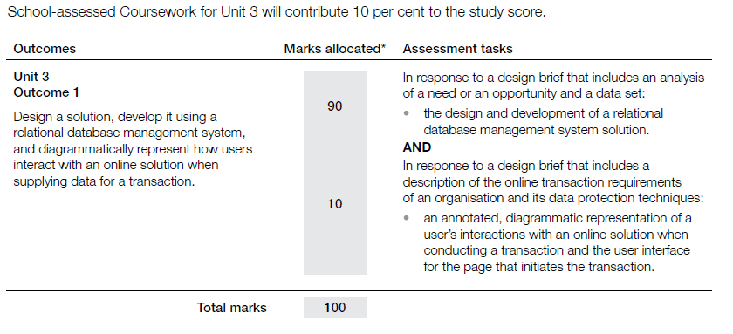
Source: VCAA Computing Study Design 2015 – 2019
Students should organize the content (key knowledge and skills) within these 4 concepts
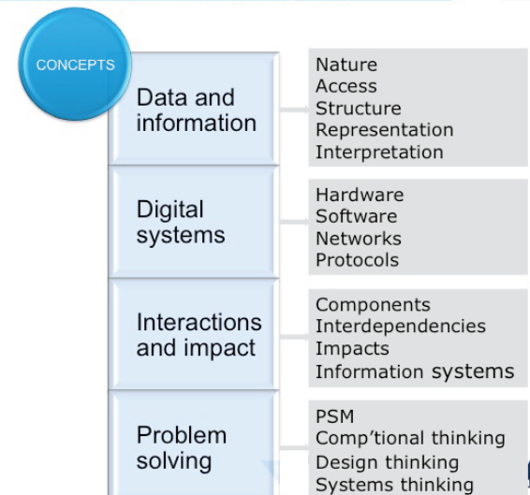

Key knowledge
Data and information
- techniques used by organisations to acquire data through their interactive online solutions and reasons for their choice
- techniques for efficient and effective data collection
- characteristics of data types
Digital systems
• physical and software security controls used by organisations to protect their data
Approaches to problem solving
- purposes and structure of an RDBMS, including comparison with flat file databases
- naming conventions to support efficient use and maintenance of an RDBMS
- a methodology for creating an RDBMS structure: identifying entities, defining tables and fields to represent entities; defining relationships by identifying primary key and foreign key fields; defining data types and field sizes; normalisation to third level
- design tools for describing data types and the value of entity relationship (ER) diagrams for representing the structure of an RDBMS
- design principles that influence the functionality and appearance of solutions
- design tools for representing solutions
- functions and techniques within an RDBMS to efficiently and effectively validate and manipulate data
- functions and techniques to retrieve required information through searching, sorting, filtering and querying data sets
- methods and techniques for testing that solutions perform as intended

Interactions and impact
- reasons why organisations acquire data using online facilities, including 24-hour customer access, improved
- efficiencies through direct data entry by customers, improvements in effectiveness, and access to global markets, marketing opportunities and ongoing services
- reasons why users supply data for online transactions, including convenience, variety of choice, reducing costs
- techniques used by organisations to protect the rights of individuals and organisations who supply data, including security protocols and stating privacy, shipping and returns policies
- user flow diagrams that depict different ways in which users interact with online solutions.

Key skills
- select and apply design tools and techniques for describing data types and representing the structure and functionality of solutions
- use RDBMS functions and techniques to construct a relational database to manipulate and validate data
- apply functions and techniques to construct queries that efficiently retrieve required information
- select and apply testing methods and techniques to confirm whether the solutions operate as intended
- use software tools to represent the user interface of the page on which online transactions begin, including data protection, where appropriate
- use software tools to represent the interactions between users and online solutions (user flow diagrams)
- annotate user flow diagrams to identify where and why data protection is used.
- The User Flow Diagram diagrammatically represents how a user gets form one point to another in a transaction. There is no mandated style of User Flow Diagram. However, design elements such as consistency are important.

