Building a website with basic HTML and CSS
HTML = Hyper Text Markup Language = Coding language to structure and lay out content in webpages.
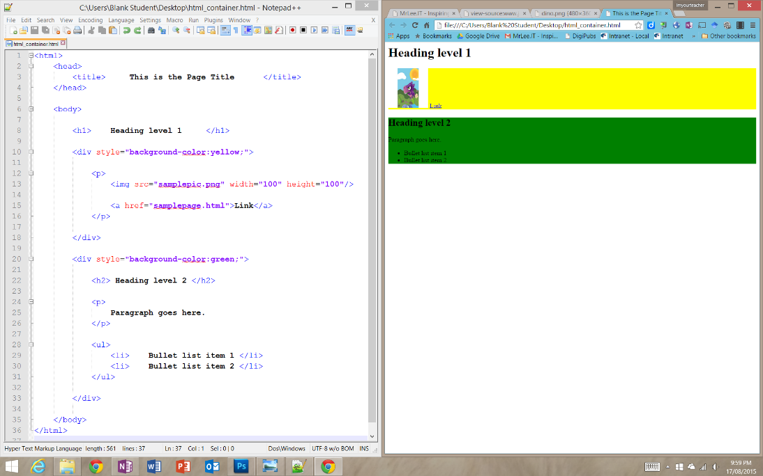
HTML Tags are used to form boxes or containers around the content.
Image 1: Representation of HTML as a container/box structure | Image 2: HTML Code representing that structure. | Image 3: The HTML structure shown in a web browser.

Part 1: HTML Basic structure and paragraphs

Code Summary:
<html></html> = Anything in this is Website code.
<body></body> = Anything in this will display in the web browser
<p></p> = Paragraph Anything in this appears as a paragraph

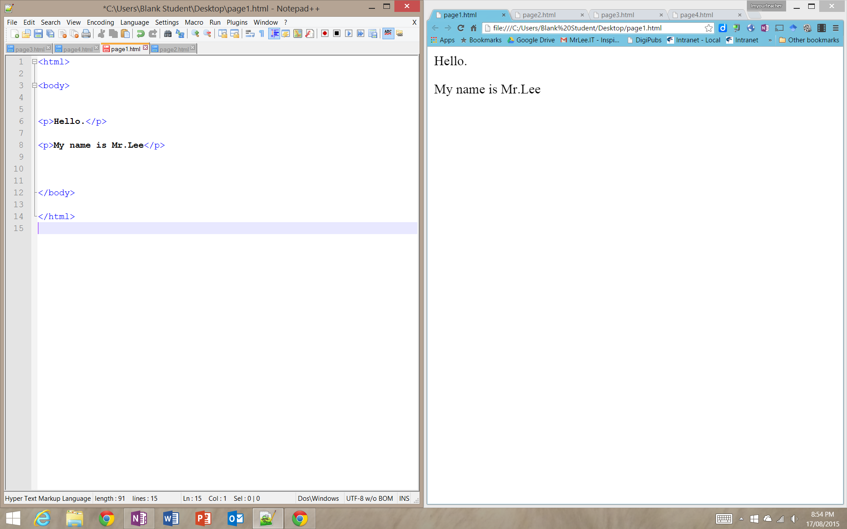

Part 2: Adding Links

Code Summary:
<a></a> = Anything in this is a clickable link.
Some HTML tags, like the <a></a> tag, have properties:
<a></a> tag properties:
href=”” = Anything in the “” specifies what website the link takes you when clicked.

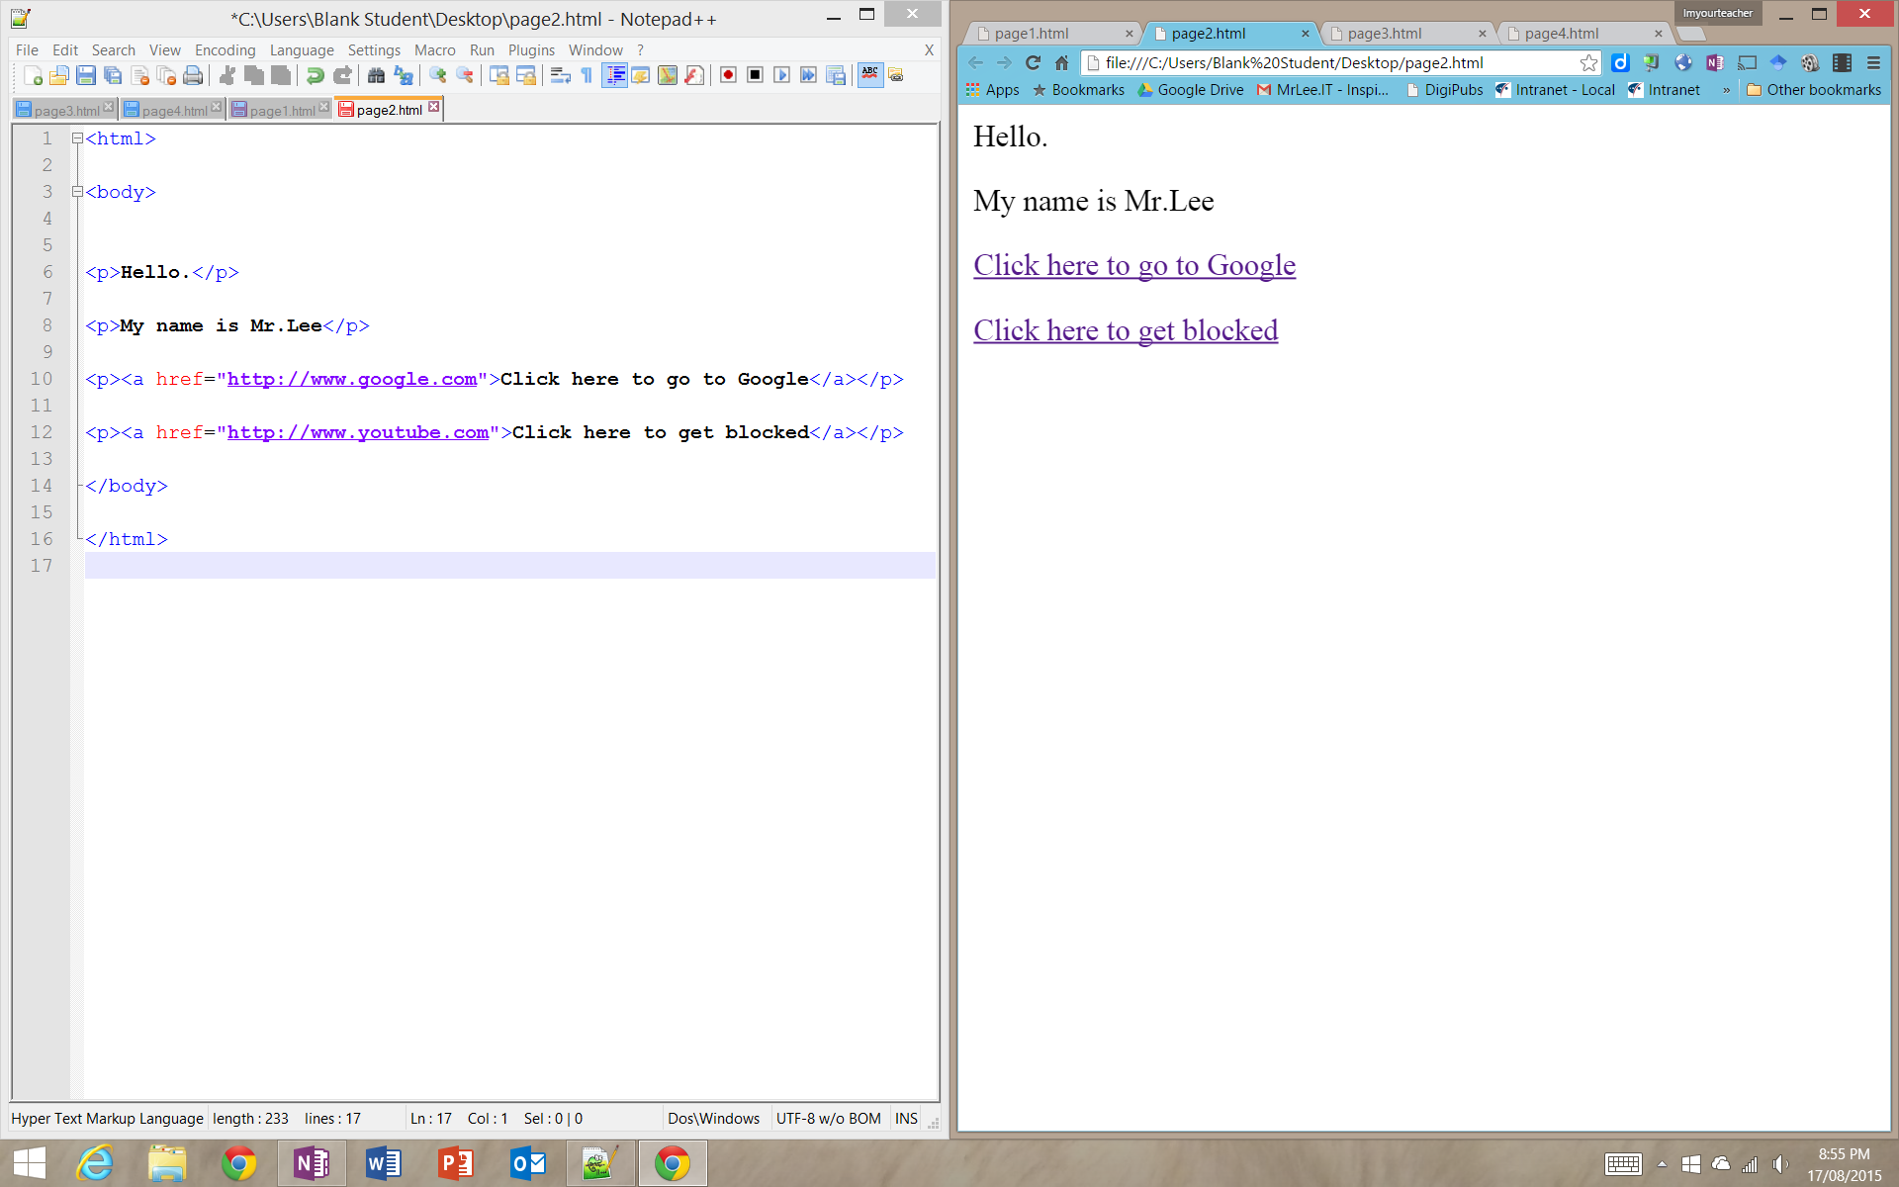

Part 3: Adding Images

Code Summary:
<img>= Anything in this is related to how and what image is displayed.
This tag is special as it doesn’t need a </img> part since nothing goes between it.
Some HTML tags, like the <img> tag, have properties:
<img></img> tag properties:
src=”” = Anything in the “” specifies what image is displayed.
width=”” = Anything in the “” specifies the width of the image.
height=”” = Anything in the “” specifies the height of the image
alt=”” = Anything in the “” specifies what text appears when mouse hovers over image.

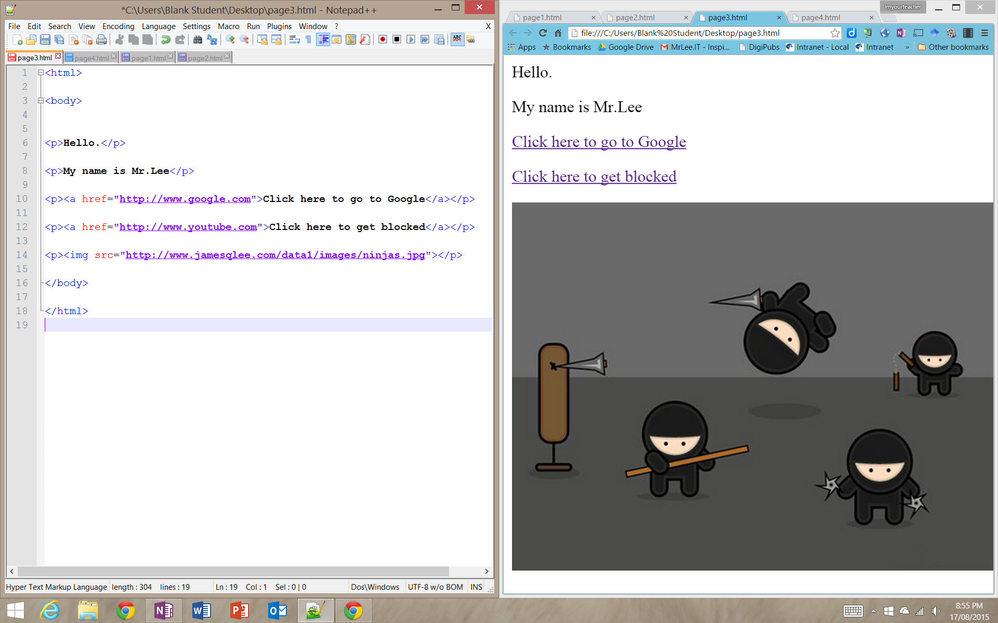

Part 4: Introducing Cascading Style Sheets (CSS) to pretty up the HTML.

Code Summary:
Can be used as a property of any HTML tag.
style=”” = Anything in the “” specifies how you want a specific HTML tag to present its content.
The style property has its own properties to make a HTML tag present its content a certain way.
color:_____; = anything in the gap is the colour used (note American spelling for the word “colour”. See next page for list of color codes)
font-family:_____; = anything in the gap is the font used (see last page on font-family types used)
font-size_____; = anything in the gap is the size of the font (as points (pt) or pixels (px))
background-color:_____; = anything in the gap is the background colour used (note American spelling for the word “colour”)
Visit http://www.w3schools.com/cssref/ for the whole list of CSS properties you can use

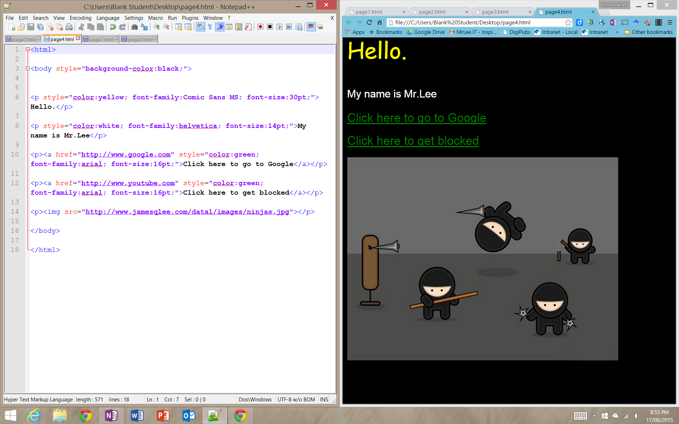

HTML/CSS (hexadecimal) colour codes
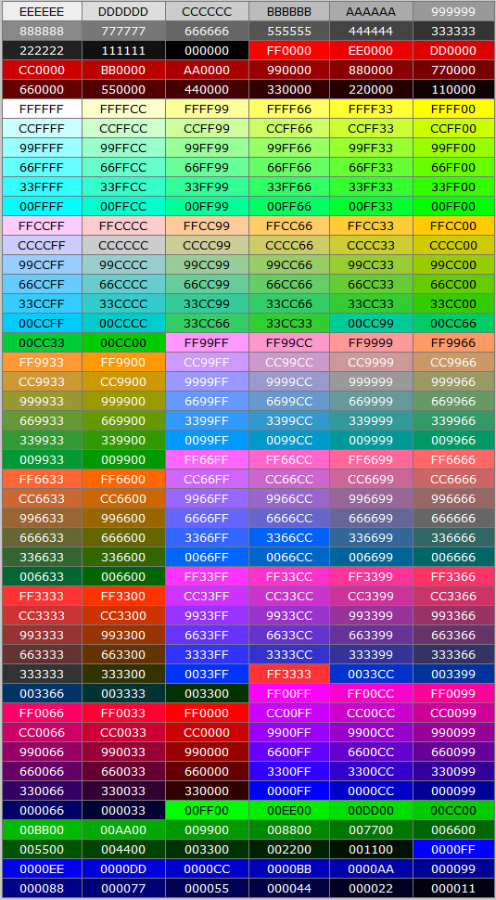
For more specific colour shades, use hexadecimal codes.
This is a Hashtag “#” followed by 6 letters/numbers of
ranges A-F and 0-9).
Eg;
Light grey would be color:#EEEEEE;
Dark orange would be color:#FF6600;
Ugly pink would be color:#CC6699;

Font-Family CSS Style Types
From: http://www.w3schools.com/cssref/css_websafe_fonts.asp

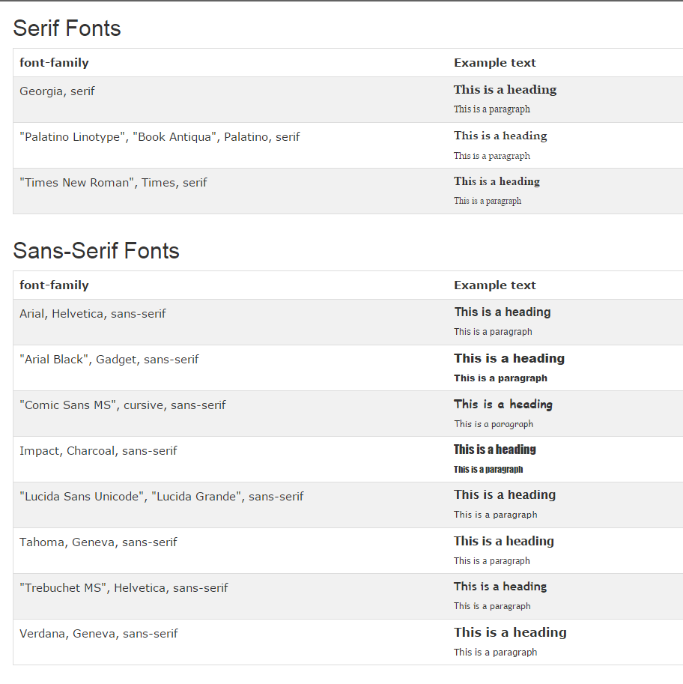
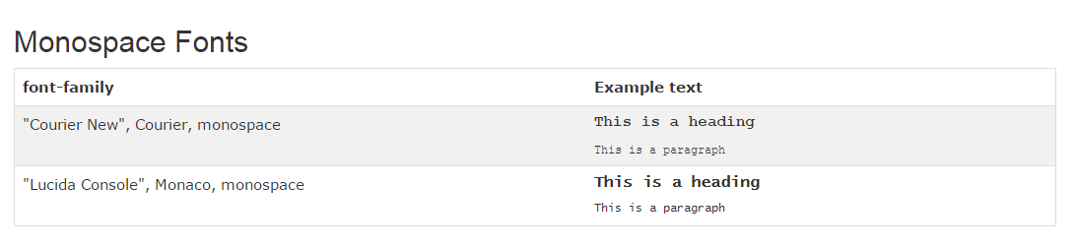

Some Common CSS properties

Property | Values | Used with Elements
color | #RRGGBB (Red, Green, Blue hex values) | any element that contains text
text-align | left | right | center | justify | block elements h1..h6, p, li, etc.
text-decoration | none | underline | overline | line-through | blink | inherit | mostly with a (anchor) elements
text-transformation | none | capitalize | uppercase | lowercase | any element that contains text
line-height | % or px | block elements h1..h6, p, li, etc.
letter-spacing | normal or px value | any element that contains text
font-family | font or font-family [, font or font-family ...] | any element that contains text
font-size | px or em value | any element that contains text
font-style | normal | italic | oblique | any element that contains text
font-weight | normal | bold | any element that contains text
background-color | #RRGGBB (Red, Green, Blue hex values) | any element with a background
background-image | url("[image url]") | mostly with body
background-repeat | repeat | repeat-x | repeat-y | no-repeat | mostly with body
background-position | left | center | right | top | center | bottom | mostly with body
list-style-type | disc | square | circle | ul
list-style-type | decimal | lower-roman | upper-roman | lower-alpha | upper-alpha | ol

Other Common CSS properties

Text
Property | Description | Values | Examples | Notes
color | sets color of text | Hex values or color names | p { color: #0699b4;}  p { color: blue;} | Finding hex values:  - Use Photoshop  - Google them
text-align | aligns text | left  right  center  justify | p { text-align: right;}
text-decoration | add decoration to text | none  underline, etc. | a { text-decoration: none;}
text-transformation | controls letters | none  capitalize  uppercase  lowercase | h2 { text-transformation: uppercase;}
line-height | sets distance between lines | % or px | p { line-height: 18px;}  p { line-height: 150%;}
letter-spacing | sets the distance between characters | normal or px value | h1 {letter-spacing: 1px;}

Font
Property | Description | Values | Examples | Notes
font-family | sets the font family of the text | font or font family name | p { font-family: “Times New Roman”, Times, serif;} | for other font families visit: http://www.w3schools.com/css/css_websafe_fonts.asp
font-size | sets the size of the text | values in px or em | h3 { font-size: 18px;}  h3 { font-size: 1.1em;} | “em” is a relative value (decimal values are ok to use)  - 1: same size as the current/parent element’s font size  - 2: double the size of the current/parent element’s font size  - 0.5: half the size of the current/parent element’s font size
font-style | sets the text style | normal  italic  oblique | h2 { font-style: italic;}
font-weight | sets the weight of a font | normal  bold  bolder  lighter, etc. | a { font-weight: bold;}

Background
Property | Description | Values | Examples
background-color | sets the color of an element’s background | hex color values or color names | body { background-color: #ffffff;}
background-image | sets an image as a background | image url | body { background-image: url (‘images/red-dots.jpg’);}
background-repeat | specifies if/how a background image should be repeated | repeat  repeat-x  repeat-y  no-repeat | body { background-repeat: repeat-x;}  body { background: url (‘images/red-dots.jpg’) no-repeat;}
background-position | sets the starting position of a background image | left top  right bottom  center top  center center, etc. | body { background-position: left top;}  body { background: url (‘images/red-dots.jpg’) no-repeat left top;}

Lists
Property | Description | Values | Examples
list-style-type | specifies the bullet style | circle  square  upper roman  disc, etc. | ul { list-style-type: square;}

Divs, tables, other
Property | Description | Values | Examples
margin | clears an area around an element (outside of the border) | px value | - p {margin: 10px;}  - top, right, bottom & left marings are 10px  - p {margin: 10px 5px;}  - top & bottom marings are 10px and left & right margins are 5px  - p {margin: 10px 15px 20px;}  - top margin is 10px, left & right marings are 15px and bottom maring is 20px  - p {margin: 10px 0 15px 2px;}  - top margin is 10px, right margin is 0px, bottom margin is 15px & left margin is 2px  - p {margin-top: 15px;}  - also margin-left, margin-right, margin-bottom
padding | clears an area around an element (inside of the border) | px value | follows same order as margins, see above  - p {padding: 10px;}  - p {padding: 10px 5px;}  - p {padding: 10px 15px 20px;}  - p {padding: 10px 0 15px 20px;}  - p {padding-top: 10px;}
border | specifies the type of border (could also be set to ‘none’) | - color  - hex value or name  - style  - solid  - dashed  - dotted, etc.  - left, right, top, bottom | img {border-color: #cccccc;}  img {border-style: solid;}  h2 { border-bottom: 1px;}  h3 { border-bottom: 1px solid #cccccc;}img {border: none;}
float | specifies whether an box should float | right  left  center  none | img {float: left;}
clear | no floating allowed to the specific side of an element | right  left  both | #wrap {clear: both;}

