Making a web page with centred content

What you will learn
You will learn to set up a web page with centred content using CSS properties for position and left and right margins.

What we are going to do
Making a web page with its content centred involves a couple of tricks. First you create a container layer and fix its setting so it is centred, then you draw your other layers and move them into the container using the layers panel. When you preview your page it will look similar to this
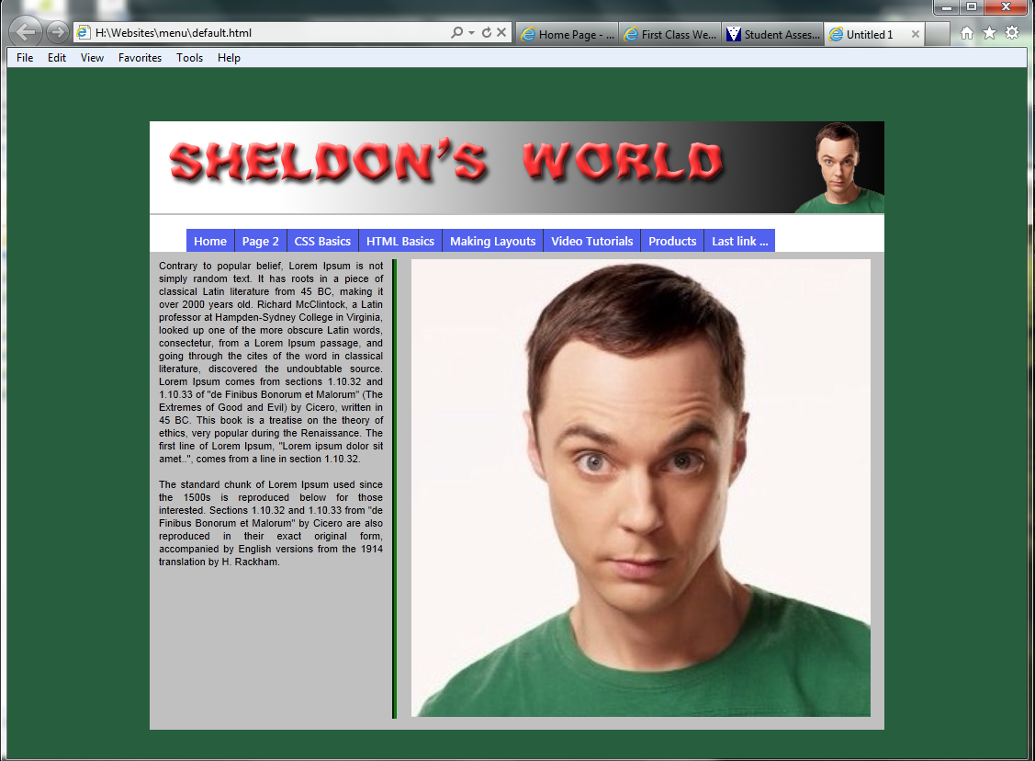
Figure 1 Example page: Sheldon's World

Planning
Here is a layout diagram (or wireframe) of my page. The container is the layer holding the banner, links, articles and picture layers. The outside box is just the edge of the browser window. You should always sketch your pages before you make them.
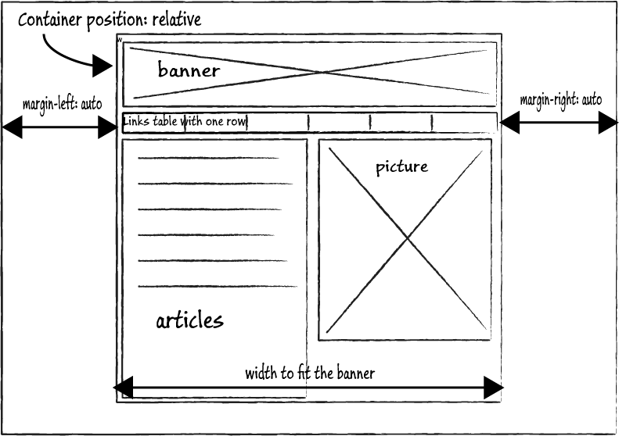
Figure 2 My wireframe

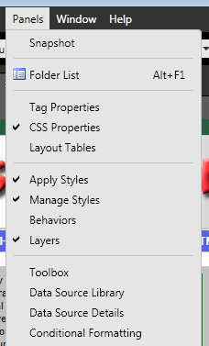
Making a practice page
- Open Expression Web, make a new HTML page and open it. To keep my workspace uncluttered I turn off the tools and panels I don’t use. Open the Panels menu and untick everything except for CSS properties, Apply styles, Manage Styles and Layers.
- Draw a layer on your web page that is roughly the size you want for your container.
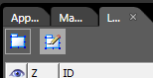
- Double click on its name in the Layers panel and rename it container
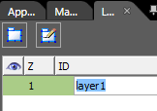
- When you draw the layer you set its CSS properties. Let’s change the layer’s CSS properties so it is big enough and centred.
Property | Value | Essential
Left | 0 | Yes: don’t change
Position | Relative
Margin-left | Auto
Margin-right | Auto
Width | My banner is 800px wide so that is how wide my container layer is | No: you can fiddle with these
Height | We can fix that later
Top | 25px is OK but we can fix that later
- Look at my wireframe (on page 2) and draw layers on your page to roughly match mine.
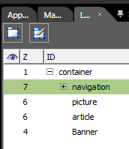
- Name each layer: banner, articles, picture, links etc. Insert a one-row table in your links layer to make a navigation bar.
- Now your layers are sitting on top of the container not in it. We use the layers panel and drag each layer onto the container panel so they end up looking indented like this. Don’t worry about the (+) next to my navigation layer or the numbers.
- Your layers will have moved on the screen, adjust them by dragging with your mouse. You can select a layer by clicking its name in the layer panel.
- Insert some text and pictures into your layers. Try changing the background colours or image for your page and your layers.

