Creating a Style Sheet with EW3

What you will learn
How to create new style sheet, link your page to it, rename styles and drag them into the style sheet using the Styles Panels. You will also learn it takes much longer to read these instructions than it does to do them!

What you will do
- Open the website you made earlier and open the home page (The page about Harp Seals).
- Make sure the Apply Styles and Manage Styles panels are open (Panels Apply Styles, Manage Styles). You will see something like this EW3 (or 4) tries to preview your styles.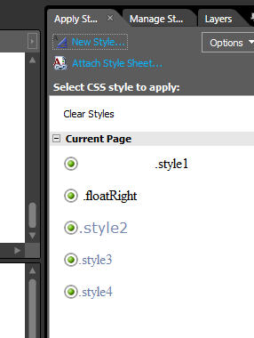
- Click on the Site View tab and create a new CSS file, call it main.css.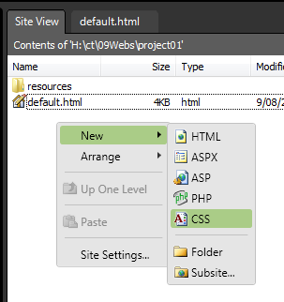
- Go back to your web page and locate the link to Attach Style Sheet on the Manage Styles OR Apply Syles panel.
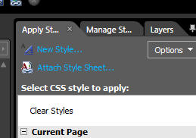
- Attach main.css as a link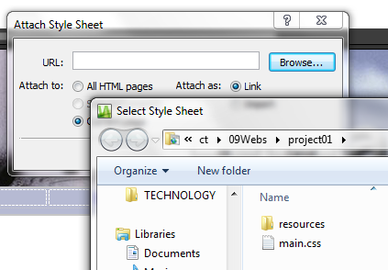
- At this stage is will be useful to rename your styles by right clicking on the style’s name in the Manage Styles panel
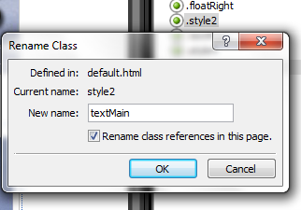
- Drag any styles you want to use across the website onto the stylesheet.
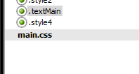 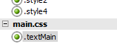
- Click the Save All icon to register your changes to both files.
- Open your style sheet and you will see the changes you’ve made.
You can edit the styles directly in the style sheet or by using the Mange/Apply Styles panels.

