IT APPLICATIONS
UNIT 4 OUTCOME 1

REVISION NOTES

Unit 4 Outcome 1
Using selected software to solve an ongoing information problem, and evaluate the efficiency and effectiveness of the solution in meeting the information needs of an organisation

Key Knowledge

1. Types of goals of organisations and information systems

2. Role of components of information systems

3. Characteristics of strategic, tactical and operational decisions made in organisations

4. Stages of the problem-solving methodology

5. Problem-solving activities relating to the analysis of ongoing information problems

6. Design tools for representing the functionality and appearance of solutions

7. Criteria for evaluating the efficiency and effectiveness of solutions to ongoing information problems

8. Functions, techniques and procedures for efficiently and effectively manipulating data using an RDBMS or spreadsheet software, including the application of formats and conventions, the validation of data and the management of files

9. Techniques for testing solutions and user acceptance

10. Strategies for evaluating the extent to which solutions meet organisations’ needs

11. Content and types of onscreen user documentation, including quick start guide, tutorial, content sensitive help and manual

12. Characteristics of efficient and effective user interfaces and information architecture

13. Functions, techniques and procedures for efficiently and effectively manipulating data using web authoring or multimedia authoring software

1. Types of goals of organisations and information systems

1. Explain the relationship between a ‘mission statement’ and ‘organisational goals’

_____________________________________________________________________

_____________________________________________________________________

_____________________________________________________________________

2. Distinguish between an ‘organisational goal’ and an ‘organisational objective’

_____________________________________________________________________

_____________________________________________________________________

_____________________________________________________________________

3. Identify how ‘organisational goals’ differ from ‘information system goals’

_____________________________________________________________________

_____________________________________________________________________

_____________________________________________________________________

4. Complete the following table:

Scenario | Organisation or Information System | Goal or Objective
Reduce data entry errors by 20%
Produce accurate information
Improve customer service
Increase Profit
Increase Sales by 10%

2. Role of components of information systems

1. Describe the purpose of an ‘information system’

_____________________________________________________________________

_____________________________________________________________________

_____________________________________________________________________

2. List the four components of an ‘information system’

_____________________________________________________________________

_____________________________________________________________________

3. Define the term ‘procedures’

_____________________________________________________________________

_____________________________________________________________________

_____________________________________________________________________

One of Ballarat Bank’s organisational goals is to have ‘convenient access to its services for customers’. To support the goal the Bank are installing 20 new automatic teller machines (ATM’s) around Australia.

4. Complete the table below identifying one example for each component of the above information system:

Component | Example
Equipment
Data
Personnel
Procedure

3. Characteristics of strategic, tactical and operational decisions made in organisations

1. Complete the following table:

Decision | Level of  Management | Time  Frame
Strategic
Tactical
Operational

2. Describe how strategic and tactical decisions are linked. Illustrate your answer with an example

_____________________________________________________________________

_____________________________________________________________________

_____________________________________________________________________

3. Define the term ‘Operational Decisions’

_____________________________________________________________________

_____________________________________________________________________

_____________________________________________________________________

4. Complete the table below by selecting the type of decision being made in each scenario:
Scenario | Decision
Reduce the price by 10% off items that are close to their ‘use-by’ date
Decide to open up a chain of stores in China
Decide in which cities, in China, the new stores should be open in

4. Stages of the problem-solving methodology

1. Complete the diagram below showing all stages and activities of the ‘problem-solving methodology’ (PSM)

Problem-Solving Methodology

5. Problem-solving activities relating to the analysis of ongoing information problems

1. Explain the purpose of the ‘Analysis stage’

_____________________________________________________________________

_____________________________________________________________________

_____________________________________________________________________

2. Discuss what occurs in the ‘Identifying Solution Requirements’ activity
_____________________________________________________________________

_____________________________________________________________________

_____________________________________________________________________

3. Define the term ‘Solution Constraints’

_____________________________________________________________________

_____________________________________________________________________

_____________________________________________________________________

4. Identify the tasks that occur when ‘Defining the Scope of the solution’

_____________________________________________________________________

_____________________________________________________________________

_____________________________________________________________________

6. Design tools for representing the functionality and appearance of solutions

1. List two design tools suitable to show the functionality of a spreadsheet

_____________________________________________________________________

_____________________________________________________________________

2. List two design tools suitable to show the appearance of a spreadsheet

_____________________________________________________________________

_____________________________________________________________________

To calculate the Total Cost of a transaction the Quantity of items purchased is multiplied by the Unit Cost of each item

3. Complete an IPO chart to represent the scenario above

Input | Processing | Output

4. Place the number corresponding to the correct action in the appropriate position in the flowchart shown below
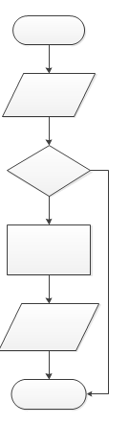
1. No
2. Print Unsatisfactory Notice
3. Start
4. Is Grade less than 50%?
5. End
6. Enter Grade
7. Yes
8. Create Unsatisfactory Notice

7. Criteria for evaluating the efficiency and effectiveness of solutions to ongoing information problems

1. Explain how ‘efficiency’ differs from ‘effectiveness’

_____________________________________________________________________

_____________________________________________________________________

_____________________________________________________________________

2. List three attributes related to both efficiency and effectiveness

Efficiency | Effectiveness
Ease of Use | Accurate

3. Identify whether each of the following criteria is related to efficiency or effectiveness

Criteria | Efficiency or Effectiveness
The solution contains all the information necessary
The new solution will produce the same information using less processing speed
The new solution will make available the required information on time
The new solution will be easier to use than the old system
The current system is needed to be replaced as it is difficult to use
Larger fonts will be used in the new system to assist older users
Less data entry will be required in the new system

8. Functions, techniques and procedures for efficiently and effectively manipulating data using an RDBMS or spreadsheet software, including the application of formats and conventions, the validation of data and the management of files

1. List three conventions used in spreadsheet software

_____________________________________________________________________

_____________________________________________________________________

_____________________________________________________________________

2. Define the term ‘Validation’

_____________________________________________________________________

_____________________________________________________________________

_____________________________________________________________________

3. Identify which validation method is most suitable in the following situations

Range Existence Data Type Restricted Entry

Situation | Validation Method
Users must enter an email address
Salary details must be a whole number
A day of the week must be entered
Only numbers between 1 and 100 are allowed

4. List three rules related to naming a file that will help with the management of the file

_____________________________________________________________________

_____________________________________________________________________

_____________________________________________________________________

9. Techniques for testing solutions and user acceptance

1. Explain how ‘Testing’ is different to ‘Validation’

_____________________________________________________________________

_____________________________________________________________________

_____________________________________________________________________

A spreadsheet is designed to produce a message whenever the stock on hand for an item drops below 5

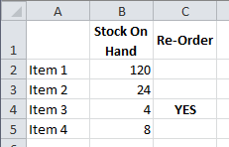
The formula entered in cell B5 is =IF (B4 >= 5, “Yes”, “ “)

2. Complete the following test table with the most appropriate test data

Test | Test Data | Expected Result | Actual Result
1
2
3

3. Explain how testing is conducted for ‘User Acceptance’

_____________________________________________________________________

_____________________________________________________________________

_____________________________________________________________________

10. Strategies for evaluating the extent to which solutions meet organisations’ needs

1. Explain the purpose of the ‘Evaluation Stage’

_____________________________________________________________________

_____________________________________________________________________

_____________________________________________________________________

2. Explain how ‘Evaluation’ differs from ‘Testing’

_____________________________________________________________________

_____________________________________________________________________

_____________________________________________________________________

3. Discuss when the evaluation of a new information system should occur

_____________________________________________________________________

Criteria for a new spreadsheet information system is listed below

4. Complete the following table

Criteria | Data Required | How Collected
Data entry needs to be quicker than the existing system
Information produced is free of errors
The payroll report is produced by 5pm each Thursday
New system must be easy to use

11. Content and types of onscreen user documentation, including quick start guide, tutorial, content sensitive help and manual

1. List the stage of the PSM that ‘Documentation’ is created in

_____________________________________________________________________

2. Complete the following table:

User  Documentation | Format | Description
Quick Start
Guide
Tutorial
Content Sensitive Help
Manual

3. Contrast when ‘Content Sensitive Help’ is likely to be used compared with a ‘Tutorial’

_____________________________________________________________________

_____________________________________________________________________

_____________________________________________________________________

12. Characteristics of efficient and effective user interfaces and information architecture

1. Define the term ‘User Interface’

_____________________________________________________________________

_____________________________________________________________________

_____________________________________________________________________

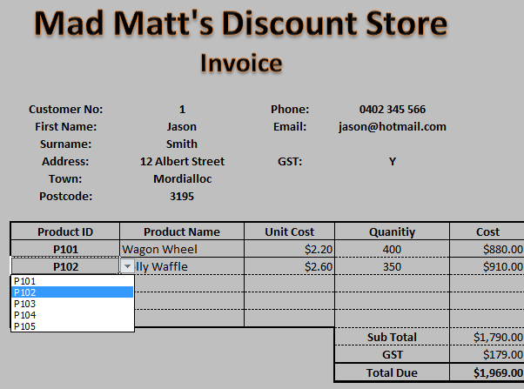

2. Describe reasons why the above user interface can be considered both efficient and effective

_____________________________________________________________________

_____________________________________________________________________

_____________________________________________________________________

3. Explain how having different worksheets for different data (calculations, lookup data, graphs, etc.) helps to improve the ‘Information Architecture’ of a spreadsheet

_____________________________________________________________________

_____________________________________________________________________

_____________________________________________________________________

13. Functions, techniques and procedures for efficiently and effectively manipulating data using web authoring or multimedia authoring software

1. Explain why using a template for each page of a website is both efficient and effective

_____________________________________________________________________

_____________________________________________________________________

_____________________________________________________________________

2. Describe what a ‘Cascading Style Sheet’ is and explain the advantages of using CSS

_____________________________________________________________________

_____________________________________________________________________

_____________________________________________________________________

3. Explain how ‘Alt Tags’ and ‘Meta Tags’ improve the effectiveness of a website solution

_____________________________________________________________________

_____________________________________________________________________

_____________________________________________________________________

4. Discuss how the size and file types of images and video used on webpages may affect the performance of the site

_____________________________________________________________________

_____________________________________________________________________

_____________________________________________________________________

