IT APPLICATIONS
UNIT 3 OUTCOME 2

REVISION NOTES

Unit 3 Outcome 2
Design & develop, using a relational database management system, a solution to an information problem, and discuss why and how data is acquired via websites

Key Knowledge
1. Reasons why organisations acquire data via websites

2. Reasons why individuals and organisations supply data via websites

3. Techniques used by organisations to acquire data on websites and reasons for their choice

4. Techniques used by organisations to protect the rights of individuals and organisations supplying data

5. Stages of the problem-solving methodology

6. Purposes and structure of an RDBMS

7. Naming conventions to support efficient use of an RDBMS

8. Data types, including text (string), number, date/time, currency, Boolean

9. Data formats used for display, including fixed decimal places, various date formats, 12 hour/24 hour time, true/false, yes/no

10. A methodology for creating an RDBMS structure

11. Design tools for describing data types, and the value of entity relationship (ER) diagrams for representing the structure of an RDBMS

12. Design tools for representing solutions

13. Functions and techniques within an RDBMS to efficiently and effectively manipulate and validate data

14. Functions and techniques to retrieve required information through searching, sorting, filtering and querying data sets

15. Methods and techniques for testing that the solutions perform as intended

1. Reasons why organisations acquire data via websites

1. Discuss a common method used by organisations to acquire data via a website

_____________________________________________________________________

_____________________________________________________________________

2. Explain two advantages for an organisation by collecting data via a website

_____________________________________________________________________

_____________________________________________________________________

_____________________________________________________________________

_____________________________________________________________________

3. Describe, in terms of both efficiency and effectiveness, the advantage for an organisation by allowing customers to enter their details directly

Efficiency

_____________________________________________________________________

_____________________________________________________________________

Effectiveness

_____________________________________________________________________

_____________________________________________________________________

2. Reasons why individuals and organisations supply data via websites

1. List four reasons why individuals supply data via websites

_____________________________________________________________________

_____________________________________________________________________

_____________________________________________________________________

_____________________________________________________________________

2. Discuss advantages for individuals to shop online

_____________________________________________________________________

_____________________________________________________________________

_____________________________________________________________________

3. Discuss disadvantages for individuals when shopping online

_____________________________________________________________________

_____________________________________________________________________

_____________________________________________________________________

4. List three pieces of data individuals usually supply when joining a social networking site

_____________________________________________________________________

_____________________________________________________________________

_____________________________________________________________________

3. Techniques used by organisations to acquire data on websites and reasons for their choice

1. List four techniques organisations uses to acquire data via a website

_____________________________________________________________________

_____________________________________________________________________

_____________________________________________________________________

2. Discuss the advantages of using a form to collect data via a website

_____________________________________________________________________

_____________________________________________________________________

_____________________________________________________________________

_____________________________________________________________________

3. Explain why an organisation may use a Poll on a website – even though users are not required to enter any personal details to vote

_____________________________________________________________________

_____________________________________________________________________

_____________________________________________________________________

4. Discuss two advantages for an organisation to have a forum associated with their website

_____________________________________________________________________

_____________________________________________________________________

_____________________________________________________________________

_____________________________________________________________________

4. Techniques used by organisations to protect the rights of individuals and organisations supplying data

1. Explain how the protocol HTTPS works

_____________________________________________________________________

_____________________________________________________________________

_____________________________________________________________________

2. Describe the purpose of a ‘Privacy Policy’

_____________________________________________________________________

_____________________________________________________________________

_____________________________________________________________________

3. Explain the type of information that would be found in a ‘Shipping & Returns Policy’

_____________________________________________________________________

_____________________________________________________________________

_____________________________________________________________________

4. Discuss how the ‘policies’ help protect both individuals & organisations

_____________________________________________________________________

_____________________________________________________________________

_____________________________________________________________________

5. Stages of the problem-solving methodology

1. List two activities involved in the design stage of the PSM

_____________________________________________________________________

_____________________________________________________________________

2. Explain why criteria to evaluate the solution are created in the design stage

_____________________________________________________________________

_____________________________________________________________________

_____________________________________________________________________

3. List four activities involved in the development stage of the PSM

_____________________________________________________________________

_____________________________________________________________________

_____________________________________________________________________

_____________________________________________________________________

4. Explain how validation is different to testing

_____________________________________________________________________

_____________________________________________________________________

_____________________________________________________________________

6. Purposes and structure of an RDBMS

1. Explain the purpose of a Relational Database Management System (RDBMS)

_____________________________________________________________________

_____________________________________________________________________

_____________________________________________________________________

2. Explain how a database differs from a RDBMS

_____________________________________________________________________

_____________________________________________________________________

_____________________________________________________________________

Username | First  Name | Surname | Discount | Cost per  Month | Months | Total  Cost
ant@pond.com | Anthony | James | N | $10 | 6 | $60
pete@dogs.com | Peter | Smith | Y | $8 | 3 | $24

3. Explain the purpose of a table in a database

_____________________________________________________________________

_____________________________________________________________________

4. From the table above list how many fields and how many records are shown

_____________________________________________________________________

5. Identify which field is the ‘Primary Key’ and explain the purpose of a ‘Key field’

_____________________________________________________________________

_____________________________________________________________________

_____________________________________________________________________

7. Naming conventions to support efficient use of an RDBMS

1. Explain why naming a database table as ‘Table1’ would not be appropriate

_____________________________________________________________________

_____________________________________________________________________

_____________________________________________________________________

2. Define the term ‘Hungarian Notation’

_____________________________________________________________________

_____________________________________________________________________

_____________________________________________________________________

3. Discuss two advantages of naming a table ‘tblMembers’

_____________________________________________________________________

_____________________________________________________________________

_____________________________________________________________________

4. List an appropriate name for each of the following database objects

Database Element | Appropriate Name
A table holding details about books
A form used to enter book details
A query which sorts books alphabetically
A query which searches for all books by author

8. Data types, including text (string), number, date/time, currency & Boolean

1. Define the term ‘data type’

_____________________________________________________________________

_____________________________________________________________________

2. Explain why it’s important to select the correct type for each field

_____________________________________________________________________

_____________________________________________________________________

_____________________________________________________________________

3. Explain why the Primary Key does not have to be an Auto Number

_____________________________________________________________________

_____________________________________________________________________

_____________________________________________________________________

4. Complete the following table
Field Name | Data Type | Description
Member ID |  | First three letters of the member’s surname and three numbers
Name |  | Name of member
Phone |  | (03) 9412 1234
Date Joined |  | Date member joined the club
Years of Membership |  | Number of years of continuous membership
Membership Fee |  | Annual Membership fee payable
Membership Fee Paid? |  | Whether the member has paid or not

9. Data formats used for display, including fixed decimal places, various date formats, 12 hour/24 hour time, true/false, yes/no

1. Explain how a data format differs from a data type

_____________________________________________________________________

_____________________________________________________________________

_____________________________________________________________________

2. Explain why is it important to select the correct data format for each field

_____________________________________________________________________

_____________________________________________________________________

_____________________________________________________________________

3. Complete each column in the table below by selecting from the following options:

Data Type: Text, Number, Date/Time, Currency or Boolean
Data Format: Integer (Whole Number), Two Decimal Places, Short Date,
Medium Date, Long Date, 12 Hour Time, 24 Hour Time, True/False or Yes/No

Field Name | Data Type | Data Format | Description
Student ID |  |  | Unique Six Number ID e.g. 012345
Name |  |  | Name of Student
Average Mark |  |  | Out of 100, rounded to 2 decimal places
Fees Paid? |  |  | Are School Fees up to Date?
Date of Enrolment |  |  | dd/mm/yyyy
Time of Next Lecture |  |  | 19:00

10. A methodology for creating an RDBMS structure

1. Explain the purpose of Normalisation

_____________________________________________________________________

_____________________________________________________________________

2. Explain how Normalisation assists to improve “Data Integrity”

_____________________________________________________________________

_____________________________________________________________________

3. Explain why the table below is not in Second Normal Form (2NF)

Student ID | Surname | Tutor Group | Tutor | Tutors Office
20120001 | Jones | 12 SM | Mr Smith | S 17

_____________________________________________________________________

_____________________________________________________________________

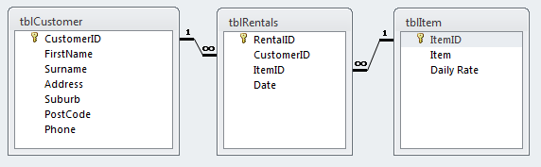

4. Identify in which table Item ID is the Primary Key and which table Item ID is the Foreign Key

_____________________________________________________________________

_____________________________________________________________________

5. Explain the relationship between the Customer & Rentals tables

_____________________________________________________________________

_____________________________________________________________________

11. Design tools for describing data types, and the value of entity relationship (ER) diagrams for representing the structure of an RDBMS

1. Complete the following data structure table:

Data Structure Data
Field Name | Data Type | Data Format | Length  (If Text) | Description
Username |  |  |  | Email address
Name | Text |  |  | Name of Student
Age |  | Integer
OnlineNow? |  |  |  | Is user online now?

2. List the three basic elements of entity relationship diagrams and provide an example of each from the diagram below

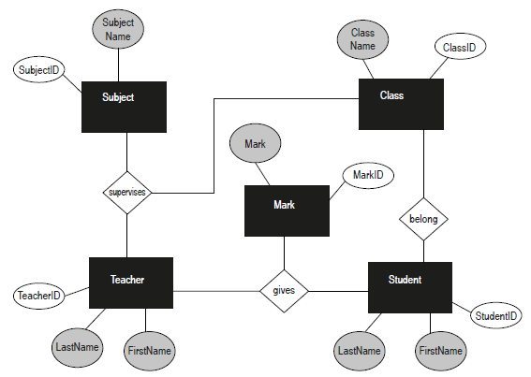

_____________________________________________________________________

_____________________________________________________________________

_____________________________________________________________________

12. Design tools for representing solutions

The table below stores details of the suppliers for Harry’s Hamburger Shop

Supplier ID | Company | Contact | Title | Address | City | Postcode
1 | ABC Meats | Bill | Accountant | 12 High Street | Elwood | 3184

1. Draw an input form for Harry’s to add a new supplier and save the record
Harry’s standard font is Calibri size 14 and background colour is white

A query is required to sort all Products into categories and then sort by price – then show only Name; Price & Location fields

2. Complete the query design below

Field | Name | Category | Price | Quantity | Location
Table | tblProducts | tblProducts | tblProducts | tblProducts | tblWarehouse
Sort
Show
Criteria

13. Functions and techniques within an RDBMS to efficiently and effectively manipulate and validate data

1. Describe the term validation and explain the purpose of validating data

_____________________________________________________________________

_____________________________________________________________________

_____________________________________________________________________

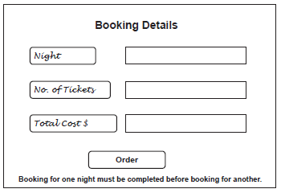

2. Recommend an electronic technique for the Night field to enhance the likelihood of inputting accurate data. Justify your choice

_____________________________________________________________________

_____________________________________________________________________

_____________________________________________________________________

Employee | Hours Worked | Hourly Rate | Gross Pay $
Jenkins | 20 | 15 | 300

3. Define the term ‘calculated field’. Identify which item is calculated field and state the formula used in the calculated field

_____________________________________________________________________

_____________________________________________________________________

_____________________________________________________________________

14. Functions and techniques to retrieve required information through searching, sorting, filtering and querying data sets

1. List the records that would be selected if the following query was designed:

Food supplier = “TOP” OR Feeds per week = 7

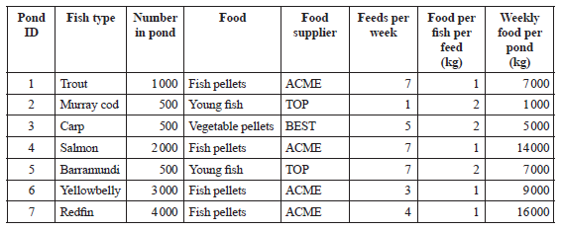

_____________________________________________________________________

2. List the movie ID(s) that would be returned if the query below was entered?

Category < > Thriller and Time < 90

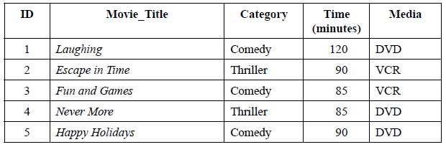

_____________________________________________________________________

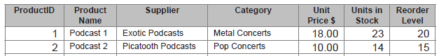

3. Write a rule for a query that will return a list of all items needed to be
Re-ordered

_____________________________________________________________________

15. Methods and techniques for testing that the solutions perform as intended

1. Explain how testing is different to validation

_____________________________________________________________________

_____________________________________________________________________

2. Identify which field from the above database form requires testing. Calculate the expected outcome if tickets cost $5 and 4 tickets are being purchased

_____________________________________________________________________

The IPO chart below is set up to represent part of a database is shown below:

Input | Process | Output
Quantity  Unit Cost | Total Cost = Quantity x Unit Cost | Total

3. Indicate which fields would be validated and which tested

_____________________________________________________________________

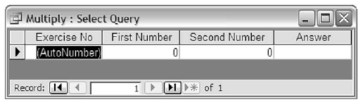
4. To test the calculate field above, identify which fields require test data

_________________________________________________________________

