IT011 SPREADSHEETS – APPLIED PROCESSING FOLIO TASK 7

X-Treme Video Store wants you to design a spreadsheet showing all their available movies for hire.

They want to have columns for the Name of the video, the date purchased (date format) and cost (currency format) , the number they own and its running time.

They want to remind staff how to fill in the spreadsheet and alert the user if a mistake is made.

The want the following validation rules to be observed:

- The date has to be no earlier than 1990.
- The amount has to be between $10 - $40
- The number owned has to be any number up to 20 (no more than 20 copies of a video are ever purchased)
- The running time has to be between 30 minutes and 3 hours.

- Design your spreadsheet (get a sheet from your teacher) showing how it will look before you go on the computer. Show your teacher before you start.

- Type your spreadsheet with the following information:

Flying Low 1 February 1991 $20.00 5 100
Explore Antarctica 15 July 1997 $25.99 7 85
Ocean Hunt 22 December 1996 $22.05 11 96
Planet Trek 13 April 1992 $15.00 6 82
Robot Wars 6 June 2000 $19.98 16 133

- 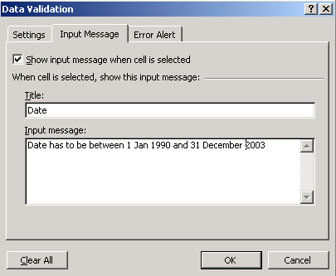Set up your validation as per the dot points above. To do this, click on the Data menu, and choose Validation
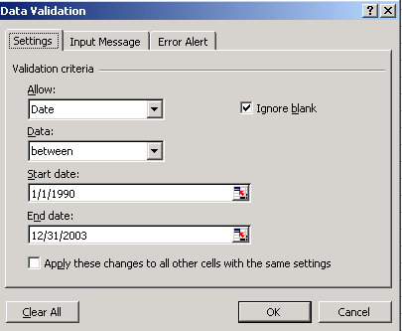

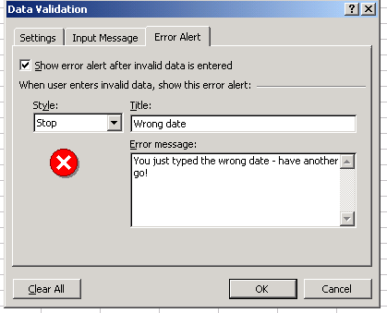

- Make up some data that will test your validation messages (ie, data that is deliberately out of range).

Eg. Crooked Capers 8 August 1989 (date is out of range)
Backyard Disasters $5.00 (price is wrong)
Battles of the Amazons 22 (too many copies)
Amazing Escapes 25 (time too short)

Make up the rest of the details.

- When the error alert appears, do a screen dump (Print screen) showing your message (Paste it into Word). You should end up with 4 screen dumps showing the four error messages. Put your name on your work and print it out (Task 7A).

- Correct your spreadsheet so all the data is within range. Use this information

Crooked Capers | 8-Aug-90 | $ 15.50 | 12 | 158
Backyard Disasters | 24-Mar-97 | $ 16.60 | 4 | 135
Battles of the Amazons | 7-May-93 | $ 17.75 | 3 | 122
Amazing Escapes | 13-Sep-94 | $ 18.85 | 2 | 115

- Finally, sort your spreadsheet so that you print out two copies (Task 7B & 7C)

  - A list of movies in alphabetical order
  - A list of movies that are sorted by running time (longest to shortest).

