IT011 – SPREADSHEETS – APPLIED PROCESSING FOLIO TASK 2

In this task, you will be making 5 separate sheets in one workbook. Start by labelling the first three tags Grocery, Scores, Golf, then add in two more sheets called Sales and Canteen.

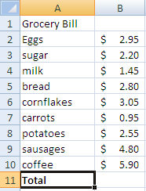
You can perform a variety of mathematical functions on a spreadsheet. For example, you may like to add up a column of figures. There are two ways of doing this:

- Manually.
First of all you have to determine the cell references you want to add. For example, the grocery bill right is contained in cells B2 to B10. (B2:B10)

Go to the cell where you want to place the answer (B11) and type an = sign. This tells the computer you are about to enter a formula into that cell.
Continue with the rest of the formula =Sum(B2:B10) ENTER. Calculate the answer now.

The computer will calculate the total of the cells B2 to B10. If you had typed = sum (B2:B7), which items would have been included? What will the new total be? Calculate this underneath. It is important to note that you can either type in the cell references using the keyboard, or simply highlight them with the mouse. Try using both ways on the grocery tab of your worksheet.

- Using Autosum – the key

After you have become competent using the manual commands, you can try using autosum which does exactly the same thing – puts in the formula = sum(B2:B10) without you having to type it. However, it is important to remember that autosum adds up the whole column (not just parts of a column) so you couldn’t use autosum if you only wanted to add B2:B7.

To use autosum, go to cell B11 (make sure the cell is clear) and click on the autosum key and press enter.

Task 2A: Do this on the scores tab of your worksheet.
Try adding up scores for three test results for the following four students: use both manual method and autosum.

Name | Wilma | Betty | Fred | Barney
Test 1 | 63 | 49 | 62 | 58
Test 2 | 25 | 33 | 52 | 74
Test 3 | 42 | 68 | 41 | 33
Total

Task 2B: Type this on the golf tab of your worksheet.
During a week, these keen golfers played three times. These are the scores:

Name | Sunday | Tuesday | Friday | Total
Dino | 78 | 85 | 90
Pebbles | 85 | 77 | 75
Bambam | 88 | 92 | 98
Mr Slate | 92 | 98 | 86

This time you will be adding across the rows (from B2:B4).
Save your whole spreadsheet as Spreadsheet Folio task 2.

Formatting Cells:

Sometimes it will be necessary to reformat (change the appearance of) your spreadsheet. Some of the most commonly used formats are already on your toolbar. From left they are “currency”, Percentage, add in a comma, increase decimal places, reduce decimal places.

Remember to highlight the cell(s) you want to change, then select the format you want. You can also do more complex formatting and shading by right mouse clicking onto the cells, and choosing “format cells”.

- Go to your scores spreadsheet and format the results to one decimal place. Align all names in the centre of their cells.
- Go to your golf spreadsheet and format the results to 0 decimal places. Align all information in all cells to the left hand side.
- Put on an appropriate header (task number, your name), and print both spreadsheets. Put them in your folder and tick off the list.
- Resave spreadsheet Folio task 2.

Using fill across and fill down

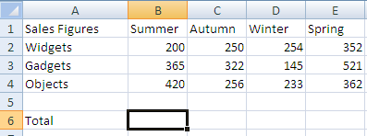
As you have probably realised by now putting the same function in 3 different cells can be very tedious. If you want to continue the same pattern (either down a column of cells or across a row of cells) click onto the original cell and then use Fill down or Fill across.

Task 2C: Type this on the sales tab of your worksheet.

Now use the sum formula to total up the sales figures for Summer only (cell B6). Then drag the little corner box in cell B6 across to E6. The computer will automatically fill the remaining cells for you with the same (sum) formula.

Now add in a new column at F called Total items. Put in the total for widgets at F2.
Once again, use the same little corner block to drag the same formula down to F4. Put in the grand total at F6.
Format Row 6 with a top and double bottom underline to show that this is the final total.

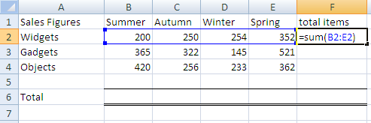

Resave your spreadsheet.

Task 2D: Type this on the canteen tab of your worksheet. Calculate the total for each day, the total number sold for each item and the grand total.
Resave your spreadsheet.

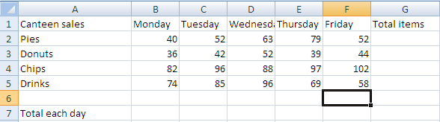
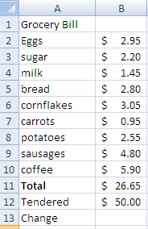
Subtracting cells:

So far our examples have mostly been about addition, however you can subtract, multiply and divide cells just as easily. In fact anything you can do on a calculator can be done on a spreadsheet

For example, in our grocery example, we bought goods totalling $26.65. If we handed a $50 note to the cashier, how much change would be given? Our spreadsheet might look like this:

To calculate the change, we want to know what $50
(B12) minus $26.65 (B11) is. Therefore our formula at B13 is: = B12 – B11 ENTER.

Go to your sales tab.

Add in last year’s totals at row 8 and calculate the difference at Row 10. Make sure you complete column F as well.

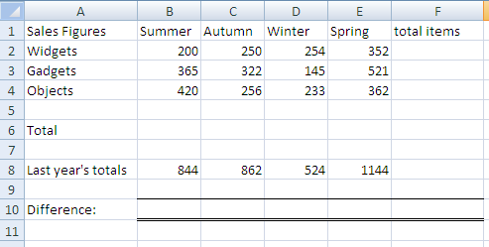

Note how the computer shows the figure for autumn as a negative value.

Multiplying cells:
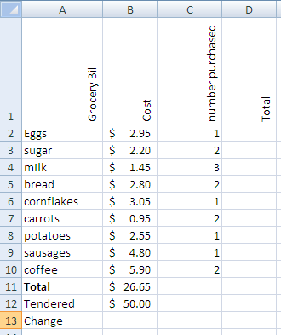
It is just as easy to multiply cells. Say we bought more than one item of each of our groceries. Add an extra column to your grocery spreadsheet entitled Number purchased and a further column entitled “total item cost”.

As the headings are becoming larger, tilt them so they are on an angle or vertical, using the icon.

To work out the total for each item we need to multiply the cost by the number purchased. Take eggs for example, the formula would be =B2*C2 ENTER. A star represents multiply.

Work out the total for each item, (use fill down to save time), then the grand total at D11. How much change would you now get from your $50? Show this at D13. Print out your grocery spreadsheet and put it in your folder. Don’t forget your headers!

Open up your Canteen tab and in another column entitled price per item and after that a total price column. Enter in the prices of the items: Pies: $1.60, Donuts $1.00, Chips $1.80, Drinks $1.50

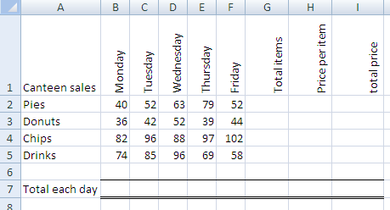

To calculate the total price, multiply the number sold *the price per item. Use fill down to calculate the rest of the columns and put a grand total in at I7. Format columns H and I to decimal currency.

- Print out your canteen spreadsheet and put it in your folder. Don’t forget your headers!

Dividing cells:

To divide cells, you use the forward slash key (/). Go to your sales spreadsheet. You have calculated how many items you sold in column F (total items) Say you also wanted to know how efficient your sales staff were, by calculating how many items were sold, per salesman. Add another column entitled “Number of staff” and then a further one entitled “Efficiency”. Enter these figures: 2 people sold widgets, 3 people sold gadgets and 4 people sold objects.

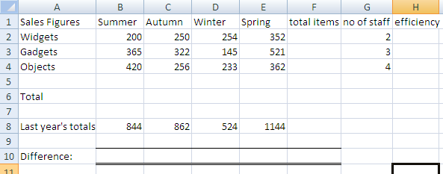
For widgets, ou want to know what the total items divided by the number of staff was (ie, = G2/H2). Calculate the efficiency for all the items – then you can see who was the most efficient by seeing who had the highest figure in column H.

- Print out your sales spreadsheet and put it in your folder. Don’t forget your headers!
- Save your spreadsheet.

Conditional formatting:

Conditional formatting allows us to format certain parts of the spreadsheet to highlight specific data.

Open your sales spreadsheet. The management wants to highlight the most efficient sales team (ie over 500 sales) in red, teams that sell between 400 – 500 in yellow and 300 – 400 in green.

Highlight the data in the efficiency column.

Go to conditional formatting, and choose Highlight cell rules. Put in the first rule (over 500) and choose the formatting that is red, then repeat for the other two divisions -between 400 -500 is yellow and 300 – 400 is green.

Try it out on your spreadsheet!

