VCAA Exam 2011 Part B Question 7: The BIG one
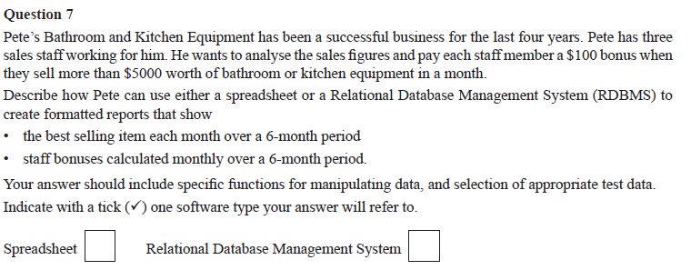
SS
Create a workbook with multiple sheets

First sheet an INPUT sheet called “Sales Data” to enter sales data has a table with
*SalesPerson, *ItemSold, *Cost, *SaleDate
-Data could be imported from a POS system or entered in. If entered in, then validating the salesperson (from a drop list) and the itemSold from a reference table would be important

Second sheet called “Reference data” would contain
* List of sales staff for the input drop list
* list of items for sale and their usual cost

Third sheet to calculate “Best-Selling Items” using COUNTIF function for each item for sale the number of times it was sold in each of the 6 months checked. A two-way table would be established with MONTHS across the top and ITEMS down the side. These lists would then be SORTED for each month with the highest selling items on top.

Forth sheet to calculate “staff bonuses” would use SUMIF to tally the sales for EACH SALES person by EACH MONTH. Using CONDITIONAL FORMATTING any cell that contains > 5000 (being the sales for one person in one month) would be shaded GREEN.

Sheets 3 and 4 would be protected to reduce accidental deletion of formulae. Relevant fields on the INPUT page would need to be unlocked and these would have formatting (pale yellow background) to show where data input was required and which cells can be altered)

All sheets would have clear headings at the top of the sheet to indicate the purpose of that sheet (Arial size 16)
Tables would be solid borders with bold table headers (Arial size 12)
Any cells containing currency amounts (ie costs and sales figures) would be formatted as currency, right aligned on the decimal point.

Testing data would include several different items sold be each of the sales people over at least two months, ensuring at least on below $5000, at least on exactly $5000 and at least one over $5000 to test margins of formula.
*Actual sales data from the two previous months could be used and the results compared to the previous methods used to calculate these results to test accuracy

RDBMS
Create a solution with multiple tables
- tblSales to enter or import sales data from POS system
  - Fields: SalesID (PK), StaffID (FK to tblStaff), ItemID (FK to tblItems), Cost, SaleDate
- tblStaff to store the sales people at Pete’s business
  - Fields include: StaffID (PK), FirstName, LastName
- tblItems to store information about each item such as
  - ItemID (PK), ItemName

If data is to be entered directly, a FORM will be required to enter the sales data. This would include validation of staffID (from the linked tblStaff), ItemID (from the linked tblItem) and a calendar control to ensure valid dates are entered.
If data is to be imported, then determining the correct file format is important.

Create a QUERY for Items Sold (qryBestSellers)
- SELECT TOP 1 (gives best item)
- GROUP BY ITEMID and GROUP BY MONTH
- Use COUNT() function to tally items sold
- Use a FILTER to limit the data set WHERE tblSales.SaleDate only in last 6 months
Create a REPORT based on this query which has
- clear headings including Pete’s company logo and details
- Each month and best-selling item will appear in a simple table with clear headings

Create a QUERY for staff bonuses (qryBonus)
- Use SUM() on tblSales.Cost and GROUP BY on tblSales.StaffID
- Use a PARAMETER so Pete can enter a MONTH to run the query for
- Use a calculated field BonusAmt which will be 100 if SUM() > 5000 else 0
- The data and time the report was run
Create a REPORT based on this query which has
- Clear heading including Pete’s company logo and details
- A heading (size 20) stating the Month this report is for (from the Parameter of the query)
- A list of staff who have earned their bonus this month and the total of their monthly sales
- The data and time the report was run at the bottom of the page

Test data would need to include several different items sold by each of the sales staff over at least two different months. Testing of the sales bonus would need to include total sales <$5000, =$5000 and >$5000.
*Using the actual sales data from the two previous months would test the system very well as it would provide realistic data and the results can be compared to those achieved using the current method to check for accuracy.

