QAT ITA U4O1B – Fony Frog Wages

Unit 4 Outcome 1b (60 marks)

Task 1 Spreadsheet solution (35 marks) – a solution and information product in response to a design brief. Students annotate the solution and information product to indicate how the information needs of an organisation are met.
Task 2 On-screen user documentation (15 marks)
Task 3 Visual retracing of decisions and actions taken when problem-solving and evaluation of the effectiveness of these strategies (10 marks)
On completion of this unit the student should be able to use spreadsheet software to solve an ongoing information problem, taking into account the information needs of an organisation, and evaluate the effectiveness of their problem-solving strategies.

Key knowledge
- KK4.1.01 - types of decisions made in organisations, including strategic, tactical and operational;
- KK4.1.02 - goals of organisations and information systems;
- KK4.1.03 - role of hardware and software components of information systems;
- KK4.1.04 - a problem-solving methodology involving analysis, design, development, testing, documentation, implementation and evaluation;
- KK4.1.05 - reasons why information problems occur;
- KK4.1.06 - design tools for representing solutions and information products;
- KK4.1.07 - techniques and procedures for efficiently and effectively processing data to create solutions and information products that meet specific needs, including the application of formats and conventions, the validation of data and the testing of the solutions;
- KK4.1.08 - criteria for evaluating the efficiency and the effectiveness of solutions and information products;
- KK4.1.09 - content and types of on-screen user documentation including quick start guide, tutorial, content sensitive help and manual;
- KK4.1.10 - design elements that influence the appearance of information presented on-screen, including proportion, orientation, clarity and consistency, colour and contrast, usability and accessibility, appropriateness and relevance;
- KK4.1.11 - characteristics of high-quality user interfaces and effective information architecture of on-screen information products;
- KK4.1.12 - techniques for visually representing the decisions to be made and actions taken when problem solving;
- KK4.1.13 - criteria for evaluating the effectiveness of the decisions made and actions taken when problem solving.

Key skills
- KS4.1.01 - identify the goals of information systems and explain how the systems enable the creation of the information needed by organisations;
- KS4.1.02 - analyse current information-processing practices in order to identify the nature of the problems, the requirements of the ongoing solutions and the constraints;
- KS4.1.03 - select and apply appropriate tools and techniques to represent the input requirements, the processing steps and the output requirements of solutions and information products, and the on-screen user documentation;
- KS4.1.04 - use spreadsheet software and apply suitable functions, formats, conventions, data validation and testing techniques to efficiently and effectively produce solutions and information products for ongoing information problems;
- KS4.1.05 - use web authoring or multimedia authoring software to create on-screen user documentation;
- KS4.1.06 - evaluate how the solutions, information products and user documentation meet the information needs of organisations;
- KS4.1.07 - record visually the decisions made and actions taken when problem-solving;
- KS4.1.08 - evaluate the effectiveness of problem-solving strategies.

THE CASE STUDY

Fony Frogs Pty Ltd is a small manufacturing business in a northern Melbourne suburb. They are the leading fake frog makers in Australia, and are highly regarded in the international artificial amphibian world.

They have a total of 8 staff in four sections: management, accounts, manufacture and sales.

Currently, weekly pay figures are calculated manually by the accounts department, but it consumes a lot of their time every week. The owner of Fony Frogs, Mr Kermit, was inspired by a talk at the annual International Toad Assemblers’ Conference: he realised he could automate the payroll process to make it faster and more accurate and in the process he could generate more useful data about his business’ performance.

How pays are currently calculated.

Each section of the business has a different base pay per hour, and a different normal number of hours they are expected to work. Any hours they work beyond their “normal” hour limit is paid as overtime. The overtime rate is currently 150% of their normal hourly pay rate, but this figure can change, and should be easily changeable without editing any formulas.

Because their factory is in a densely populated part of the city, off-street parking is rare and expensive. The company gives employees the option of using a reserved off-street parking spot for a nominal weekly fee. The amount of the fee is based on what section they work in, as shown in figure 1.

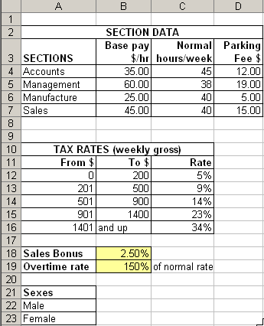
Figure 1 – basic setup data
Figure 2 shows the data currently used in the manual calculations of wages. The “Total hours worked” and sales staff’s weekly sales figures often change each week, while the other data tends to stay static. Only sales staff have entries for “weekly sales”.

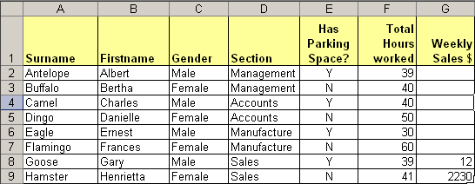
Figure 2 - Data entered by the company.

The remaining data are all formulas, and must be protected from accidental damage or deletion. Mr Kermit is worried about his own clumsiness and lack of skill with computers. The solution must be really easy to use.

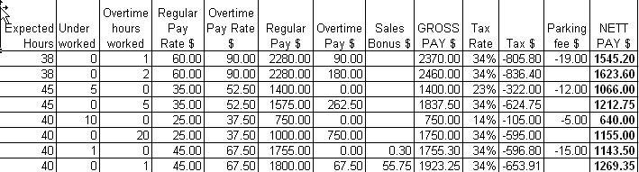
Figure 3 - Data calculated by the spreadsheet

In order, the following columns contain:
- Expected hours: how many hours a person in the department is expected to work at the normal pay rate:
- Under worked: if the worker failed to work the expected hours, this shows the number of hours that were missed.
- Overtime hours worked: how many hours were worked beyond the expected hours.
- Regular pay rate: payment per hour, taken from the section data table.
- Overtime pay rate: the regular pay per hour rate multiplied by the overtime percentage (in the setup section).
- Regular pay: total earnings from the expected hours worked.
- Overtime pay: total earnings from overtime hours worked.
- Sales bonus: only for sales staff: their weekly sales multiplied by the sales bonus percentage (in the setup section).
- GROSS PAY: regular pay plus overtime pay plus sales bonus, if applicable.
- Tax rate: the percentage of tax to be paid on the gross pay. It is taken from the tax table in the setup area.
- Tax $: the calculated amount of tax to be deducted.
- Parking fee: if the person has reserved a parking spot, the fee is calculated based on the section they work in.
- NETT PAY: the take-home page is gross pay minus tax and parking fee, if applicable.

Mr Kermit also wants some summary statistics that will give a quick overview of his company’s status. It would look like this (in figure 4). He would also really like to see a pie chart of the wages earned by all workers.

Mr Kermit is not very skilled with computers. He will need some form of onscreen documentation to show him how to start up the spreadsheet, how to produce output, how to edit data, how to navigate through the spreadsheet and how to handle likely problems.

Of course your spreadsheet will be so easy to use that the onscreen documentation will not need to be too extensive! Your documentation will NOT have to instruct Mr Kermit in how to rewrite formulas since your formulas will contain no hard-wired values such as tax rates or overtime rates!

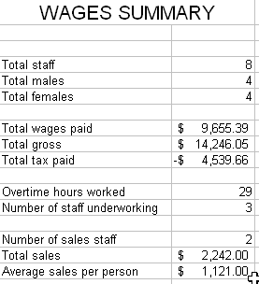
Figure 4 - Summary statistics calculated by the spreadsheet

.

Task 1 – Spreadsheet (35 marks)

1. Analysis (5 marks)
Analysis is to be done under test conditions with pen and paper with the computers turned off. Recommended time limit is 20 minutes.

1.1 What information problem does Fony Frogs have? Express it as a goal to be achieved. E.g. “The problem is to…” (1 mark)
1.2 What is the cause of their information problem? (1 mark)
1.3 List the input and output required for the new system. (1 mark)
1.4 How will your solution solve the organisation’s information problem? (1 mark)
1.5 What constraints will there be how you choose to solve the information problem? (1 mark)

2. Design (13 marks)
Design is to be done with pen and paper with the computers turned off. It is to be handed in at the end of design time (suggested duration: 90-120 minutes). It will either be assessed and returned by the time development begins, or your teacher will photocopy it and keep the copies for assessment. Any changes that you make to your design (except for the testing table) will not be assessed!

2.1 Create an IPO chart to plan how your formulas will process data to produce the necessary information what will appear in the output. (2 marks)
2.2 Produce a mockup of each worksheet showing: (7 marks)
2.2.1 How data and information will be positioned, including lookup tables, the chart and cells that contain key setup values.
2.2.2 How cells and ranges will be named and how cell protection will be applied.
2.2.3 how formatting features such as colours, borders, cell shading, font faces, text orientation, number formatting (e.g. $, decimal places) will be applied. Be wary with colour choices if output will be printed in black & white. Some colour combinations will not be very legible when printed.
2.2.4 What data needs to be validated and how it should be validated.
2.3 How could advanced features such as drop-down lists, conditional formatting, or macros could be used to make the solution better or easier to use (You do not necessarily have to create such advanced features, but if you do create them later, it will help your development assessment.) (1 mark)
2.4 Create a relevant and complete set of evaluation criteria by which the success of the spreadsheet and its output could be evaluated after it is developed. (1 mark)
2.5 Create a testing table with the following columns: (2 marks)
Item to be tested (e.g. “nett pay”).
Method of testing. (e.g. “Manually recalculate the figure.”)
Expected result.(e.g. “$1584.80”
Actual result.*
Remedy (if necessary)*

* The first 3 columns of the testing table should be completed during the design phase. The final two columns will be finished after development.

3. Development (15 marks)
Recommended duration: 240-300 minutes.
3.1 Produce your spreadsheet solution, referring closely to your design. Be sure to apply appropriate formats and conventions. Make your spreadsheet as accurate and easy to use as possible.
3.2 Complete your testing table.
3.3 Print**:
- all worksheets, showing data and information, including charts and lookup tables.
- all worksheets, showing formulas
- macro definitions, if applicable.
3.4 If you used any clever features that are not visible in printouts but you wish to be taken into account in assessment (e.g. conditional formatting), annotate the printouts to highlight their use.
** To minimise paper waste, print in landscape format and do a print preview before printing to avoid wasted pages. Sheets often need reformatting of column widths before printing formulas! If ‘shrinking to fit’ a page, it must not be shrunk so much that the printout is unreadable. Warning: all answers and formulas must be fully visible. Your assessment will suffer greatly if formulas or data are cut off.

4. Evaluation (2 marks)
To be done after production, within the time allocated for production.

4.1 Referring to your evaluation criteria developed in step 2.4 above, annotate your printouts (preferably in a different colour ink to your other annotations) to explain how your solution and its output have met the needs of the organisation.

What to hand in:

After Analysis: Analysis questions
After Design: Design
After Production: Printouts of worksheets showing data and information; formula printouts and macro definitions, if applicable; completed testing table

Task 2 – Onscreen User Documentation (15 marks)

1. Analysis (4 marks)

To be done under test conditions and handed in at the end of the allocated time (40 minutes recommended).

1.1 Describe the characteristics and needs of the person who will be using your spreadsheet’s onscreen documentation. (1 mark)
1.2 Outline at least three feasible options for how you could create and present your onscreen documentation. For each one, outline its advantages and disadvantages for the user and/or for you as the developer. (1 mark)
1.3 From your options, choose the method you consider to be best. Justify your choice, with reference to the rejected options. (1 mark)
1.4 Keeping in mind the needs of Mr Kermit, with what criteria will you evaluate your documentation when it is finished? (1 mark)

2. Design (4 marks)

To be done in a limited time with the computers turned off. Recommended time: 45-60 minutes. To be handed in for assessment at the end of the allocated time.

2.1 Use at least two appropriate design tools such as storyboards, screen mockups, flowcharts etc to thoroughly explain the content (e.g. headings and subheadings,) appearance and architecture of the documentation including the user interface, content and navigation

3. Development (5 marks)

Recommended time limit: 160-200 minutes. It will be evaluated onscreen.

3.1 Produce your on-screen documentation which contains the content and qualities described in the case study. Aim to demonstrate highly-developed skills in the use of multimedia or web authoring software to create instructions that are accurate and easy to read. (4 marks)
3.2 Apply relevant design elements, formats and conventions (1 mark)

4. Testing (2 marks)

To be completed within the time allocated for development.

4.1 Show evidence that you thoroughly tested your user documentation’s readability (e.g. surveys of test users; questioning readers to ensure they’ve understood your instructions)

Task 3 – Visual representation of thinking strategies, actions and decisions (10 marks)

Recommended time limit for all of task 3: 160-200 minutes. Your teacher will specify whether you need to print it or if it will be evaluated onscreen.

1. Development (8 marks)
1.1 Use appropriate software to create an effective visual representation of all the thinking strategies used to analyse the information problem, to design, develop and test the solution, and to design, develop and test the user documentation.

2. Evaluation (2 marks)

2.1 Annotate or modify the visual representation to evaluate the effectiveness of the thinking strategies. Make it clear upon what criteria you are evaluating the strategies. An extract from an example of visual representation of thinking strategies (created with Inspiration) appears below:
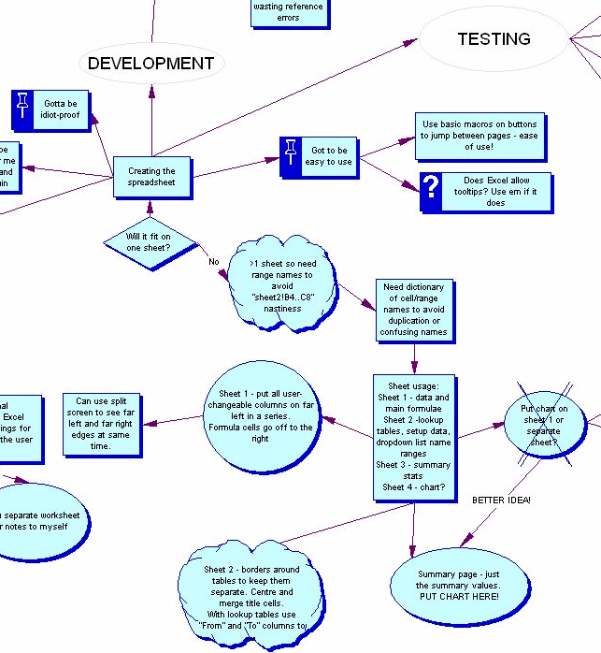

IT Applications

Unit 4 Outcome 1a

Spreadsheet, Documentation and Representation of Thinking

Solution Pathway

Task 1 – The Spreadsheet
Task 2 – User Documentation
Task 3 – Visualising Thinking

Task 1 – Spreadsheet (35 marks)

1. Analysis (5 marks)

1.1 The problem for Fony Frogs is to speed up their process of producing pay cheques, and to generate useful statistics about the company’s financial operations.
1.2 Their information problem is caused by carrying out a complex financial task manually.
1.3 Input required: Students should list the values typed into the spreadsheet by the accountants each week (mainly hours worked, sales figures).
The output consists of the main calculated paycheque figures (e.g. nett pay, tax), the summary statistics and the pie chart.
Some students may provide a much more itemised list including things like the tax brackets and overtime bonus, but don’t expect too much for a single mark!
1.4 The solution will greatly reduce the time it takes them to produce paycheques, it will provide useful summary information and it should be less prone to errors than the existing system.
1.5 It must be easy to use and accurate. The developer will be constrained by limited production time.

2. Design (13 marks)

2.1 The IPO chart should have algorithms for all of the formula cells. For each formula, the data requirements, a pseudocode algorithm and the resultant information is required. Allow full marks if a formula or two are missing, so long as they are not vital. Deduct marks for leaving out vital formulae or notable errors in input, output or logic.
2.2 You want to find the whole spreadsheet mocked up with no significant omissions. Both the appearance and the underlying structure need to be addressed. To get full marks, all 4 sections need to be addressed, and it needs to contain enough detail to get a good mental picture of how the solution will look and work.
2.3 This is more for the high-achievers. Don’t accept vague waffle or basic features. Only useful and reasonable proposals should be rewarded.
2.4 For the mark, you’re expecting to see at least: Ease of use, accuracy, and another one like readability.
2.5 Remember that at the end of design, only the first 3 columns are due. They finish it later during production. They need to be thorough and cover all of the main calculations; they can freely suggest the same testing method for several items if it’s valid to all of the items. Don’t accept vague ideas like “Item to be tested: formulas” or “Method of testing: see if it’s right”.

3. Development (15 marks)
Marking scheme suggestion:
- Accurate answers – 4 marks
- Elegance of formulas and functions – 3 marks
- Cell protection – 1 mark
- Appearance – 2 mark
- Layout – 1 mark
- Use of useful advanced features – 2 marks
- Appropriate formats and conventions – 2 marks
Deduct marks for silly things like:
- Setup values entered as constants in formulas instead of using a reference to a cell that stores that value.
- Cluelessness, e.g. =SUM(B4*B6)
- Hideous colour schemes
Anyone who types in answers rather than using formulas (which will be made apparent in the formula printout) should only get a maximum of 3 marks – and only then if the spreadsheet is attractive!

4. Evaluation (2 marks)

It will be easier if they annotate the printouts in a different colour to the one they used for earlier annotations. You’re looking for a conscious awareness that they knew they had to satisfy certain criteria, and that they deliberately took steps to do so.

Task 2 – Onscreen User Documentation (15 marks)

1. Analysis (4 marks)

1.1 Mr Kermit is not greatly skilled with computers but is aware of their benefits. He needs a brief, easy-to-understand introduction to the use of the spreadsheet you created for him.
1.2 Options include: webpage, Flash animation, Windows Help file, Word document with links in it, Powerpoint slideshow. For each option chosen, one valid advantage and one valid disadvantage will suffice to earn the full mark.
1.3 Students should identify at least one key, valid feature of the chosen option and explain why that feature was important in making the final decision.
1.4 The main criterion could be ease of use. Other useful ones could be relevance, accuracy, searchability, clarity etc.

2. Design (4 marks)

For full marks, at least two tools need to be used. At least one must design the appearance of the documentation and at least one must design the structure or architecture of it. Design should be detailed, not a box with the word “Text” or “Picture” in it! You’d be expecting to at least get a list of the major topics that will need to be discussed in the documentation.

3. Development (5 marks)

Suggested marking scheme:

All main topics have been addressed in a sensible sequence (2)
Instructions are accurate and easy to understand (2)
Documentation is easy to read, attractively laid out, and observes formats and conventions (1)

4. Testing (2 marks)

Students should offer evidence that they tested key criteria such as:
- accuracy (by asking volunteers to follow the instructions blindly and see if they worked);
- readability (surveying test readers);
- clarity (asking test readers questions to see if the instructions were understandable)

Task 3 – Visual representation of thinking strategies, actions and decisions (10 marks)

1. Development (8 marks)
To earn any marks, the visual representation must be created with software, not done with pen and paper.
It is unlikely to chart every thought, decision and action, but the main ones should be represented.
It should cover both the creation of the spreadsheet, and the creation of the documentation.
You are hoping to see signs that the student is conscious of their own thought patterns, judgements, decision-making criteria, and the effects of their decisions. Be generous if you are given some inkling of these skills, but don’t reward vague waffle.

2. Evaluation (2 marks)

The evaluation should comment on how well the thinking processes in the picture actually worked. Some types of thinking can be less effective than others, based on criteria like originality, thoroughness, foresight, learning from mistakes, the willingness to experiment, the courage to take risks and ask questions.

