VCE IT Applications Unit 4 Outcome 1 PRACTICE TASK 2009

Name: Class:

Outcome: Use spreadsheet software to solve an ongoing information problem, taking into account the information needs of an organisation, and evaluate the effectiveness of their problem solving strategies.

Nature of Task:
- Information product in response to a design brief. Students annotate the information product to indicate how the information needs of an organisation are met.
- On-screen user documentation.
- A visual representation that retraces the decisions made and actions taken when problem solving, and evaluates the effectiveness of these strategies.

Key skills
  - identify the goals of information systems and explain how the systems enable the creation of the information needed by organisations
  - analyse current information-processing practices in order to identify the nature of the problems, the constraints and the requirements of the ongoing solutions
  - select and apply appropriate tools and techniques to represent the input requirements, the processing steps and the output requirements of information products, and of the on-screen user documentation
  - use spreadsheet software, and apply suitable functions, formats, conventions, data validation and testing techniques to efficiently and effectively produce ongoing information products
  - use web authoring or multimedia authoring software to create on-screen user documentations
  - evaluate how the solutions and user documentation meet the information needs of organisations
  - record visually the decisions made and actions taken when problem-solving
  - evaluate the effectiveness of problem-solving strategies
Scenario – Wholesale Beauty Products
Wholesale Beauty Products (WBP) has operated for six years. The Managing Director of WBP is Jennifer Polidano. She manufactures a small but exclusive range of beauty products. Jennifer makes all of the products herself from certified organic ingredients, and boasts that the products are so natural, you could eat them without any harm. She is a true believer in women using natural beauty products, but also that they shouldn’t have to pay a lot of money for them. Jennifer employs four sales representatives, Maria, Eva, Mandy and Phuong, who each look after wholesale sales to various cosmetic and pharmacy outlets throughout Melbourne and regional Victoria.

Each representative looks after a certain geographical section of Victoria (this is called their ‘Territory’):

Representative Name | Territory | Geographical area covered
Maria Venuto | Northern | Northern suburbs and northern Victoria
Eva Stankovski | Southern | Southern suburbs and Mornington Peninsula
Mandy Smith | Western | Western suburbs and south-west Victoria
Phuong Nguyen | Eastern | Eastern suburbs and south-east Victoria

The products sold by WBP are listed below. All of the products come in a box of 10.

Product | Wholesale Price for box of 10
WBP Organic shampoo | $20.00
WBP Organic conditioner | $23.00
WBP Cleanser | $25.50
WBP Toner | $17.90

Because Jennifer manufactures all of the products herself, she needs to have accurate information about which ones are selling the fastest so that she will know how much of each product she needs to produce each month.

Jennifer also needs to know how much her sales representatives are making in sales each month, so that she can pay them a monthly bonus if applicable. Any salesperson who sells more than $4,500 worth of products each month gets a $500 bonus. Jennifer would like to be able to see who will get a bonus at a glance – i.e., the employees who merit a bonus should be highlighted.

Jennifer is terrific at making good quality, natural beauty products, but she knows very little about computers, and she isn’t very well-organised. Currently Jennifer does the following to work out how to calculate each salesperson’s sales per month:

Firstly, at the end of each week, each salesperson fills in a form like this and hands it to Jennifer.
Jennifer then has to multiply the number of boxes sold by the price, and write it in the Total column, then add up the Total for the week for each salesperson.
Weekly sales
Sales Representative’s name: Phuong Week ending: 10/8/2007

Product | Number of boxes sold | Price | Total
WBP Organic shampoo | 10 | $20.00 | $200.00
WBP Organic conditioner | 20 | $23.00 | $460.00
WBP Cleanser | 5 | $25.50 | $127.50
WBP Toner | 10 | $17.90 | $179.00
Total for week |  |  | $966.50

She then transfers these amounts onto a monthly list for each representative, which looks something like this:

Total of sales for month
Sales Representative’s name: Phuong Sales for month: August

Total for week 1 | Shampoo | 10 | Conditioner | 20 | Cleanser | 5 | Toner | 10 | $966.50
Total for week 2 | Shampoo |  | Conditioner |  | Cleanser |  | Toner
Total for week 3 | Shampoo |  | Conditioner |  | Cleanser |  | Toner
Total for week 4 | Shampoo |  | Conditioner |  | Cleanser |  | Toner
Total sales for month | Shampoo |  | Conditioner |  | Cleanser |  | Toner

She has to do one of these for each of the four representatives. She sometimes gets distracted, or makes mistakes, and sometimes she writes the wrong amounts down for the wrong product, or the wrong salesperson.

At the end of the month, she adds up all the sales for each representative, so she can work out who will get a $500 monthly bonus. In addition, employees have agreed on contributing a certain percentage of their wage to their superannuation according to the monthly sales after the Bonus has been added. The rates are as follows:
- Employees who make more than $1000 in sales contribute 1% to superannuation
- Employees who make more than $2000 in sales contribute 2% to superannuation
- Employees who make more than $3000 in sales contribute 3% to superannuation
- Employees who make more than $4000 in sales contribute 4% to superannuation
- Employees who make more than $5000 in sales contribute 5% to superannuation

She also adds up all the number of each product sold so that she knows how much to make for the next month.

Jennifer would like to have a much more efficient, foolproof way of working out all of these figures. She would like to be able to see in graphical form how each representative has performed with their sales at the end of the month, and would also like to see in graphical form which of her products are the best sellers.

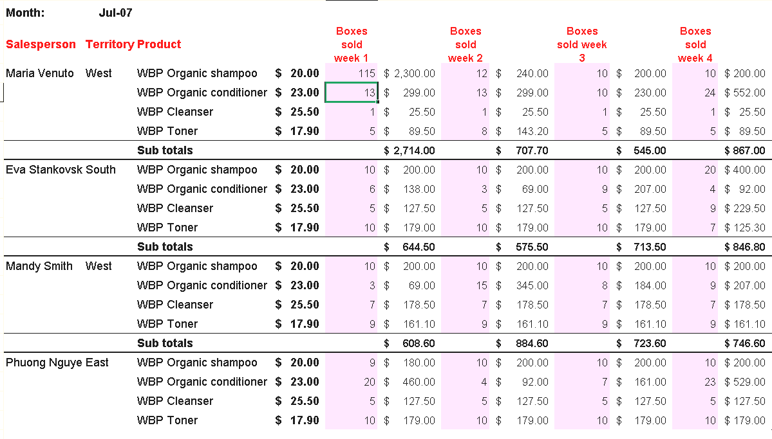
The table below shows some data for the past month:

Jennifer has asked you to create a program that will enable her to do this quickly and easily. She is scared that she will ‘wreck’ the program because she doesn’t really know much about computers. You will have to make sure that there is appropriate validation, and that Jennifer will not be able to enter any data in the wrong places.

She hopes that she will not only have up-to-date information available on the screen, but that she will also be able to print out a report showing monthly totals of the sales representative’s totals, and a report that shows the number of boxes of each type of product sold per month.

She will also need some instructions about how to open the solution, enter the data, and how to view and print reports of totals and graphs.

Problem-solving steps
- File management
- Determine the name of files to be produced; these should be logical and meaningful.
- Determine the structure of your file directory and show this in a visual format (you may use a structure chart).
- Add the full directory pathway as part of the footer in any hard copy output.
- Visual record of decision-making
As you complete this task you need to keep written and/or visual notes of
- Decisions made
- Actions taken throughout the problem solving process
- Reflections on the effectiveness of your strategies (decisions and actions)
At the end of the entire process you will transform your notes into a clear visual representation of the decisions made and actions taken when problem solving and evaluate the effectiveness of these strategies. Your visual representation should demonstrate the thinking strategies used to analyse the information problem, to design, develop and test the solution and to design, develop and test the user documentation. Your evaluation of the effectiveness of these strategies should be demonstrated by comprehensive annotations or modifications to the visual representation.
The visual presentation will be created using Inspiration or Word.
- Analysis
- Define the problem – describe the current problem faced by WBP in your own words as a goal to be achieved.
- Identify input and output requirements - analyse the problem by describing input and output requirements using an IPO chart. In the Input column of the IPO chart list all input data and graphics that will be used in the spreadsheet solution and the user documentation. In the Processing column ensure that you include all manipulation of data that will take place. In the Output column be sure to specify all products that will be developed.
- Identify any constraints - the constraints should identify any restrictions on the solution. These might include the software or hardware to be used, how often the information needs to be produced, other.
- Identify the goals of the new information system and then determine what evaluation criteria you will use to determine whether the goals have been met. (Only need to develop evaluation criteria for the spreadsheet solution – see below).
When evaluating the success of an information product it is important to remember the FA CUP. This stands for:
- Functionality is a measure of how well the technical features of the solution work. Eg. Do all of the formulas work as expected?
- Accessibility is the information to be accessed by a particular group? What restrictions (intentional or unintentional) are there on the information?
- Communication of the Message: Testing must occur to check that the message is being clearly communicated. It is important to get some feedback from a range of potential users as to what improvements could be made.
- Usability: how easy or quickly the information can be obtained when it is needed. E.g. Headings “stand out” so they can be easily found, particular colour combinations have been used, consistent placement of totals, labelling of graphs, other.
- Presentation: the way in which the information is presented – e.g. In a table or chart, electronic or printed, taking into consideration the needs of the audience. (age, gender, cultural group, level of education etc)
Adapted from Janet Bane
- Design a solution
- Produce fully annotated layout diagrams for all aspects of the spreadsheet solution. That is, sketch your spreadsheet solution including the graph and annotate this to indicate formats and conventions that will be used, calculations that will be made, formulas and functions that will be used. In particular consider and show:
- How data and information will be positioned, including lookup tables, the chart and cells that contain key setup values.
- How cells and ranges will be named and how cell protection will be applied.
- How formatting features such as colours, borders, cell shading, font faces, text orientation, number formatting (e.g. $, decimal places) will be applied. Be wary with colour choices if output will be printed in black & white. Some colour combinations will not be very legible when printed.
- How advanced features such as drop-down lists, conditional formatting, or macros could be used to make the solution better or easier to use.

In words explain what you need the spreadsheet to do. I.e.,
What does it need to calculate?
What does it need to highlight?
What graphs are required?

- Identify data validation tests. That is, define manual and electronic validation methods that will be used to validate data entered and data produced. Some common validation tools that you may employ are restricting data entry in a cell or displaying error messages.
- Identify a set of test data to test some of the validation procedures defined above and some of the formulas and functions that will be used. The test data should include typical (correct) data, unusual data and incorrect data. Your work should be set out as follows:

Feature tested | Example | Sample/Test Data
Validation rule 1 | Data validation rule in G7:G25 that only allows numbers greater than 0
Validation rule 2 | Error message should occur in H25 when the total is greater than 100 000
Function 1 | Average function in B50
Function 2 | Sum function in B48
Formula 1 | =IF (E6="Yes", "Nil", D6)
Formula 2 | =IF(OR(B8:E8),"Yes","No")

- Development - develop a solution by
- Ensuring data quality by using both manual and electronic validation techniques. Annotate the solution to illustrate the techniques and procedures used to validate the solution and/or output: i.e., submit printouts that describe and identify two validation techniques undertaken. Hence you need to:
- check spelling and grammar electronically and manually
- check data quality of information produced – i.e., accuracy, reasonableness, reliability, relevance, flexibility of access and timeliness of data
- check calculations using a calculator
- employ electronic validation rules and test that these work as expected
- Using appropriate formatting and software conventions in producing your spreadsheet solution. Submit printouts that describe and identify two formatting techniques and/or conventions employed. A list of accepted formats and conventions follows:

Text
  - one space after all punctuation
  - consistency with capitalisation of headings and names
  - consistency with margin widths, page numbering, column spacing, indention
  - minimal use of font sizes
  - consistency with dates, for example, 27 April 2001. Note: no punctuation; date/month/year in full
  - use a serif font (has small strokes at the end of the character) for paragraph text
  - use a sans-serif font for headings, tables and diagrams.

Numeric Information
  - money values usually have two decimal places or none
  - numbers are right-aligned in columns
  - align decimal points (within a column and in totals)
  - position labels next to single numbers, for example, $5
  - position labels for of columns of numbers at the top of the column
  - percentages in columns appear at the top of the columns, for example, %

Graphics and Colour
  - graphs and charts have titles
  - x-axis and y-axis must be labelled
  - use a key if more than one set of data is provided on the same graph or chart
  - include author identification and/or source of data, date and a file name (if appropriate)
  - include unit of measurement on relevant axis
  - label each segment of a pie chart
  - arrange segments (starting a 12 o'clock position) from largest to smallest
  - include absolute figures as well as percentages
  - choose colours that match the information being discussed.
- Using efficient software functions. Use a range of functions, techniques and procedures to produce a solution that meets current and future organisation needs. Submit printouts that describe and identify two software functions employed. Examples of functions that should be employed are:

  - lookup tables
  - conditional formatting
  - conditional statements
  - cell protection
  - graphs
  - insert notes/comments
  - macros
  - relative and absolute cell references
  - naming a range
  - electronic validation
  - sheet referencing
  - formatting/layout

- Evaluation of solution and information product. Use comment boxes in Excel to provide detailed annotations to the solution and information product, which are closely linked to the evaluation criteria, explain how most of the information needs of the organisation are met.
- Testing
- Conduct various tests using the test data defined in the Design phase and record and amend problems. Annotate two test output samples to highlight the test data used, anticipated and actual outcomes, errors detected and annotation of next output showing where errors have been corrected. Ensure that test outputs show where electronic validation tests have occurred. Hence submit:
  - fully detailed and complete test tables to show the entire intended testing to be done (see below)
  - two annotated printouts, which describe and identify two testing techniques undertaken.

Feature Tested | Description
Testing of the solution – the solution meets the desired goals
Testing of the output – output is as expected – it matches the design and test data
- Accuracy of information
- Relevance and completeness of information
- Correct formats and conventions are adhered
- Message of the output is clear and understandable/readable and content is appropriate
Functionality – the solution performs all of the required functions including the functionality involved with producing output; software performs all the phases of information processing that it has been designed to do | See Functionality test table below
Presentation – output produced matches the design of each output

Use of colour; graphics and overall layout
Usability – ease of use (consider readability and clarity of information)
Accessibility – solution can be used by a range of users and output is clear and timely for all users
Functionality
Feature tested | Sample/Test Data | Expected Result | Actual Result
Feature tested | Where necessary or possible, enter sample data that you will use to test the feature. Include a “correct” value, “incorrect” value and extraordinary value | Describe what you expect to occur after you have tested the feature. | Describe what occurred after you tested the feature.
Functions - test the data to ensure that all functions are correct and operate accurately |  |  | Describe what occurred after you tested the feature.
Formulas – test the data to perform a manual set of calculations for all formulae in the solution. Thus you can easily identify formulae that have been incorrectly entered |  |  | Describe what occurred after you tested the feature.
Data manipulation – test data that will highlight any errors in the manipulation process such as sorting, conditional formatting, creation of graphs |  |  | Describe what occurred after you tested the feature.
Data validation – check any validation rules established |  |  | Describe what occurred after you tested the feature.
Data formatting – use test data which checks that the full range of data is catered for by the solution. For example, that column widths are appropriate; spacing is adequate throughout, etc |  |  | Describe what occurred after you tested the feature.

- Documentation
- Describe the characteristics and information needs of the users of the documentation. Consider gender, age, special needs, skill level and what information they require.
- Determine what type of user documentation you will develop and justify why you have chosen this type of product.
- Develop evaluation criteria for the user documentation. Consider the following:
- Design elements that influence the appearance of information presented on-screen, including proportion, orientation, clarity and consistency, colour and contrast, usability and accessibility, appropriateness and relevance.
- Characteristics of high-quality user interfaces and effective information architecture of on-screen information products such as usability, font selection, accessibility, appropriateness and relevance.
- Use the storyboard and site plan templates to design on-screen user documentation:
  - Site Map – show the hyperlink interrelationships between the web pages (how the pages link to each other and to external sites) (see attached)
  - Web page design layouts/storyboard – produce a detailed drawing of the Home Page and one other page where you indicate layout, fonts, colours and textures, backgrounds, images, graphics, etc. (see attached)
- Your documentation should be a comprehensive and effective guide that explains how to use the spreadsheet solution and its structure and layout should be clear and logical. Use the checklist below to ensure that your user documentation is effectual.
Checkpoints | ü
- Presentation is clear, attractive, easy to read, easy to follow, well set out, suitable for the person in the organisation who will have the task of maintaining and adding to the solution in the future
- Any assumptions made a clearly stated at the start of the User Documentation
- White space is used well
- Language is appropriate for intended users
- Font type and size are suitable
- All important procedures to be followed are included
- Security is adequately addressed
- Instructions are in the correct order
- Given useful ‘Tips’ and ‘Warnings’
- Suggested what to do to prevent disasters being devastating
- Instructions can be carried out easily by the intended users
- Effectively used annotated illustrations
- Simple and clear instructions – not complex and difficult
- Tested the instructions as if you were a ‘basic user’ and made changes as a result
- Implementation
- Finalise your spreadsheet product and user documentation.
- Evaluation – Annotate your visual representation of the decisions made and actions taken to show the following:
- The positive and negative aspects of the processes used to create the solution – for the negative aspects, identify how they could be improved.
- How the solution has solved the information problem identified in the Analysis phase.
- How your solution and output will lead to improved efficiency (effects upon time, cost or effort), improved effectiveness (effects upon quality of output, accuracy, presentation and comprehensiveness) and/or improved decision-making (sufficient information that is communicated well and presented in a timely manner).

