Q 1 Identify two goals of the Pirelli organisation. (2)

(None specified! So generic goals: 1 increase market share and make a profit

2 provide the highest quality products (from Ch 7 p205)
Others: improve customer service and satisfaction / improve product range

Q 2 Identify two goals of the Pirelli information system. (2)

1 record financial information such as sales, expense and profit margins

2 set prices, create price lists for their customers and for budgeting purposes

Q 3a Identify two security issues that are raised with Andrea. (2)
1 Andrea however has forgotten her password on many occasions so she now keeps it written down in her top drawer. (Anyone could get access by reading her password)

2 The system is working well as passwords do not need to be changed once created. (Someone could find out the password and use it for a long time – changing passwords regularly protects the systems integrity.)

Q 3b For each of the security issues raised suggest a more suitable procedure and state how that procedure would improve security. (2)
1 Direct staff NOT to write passwords down – but use a coded password that is easy to remember, but difficult to guess or ‘complete’ by looking at someone typing it.

2 Set up auto enforcement of password change on the system.

Q 4 Identify two problems that you can identify with Michael's backup procedures. (2)
1 Michael should backup daily using at least three tapes – grandfather, father, son

2 – these must be kept securely offsite.

Q 5 Design a suitable backup regime for the network (3)
Backup all data daily using tested software to CD, DVD or tape – rotate these through at least three, but up to five media
Record backup in a log
Store media offsite in a secure environment
See page 245 – 249 and http://www.novastor.com/tech_supt/strategy_smb.html
Q 6 Assuming your backup regime has been implemented; outline in point form a suitable disaster recovery plan for a crashed HDD on the server. (3)
1 replace the defective hard drive
2 Boot computer and use the backup software to restore the data to the new hard drive
3 Test the integrity of the data
(assumptions: drive is Not the C: drive / no programs on crashed drive / only data on crashed drive
Q 7 Design a suitable document management system for Colin’s laptop. Include the folder structure and file naming convention you would recommend (3)
location of files (folder tree): use My documents and sub folders for key areas of Colin’s work
file-naming conventions: use meaningful file names and date or version info if appropriate
backup files regularly – keep backups in a secure environment

Q 8 Suggest a solution to the problem of Colin having to re-enter the clients details a number of times. (1)
Use a relational database system that allows data to be accessed to meet different information needs.
Q 9 Describe a problem with the physical security. (1)
All staff have keys to all doors in case they are the last person at work and need to lock up – so any staff member could access the building at anytime.
Q 10 Suggest a more suitable method of physical security for the information. (1)
File server room is locked – using a digital pass – backups are stored offsite.
Q 11 Describe one method of ensuring data integrity not discussed above. (1)
Use a virus checker / firewall to protect access and data
Q 12a The profitability of Pirelli tyres is dependent on the opposition tyre companies not knowing the wholesale price of their tyres. Identify two ways an opposition company might be able to obtain this information. (must be areas not already discussed) (2)
1 Hack into the system – if no firewall is used
2 Break in and use Andrea’s password from her drawer
Q 12b Describe how these concerns could be addressed. (2)
1 Install a firewall
2 Instruct staff not to write down passwords
Q 13a Pirelli tyres has a lot of information relating to its customers. You have been asked to advise the company with regard to the new privacy laws.
What privacy law would Pirelli tyres come under (1) p205 – Act name only required –
nb: >$3 000 000 limit and not involved with health industry
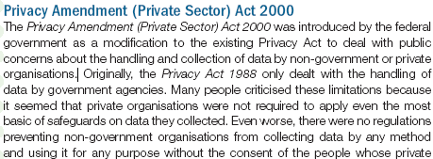

Q 13 b What advice would you give the company to ensure they respect the privacy of their customers and abide by the law when they-
- collect information from their customers (1) p207 – one only:
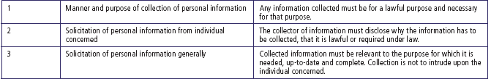
B) store information about their customers (1)
- access and disclose information (2) (2 only)
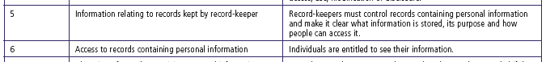
Q 14 Given that Pirelli needs to maintain its record to seven years, suggest a suitable method of archiving their files. (2)
Data could be archived to DVDs as they hold 4Gb of data and kept in a secure environment (fire, theft and degradation) and will be readable for more than seven years. At the end of this period they may be destroyed if the data is no longer required.
Q 15 Outline a suitable disaster recovery plan for Pirelli. (2) (p249 – more than 2 should be identified to show an understanding of a thorough approach – last 4 points)
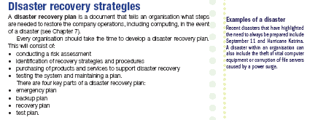
Q16 How could you test the disaster recovery plan? (1) (p250 Select from Test plan)
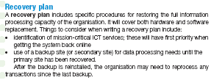
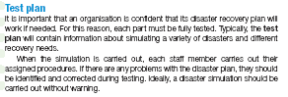

Q17 How can they evaluate the effectiveness of security measures of both data and information and ensure both are safe and recoverable. (2) (p250 – two or more points)
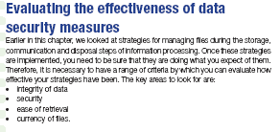
Answers by Colin Sutton
Monty SC oz.sutton@gmail.com

Adapted from an Edulist submission which was from a VITTA IPM resource (I think!!)

Images are cut from the ITA Nelson text

