

TECHNICAL DOCUMENTATION

School ICT INFRASTRUCTURE ROADMAP and strategic plan

2008 - 2011

<Insert School Name Here>

Release: Draft/Final
Date:

Author: <Insert ST Name Here>

Owner: Information Technology Division

Document Number: V1.8

Stakeholder Signoff
Name | Title | Phone No
Insert Principal Name Here | Principal  <Insert School Name Here>
Signature: Date: ___ / ___ / 2008
Insert School Council President Name Here | School Council President  <Insert School Name Here>
Signature: Date: ___ / ___ / 2008
Insert Curriculum Coordinator Name Here | Curriculum Coordinator  <Insert School name Here>
Signature: Date: ___ / ___ / 2008
Insert ICT Coordinator Name Here | ICT Coordinator  <Insert School name Here>
Signature: Date: ___ / ___ / 2008
Insert Business Manager Name Here | Business Manager  <Insert School name Here>
Signature: Date: ___ / ___ / 2008
Specialist Technician | Specialist Technician,  Technical Support to Schools Program
Signature: Date: ___ / ___ / 2008
School Technician | School Technician
Signature: Date: ___ / ___ / 2008
Revision History
Date | Details | Person | Version
 | Release to schools | ITD | 1.0
 | Re-Release to School | ITD | 1.8

Table of Contents
1. Introduction 5
1.1 School ICT Progression Strategy 5
1.2 Purpose 5
1.3 Roles 5
1.4 Pre-requisites 5
1.5 Resources 6
2. School Information 7
2.1 School Information 7
3. School Particulars 8
3.1 School ICT Vision & eLearning Statement 8
3.2 School Computer Numbers and Particulars 8
3.3 Current School Technical Support Time 8
3.4 School Contemporary Computer : Student Ratio By Year Level 9
3.5 ICT Environment Capacity (All computers and devices) 9
4. School ICT Infrastructure Roadmap 11
4.1 Strategic Intent of School ICT Infrastructure Roadmap 11
4.2 School ICT Infrastructure Roadmap Framework 12
5. Contemporary ICT Fleet Management Plan 13
6. Infrastructure Roadmap Purchasing and Support Plan 14
7. School ICT Infrastructure Implementation Plan, Timeline and Key Milestones 16

© State of Victoria
Department of Education & Early Childhood Development, Victoria, 2007
The Department of Education welcomes any use of this publication within the constraints of the Copyright Act. Provided acknowledgment is made to the source, Victorian government and non government schools are permitted to copy material freely for the purpose of teaching students in schools, or for communication with parents and others in the community. When a charge is authorised for supplying material such charge shall be limited to direct costs only. When the material is to be sold for profit then written authority must first be obtained.
Detailed requests for uses not specifically permitted by the Copyright Act should be submitted in writing to the Copyright Officer, Department of Education & Early Childhood Development, GPO Box 4367, Melbourne Vic 3001, Australia.

Introduction

School ICT Progression Strategy

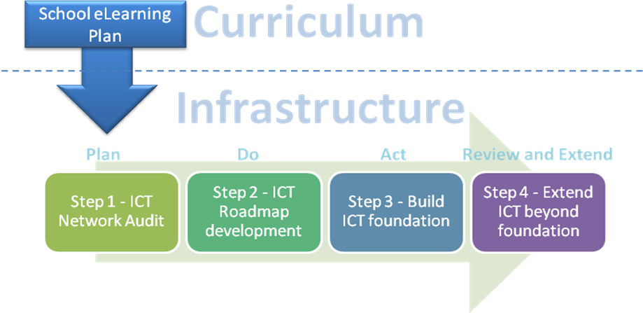

Purpose

The purpose of the School ICT Infrastructure Roadmap is to detail a broad infrastructure, support and costing roadmap required, by year, to support the eLearning goals, strategies and curriculum specified in the school eLearning plan.

Roles

The School Leadership, ICT, Curriculum and Finance Teams should be the document initiators for the School ICT Roadmap. TSSP Specialist Technicians should be utilised in providing valuable infrastructure and implementation advice. The following school staff should form the abovementioned teams:

- School Principal and Leadership Team
- School Learning Technologies Coordinator / eLearning Coordinator
- School Curriculum Coordinator
- School Business Manager
- TSSP Specialist Technician
- School Technicians
- External consultants (if applicable)

Pre-requisites

The pre-requisites to this document are:

- School ICT Inventory must be completed and updated by the TSSP Specialist Technician detailing the schools current infrastructure providing an essential baseline for future planning.
- School eLearning plan must be well progressed or completed by school staff detailing the schools eLearning and curriculum requirements.

Resources

The resources available to assist in completion of this document are:

- eLearning Plan – Provides the eLearning goals, strategies and curriculum that the school plan to implement over the next 3 years.

- School ICT Inventory – Details the school’s curriculum network technical configuration providing an essential baseline for future planning.

- Network Guidelines and Models for Schools – Provides best practice advice for the implementation of network infrastructure.

- School ICT Architecture – Provides best practice advice for the implementation of school ICT architecture at a server/client level.

- School ICT Architecture Build Guides – Extends the School ICT Architecture document to build processes, instructions and tutorials for TSSP Specialist Technicians.

School Information

School Information
School Information
School Name
Address
Phone
Fax
School Number
Principal’s Name
Key School Contact

School Particulars

School ICT Vision & eLearning Statement

<Type school ICT vision & eLearning statement here>

School Computer Numbers and Particulars

Current School Particulars
Total number of computers currently in the school:
Total number of computers with internet access:
Total Number of computers less than 4 years (48 months) old:
Total number of enrolled students:

Current School Contemporary Computer : Student Ratio

Note: The computer - student ratio should be based on those computers less than 4 years old.
Current School Computer : Student Ratio

State Government Target – 1:5
(BP3 Measure)

The School Computer Census (http://www.eduweb.vic.gov.au/computernumbers (School EduMail login required) should reflect the figures in the table above.

Current School Technical Support Time

School Technical Support
Number of weekly Technical Support hours provided under the Technical Support to Schools Program
Number of weekly technical support hours provided under local arrangements

School Contemporary Computer : Student Ratio By Year Level

Year Level (Change / add columns as appropriate)

# less than 4 years old | Year 7 | Year 8 | Year 9 | Year 10 | Year 11 | Year 12 | Spare
Enrolment
Number of ICT devices (dedicated access)
Number of computers ICT devices (shared access)
Dedicated Computer : Student Ratio

ICT Environment Capacity (All computers and devices)

Internet Capacity
Current internet connection (delete as appropriate) | VicSMART Copper 2MB  VicSMART Fibre 4MB  Other:________
Current cooling environment
Is the current cooling environment capacity sufficient to meet the needs of current and future ICT demands? | Yes / No
If no, please outline your plan to upgrade these facilities.
Current power distribution
Is the current electrical circuit capacity sufficient to meet the needs of current and future ICT demands? | Yes / No
If no, please outline your plan to upgrade these facilities.
Current network access
Is the current wired computer network / wireless network capacity sufficient to meet the needs of current and future ICT demands? | Yes / No
If no, please outline your plan to upgrade these facilities.
Current learning spaces
Are the current learning spaces sufficient to meet the needs of current and future ICT demands? | Yes / No
If no, please outline your plan to upgrade these facilities.
Security Capability
Are all ICT devices located in an appropriately secured environment (e.g. for classrooms, secured to furniture, secured in a notebook trolley or under CCTV surveillance etc.) | Yes / No
If no, please outline your plan to upgrade these facilities.

School ICT Infrastructure Roadmap

Strategic Intent of School ICT Infrastructure Roadmap

The School ICT Infrastructure Roadmap should be aligned to meet the following strategic intent. The School ICT Infrastructure Roadmap should:

- Support the school annual implementation plan, eLearning focus and teaching outcomes.

- Contribute to the schools ICT professional learning and training strategy to optimise infrastructure to delivery curriculum outcomes.

- Aim at achieving or exceeding the BP3 measure - 1:5 computer-student ratio and moving towards a 1:5 contemporary computer:student ratio,

- Aim at providing a managed fleet of ICT infrastructure (desktops, notebooks and other devices) with a 48 month turnover plan,

- Reduce total cost of ownership (TCO) through provision of an efficient and effective standardised operating environment that supports the school ICT and eLearning strategy.

- Ensure the provision of adequate quantities of appropriate licensed software for teaching and learning.

- Foster ethical and safe use of ICT in the school environment.

School ICT Infrastructure Roadmap Framework

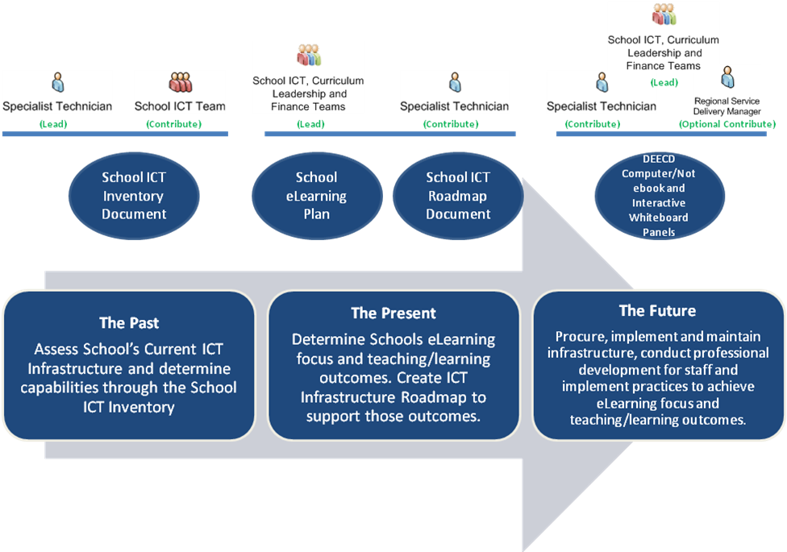

Contemporary ICT Fleet Management Plan
The section outlines the schools strategy to keep their ICT device fleet contemporary (within 48 months old). Schools should plan for replacement and expansion of current fleet. Computer fleet rotation should occur within a 48 month period.

Category | Current number of devices | Number of devices to be purchased/leased in 2008 | Number of devices to be  purchased /leased in 2009 | Number of devices to be purchased/leased in 2010 | Number of devices to be purchased/leased in 2011
Desktops
Notebooks
Other portable ICT devices
Contemporary Computer: Student Ratio
Servers
Switches
Wireless Access Points
Electronic Whiteboards
Other devices
Learning Space Modification Funding $ (Cooling, power, network access, tech support etc)
Funding dedicated to ICT capital purchase/lease

Infrastructure Roadmap Purchasing and Support Plan

Year | eLearning Focus (Provide a summary from the schools eLearning plan) | Infrastructure and Support Requirements (ensure cooling, power, network access, physical space and technical support costs are included in your plan ) | Approx Cost  (ex GST) | Type of funding (Local, Grant or Other) | Teaching and Learning Outcomes
2008
 |  | 2008 Sub-Total:
2009
 |  | 2009 Sub-Total:
2010
 |  | 2010 Sub-Total:
2011

 |  | 2011 Sub-Total:
Total Cost (2008 – 2011):

School ICT Infrastructure Implementation Plan, Timeline and Key Milestones
The implementation plan is broken into 8 steps as follows:

- Phase 1: Business Analysis – School ICT Inventory.
- Phase 2: Solution Development – School ICT Roadmap.
- Phase 3: Procurement Process – Procurement of appropriate infrastructure.
- Phase 4: Build – Build ICT foundation.
- Phase 5: Test – Test ICT foundation.
- Phase 6: Deploy – Deploy ICT foundation.
- Phase 7: Train – Train staff and students on use of technologies / incorporation into curriculum.
- Phase 8: Maintain, Review & extend – Review current ICT system and repeat the 8 steps again.

Milestones are to be placed in red font.

Phase 1: Business Analysis – School ICT Inventory.
Task Description | Responsible Officers |  | Start Date | End Date | Key Milestone (Yes/No)
Determine School eLearning focus and teaching outcomes. Results are documented in the Schools eLearning plan. | School Leadership, Curriculum and ICT Teams.
Completion of School ICT Inventory document including appraisal of School ICT infrastructure providing an essential baseline for future planning. | TSSP Specialist Technician, School ICT Team |  | 01/01/2008 | 20/03/2008 | Yes
Phase 2: Solution Development – School ICT Roadmap.
Task Description |  | Responsible Officers | Start Date | End Date | Key Milestone (Yes/No)
Review eLearning focus and teaching outcomes for ICT. |  | School Leadership, Curriculum and ICT Teams.
School based meeting to discuss infrastructure requirements to provide suitable environment to meet the school’s eLearning focus and teaching outcomes. |  | School Leadership, Curriculum, TSSP Technician and ICT Teams.
Completion of School ICT Roadmap document (this document) |  | School Leadership, Curriculum, ICT Teams and TSSP Technician.  Regional Service Delivery Manager’s can provide additional guidance on request.
Phase 3: Procurement Process – Procurement of appropriate infrastructure.
Task Description |  | Responsible Officers | Start Date | End Date | Key Milestone (Yes/No)
ITD will establish a panel of suppliers for the provision of desktop and notebook computers to schools. Suppliers will offer special pricing for School purchases. |  | ITD | 01/01/2008 | TBA
Phase 4: Build – Build ICT foundation.
Task Description |  | Responsible Officers | Start Date | End Date | Key Milestone (Yes/No)
Phase 5: Test – Test ICT foundation.
Task Description |  | Responsible Officers | Start Date | End Date | Key Milestone (Yes/No)
Phase 6: Deploy – Deploy ICT foundation.
Task Description |  | Responsible Officers | Start Date | End Date | Key Milestone (Yes/No)
Phase 7: Train – Train staff and students on use of technologies / incorporation into curriculum.
Task Description |  | Responsible Officers | Start Date | End Date | Key Milestone (Yes/No)
Phase 8: Maintain, review & extend – Review current ICT system and repeat the 8 steps again.
Task Description |  | Responsible Officers | Start Date | End Date | Key Milestone (Yes/No)
Update School ICT Inventory |  | TSSP Specialist Technician, School ICT Team

