Database Relationships
One-to-one relationship
Where a record in one table matches one (and only one) record in a second table. E.g. an employee’s department data in one table matches a corresponding department in another table, allowing data relating to that department to be fetched.
One employee can only belong to one department.
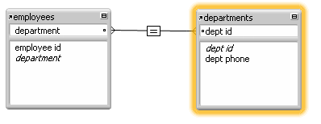
One-to-many relationship
Where a record in one table could match several records in a second table, but each item of the second table can only link to one item in the first table. E.g. one employee could be the leader of many projects in an organization, but each project can only have one leader.

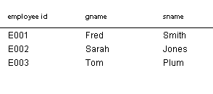

Many-to-Many relationship
Where several records in one table could match several other records in a second table. This gets more complex. E.g. many employees could be involved in many projects.
To create a many-to-many relationship, you use a third table to acts as an intermediary between the other two tables. It has relationships to the other tables and combines them. This is called a join table, or intermediate table. It is usually never used by the database user, but works in the background.

The join table’s contents might look like this:

Another example of a many-to-many relationships would be in a travel agency, where a customer might be booked on many trips, and each trip could be booked by many customers. In a newsagent, each customer might want several newspapers delivered each day, and each newspaper type will be delivered to many customers.
In a shop, a salesperson might make sales to many customers per day, and each of these customers might be served by many salespeople in that shop.
Practice: a library has a database of current loans (not historical loans). While a customer has possession of a book, this is recorded in the current loan database. Naturally, the customer might be borrowing several books at any one time. What sort of relationship would this be?
Ask yourself:
- Can one customer have many simultaneous loans? (Yes – so it’s a <something>-to-many relationship.)
- Can a single book be borrowed by many customers at the same time? (No, so it’s a one-to-many relationship)

From the 2007 ITA exam…
Which diagram best represents the relationship between these tables?
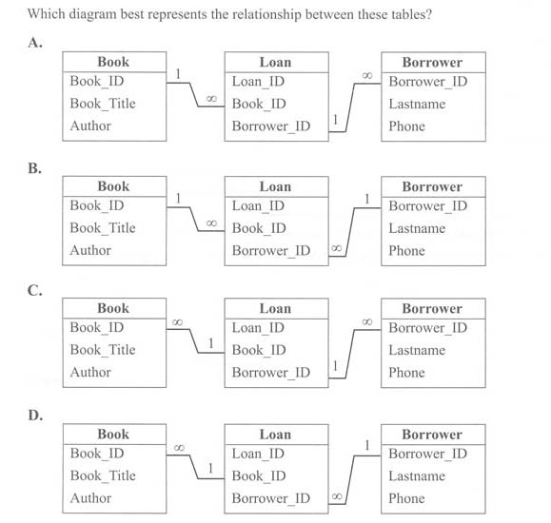
Answer is B.
Firstly, fortunately, Filemaker and Access show relationships in similar charts, so this was not a problem for either of them. Such representations are also pretty standard in the database world, so most DBMS users could make sense of it.
This was quite a challenging question: certainly a discriminator to find the A+ students in the audience. The 4 options are identical except for the "1 to many" or "many to 1" relationship indicators. This is how to read it...
- A book can be lent out to many people over time, so the Loans table could refer to the same book many times.
- A borrower can borrow many books over time, so again the Loans table would refer to the same borrower many times.
- Therefore the Loans table has many references to individual books and borrowers - each of the many loans is strictly tied to a single book and a single borrower.
- So one book can be linked to many Loans.
- One borrower can be linked to many Loans.
34% of the state got this right.
The fairly even distribution across the incorrect options suggested that many students did not understand either the one-to-many relationship or its representation in the diagram. The correct response was option B, as it was the only diagram where the Book_ID was shown as one (unique) in the Book table and the Borrower_ID was shown as one (unique) in the Borrower table.

