Assessment Mark Book
OK this just keeps track of student assessments, it automatically creates assessment sheets for the students, adds up the totals, assigns a mark and keeps track of all those marks on a summary page. It saves me a lot of time, hope it helps you ☺

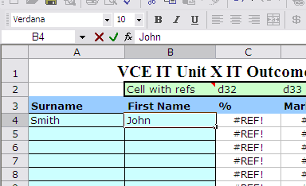
- Enter Student Names and change the title of your Assessment

- Go to the blank sheet and enter your Criteria and Marks
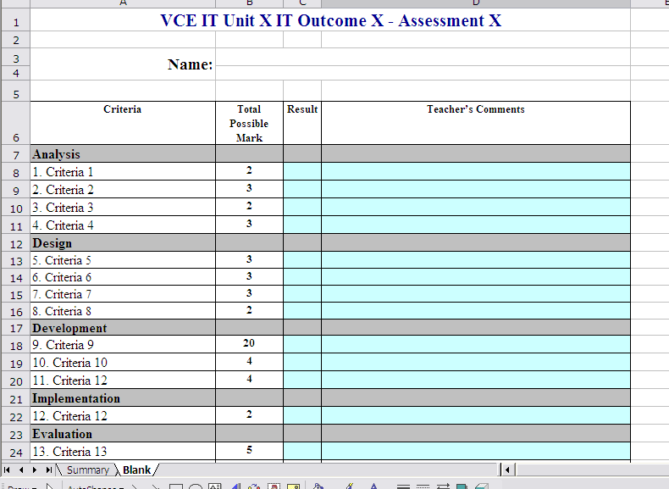

- If you edit the blank page a lot then you will need to keep track which cells have the Marks in them:
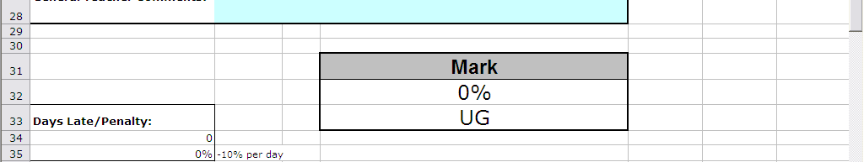
As they are referenced on the summary page here (d32, d33), so if you change them update the reference here,
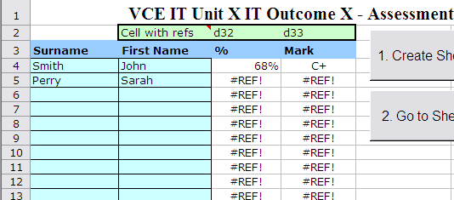

- Go back to the Summary sheet and then select the Surname of the Student you wish to create and Assessment sheet for then click Create Sheet

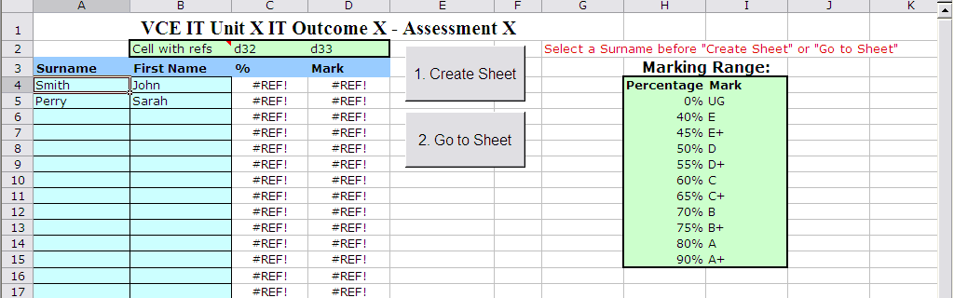

- The macro will generate a sheet based on the Student’s Surname and enter their full name at the top of the sheet. Now just fill out the blue bits
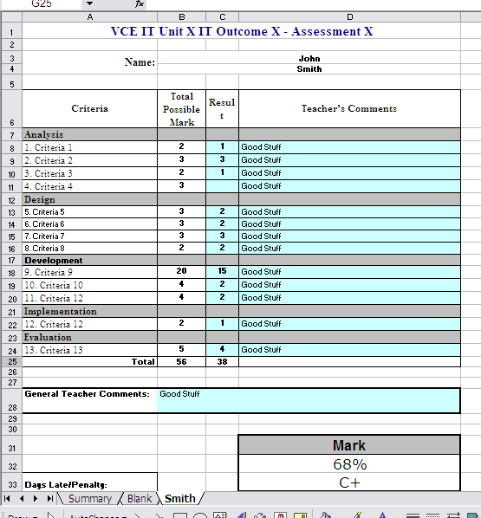
A mark will come up at the bottom based on the scale on the Summary page.
Click here to go back to the Summary page.

- If you want to go back to the detail on a student from a summary page a made a button so you can easily do this. Just select the students Surname first then click Go to Sheet
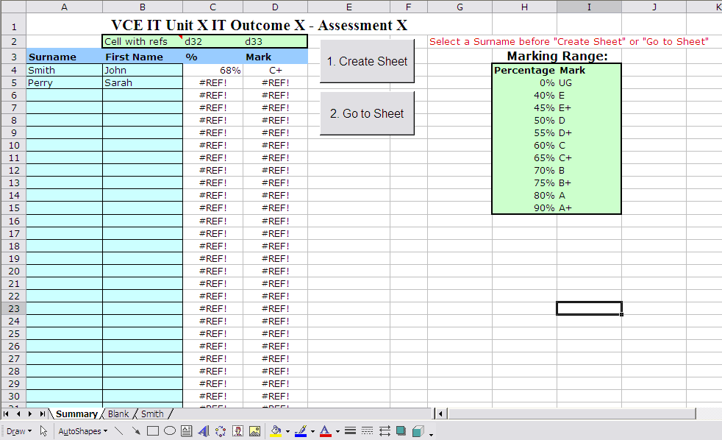

Anyway obviously you will edit this to suit your needs but I found it really useful when a student asks about where they went wrong on a specific SAC as well as having a summary of student performance. I had all their details at my fingertips. Jeez computers are amazing☺. – Rob Mercer

