EXCEL PRACTICE TASKS – Medium strength

Featuring IF, AND, OR

IF (logical test , value if test is true , value if test is false)
The logical test must be a statement that resolves into a TRUE or FALSE answer. True is represented by any non-zero value; False is represented by zero. You can also use the keywords TRUE and FALSE.
Examples
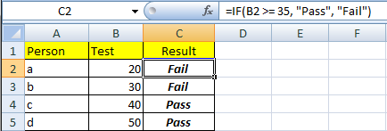
Think of the second comma as an “ELSE” operator.
Also note the possible logical operators are:
= equal to
< less than
> greater than
<= less than or equal to
>= greater than or equal to
<> not equal to
TIPS:
- Be very aware of the difference between, for example, > and >=. Get it wrong and subtle but important logical errors can creep into your answers. E.g. IF(Age > 18, “Beer”, “Soft drink”) would mean that an 18 year old would still have to drink Fanta!
- Also remember to put the true and false conditions in the right order.
- The “false” parameter is optional. If you don’t supply it, Excel will say “FALSE”. If you want something to appear if the test is true, but nothing to appear if it’s false, put in an empty string as the false parameter (i.e. a pair of double-quotes with nothing inside) e.g. IF(income<0,”Warning! Bankrupt”, “”)

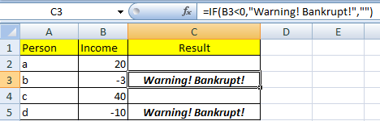
IF can also calculate expressions instead of showing text messages as shown above, e.g.
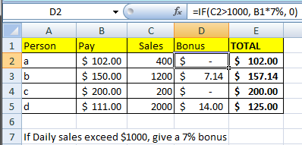
Of course, this simple example is a nasty piece of spreadsheeting. As a general rule never build important and changeable values (like $1000 and 7%) into formulas. Put the values in separate cells, and refer to that cell in the formula. This lets users change key values over time.

MORE COMPLEX DECISION MAKING

Life rarely involves a single condition when making decisions. Often a decision involves thinking like...
If this AND this then ...
If this OR this OR this then...
If this AND this, OR this then...
Excel can help you make complex decisions with the AND and OR functions.
AND(test, test, test, <etc – as many as you like>)
OR(test, test, test, <etc – as many as you like>)
Alone, they are fairly useless. Combined with IF, they are powerful.
IF( AND(B5>6, G4=”Blue”) , F6 * 3, F6 * 5)
In this example, if B5 >6 AND G4 contains “Blue”, then the answer is F6*3 otherwise the answer is F6 * 5. You can have as many tests as you like in the AND() parentheses, separated by commas. All of the tests must evaluate to true for the AND() function to return the value true.
OR() is basically the same, except that if ANY of the tests in the OR() statement are true, the OR will return a value of true.

Mixing and matching

Excel is capable of quite complex scenarios. Warning: this gets rather hairy!
Let’s say: A person earns a bonus if
Condition 1: They work more than 40 hours and have no late arrivals,
-Or-
Condition 2: They work more than 60 hours and have no more than 5 late arrivals.
IF ( OR ( AND( hours>40 , lates=0) , AND( hours>60 , lates<=5)), “Bonus!”, “No bonus”)
(which, when simplified looks like this)...
IF ( OR ( condition 1, condition 2), “Bonus!”, “No bonus”)

Your turn
- Given some annual rainfall figures, calculate the average over time, and for each year say whether it is above or below average. All the cells in italics below need formulas.
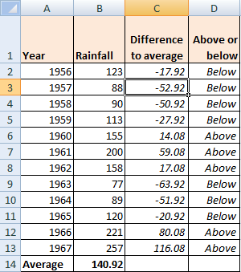
Tip: how do you avoid a whole lot of weird figures in column C after using autofill to copy down the formula in C2? Hint: name the average cell, use that name in the formula in C2.
Next step – Get Excel to count the numbers of above- and below-average years. Hint: investigate the COUNTIF( ) function.
- 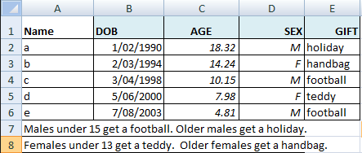
If you managed to get this working, your brain will probably be in knots after sorting out the nested IFs. Nested IF statements can be a nightmare, but fortunately they are rarely needed if you are clever. An excellent alternative is the VLOOKUP function.
As an example, visit my page on the subject at
http://www.mckinnonsc.vic.edu.au/vceit/howto/nestedif.htm

