
Artificial Realities

Harry Hypothetical is owner and manager of Artificial Realities in The Independent Territory of Applications (ITA). His firm specialises in creating and selling unconvincing and unrealistic IT scenarios to secondary schools throughout the province. The firm’s motto is “We make it real.”

He has been calculating pay rates for his workers manually, and has become frustrated with the time it takes, and the errors he is making. He has consulted a local ITA IT consultant, who recommended automating his pay calculations with a spreadsheet, one of the few pieces of software allowed in the province by the fierce and fanatical, but not too bright religious leaders.

The main religion of the province is Caninism, which believes that at judgement day, they will be licked clean of sin by the Lord their Dog.

A copy of Harry’s recent hand-written calculations appears below. The shaded cells are the only ones with raw data typed into them. All others are calculated by Harry.

First name | Surname | Related to boss? | Time Fraction | Year employed
a | Aa | y | 0.5 | 2004
b | Bb | n | 1.0 | 1999
c | Cc | y | 0.5 | 1994
d | Dd | n | 1.0 | 1989
e | Ee | y | 0.8 | 1984
f | Ff | n | 1.0 | 1979

(table continues)

Years service | Hrs per week | Pay rate | Nepotism bonus | Rate with bonus | Gross Pay | Tax rate | Tax | Nett pay
1 | 20 | $ 10.00 | 15% | $ 11.50 | $ 230.00 | 11% | $ 25.30 | $ 204.70
6 | 40 | $ 20.00 | 0% | $ 20.00 | $ 800.00 | 38% | $ 304.00 | $ 496.00
11 | 20 | $ 30.00 | 15% | $ 34.50 | $ 690.00 | 30% | $ 207.00 | $ 483.00
16 | 40 | $ 40.00 | 0% | $ 40.00 | $ 1,600.00 | 44% | $ 704.00 | $ 896.00
21 | 32 | $ 40.00 | 15% | $ 46.00 | $ 1,472.00 | 44% | $ 647.68 | $ 824.32
26 | 40 | $ 50.00 | 0% | $ 50.00 | $ 2,000.00 | 44% | $ 880.00 | $ 1,120.00

Pay Rules

Years’ service is calculated from the year of employment.

The normal hours per week is currently 40, and the employee’s time fraction is used to calculate the number of hours actually worked and paid for. Note that the normal hours per week can change in the future and must not be hard-wired into any formula!

The base pay rate is determined based on employees’ years of service, as follows:

From | To | Base $ Per Hour
0 | 5 | $ 10.00
6 | 10 | $ 20.00
11 | 15 | $ 30.00
16 | 22 | $ 40.00
23 | + | $ 50.00

As is required by law in the land of ITA, workers must receive a bonus if they are related to their boss. This bonus is added to their base pay rate. Currently this bonus is 15%, but this figure can also easily change in the future and must not be hard-wired into any formula.

After the gross pay is calculated (hours per week times pay rate with bonus, if applicable), tax is deducted. Tax rates are determined according to following rates dictated by the provincial government:

Tax brackets (weekly pay)
From | To | % Tax
0 | 100 | 0%
101 | 200 | 6%
201 | 350 | 11%
351 | 500 | 24%
501 | 700 | 30%
701 | 900 | 38%
900 | + | 44%

Pay advice slips are produced using the only other piece of software permitted by the strict religious leaders of the province, a word processor. They have decreed that the accounting packages used elsewhere are sinful and abhorrent to Dog.

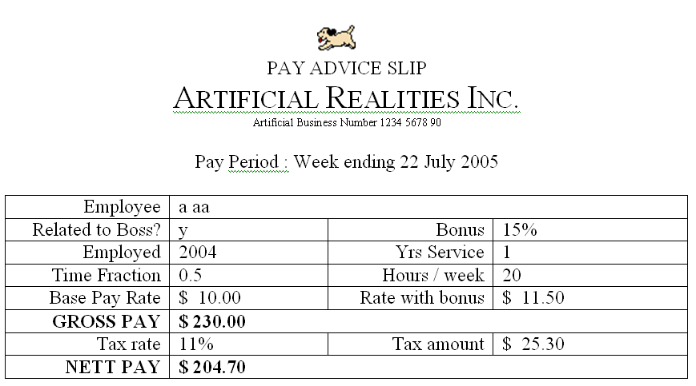
A typical pay advice slip appears as follows:

Constraints

- Harry is not familiar with using computers, so the solution must be easy to use.
- It should be constructed so he cannot accidentally type into formula cells and destroy formulas.

Your jobs:

1. Create the spreadsheet and output needed by Harry Hypothetical.
2. Write an instruction manual for Harry telling him how to use your solution. It should NOT tell him how you created the solution, or how to use spreadsheet software in general.

It should include at least:

- how to start the solution
- how to add, remove, and edit data
- how to produce the printed output
- necessary warnings and tips to prevent data loss and solve common problems
- tips to help him work more effectively and efficiently
- how to save changes
- how to exit the solution

And may the Good Dog lick your face.
(a traditional blessing of the Territory)

