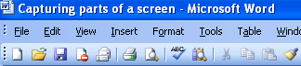
Capturing parts of a screen
You can always ‘grab’ your monitor screen by hitting the PrtSc key and then pasting it into Word or other application
OR paste it into Paint and cut or edit the image – this is tedious.
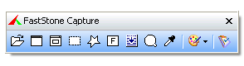
FastStone Capture is a simple solution that will allow you to select a rectangular region of a screen and capture it and paste it anywhere. It’s also got a simple image editor – you can add text/notes to the image.

It can be run WITHOUT installing it and even from a USB.

When you run it appears on your screen – you can minimise it to the Tray by clicking its CLOSE (X) button.
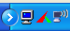
To get it to appear again, just click its Tray icon.
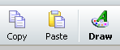
The most commonly used option is to capture a rectangular region. Just click the dotted rectangle – the FastStone toolbox will disappear. Crosshairs will appear. Drag across the area you want to select – release the mouse button.
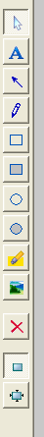
FastStone’s main window will appear – type ^C or click the COPY icon.

Then PASTE (^V) in the application.

If you want to draw on the image (eg text or arrows) click the DRAW icon.
Use the tools to edit the image. Click the OK button when you have finished editing.
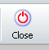
Click the CLOSE icon to minimise FastStone.

INSTALLING FastStone:

1 When you are on the school network – go to Tshare – locate the FastStone Capture53 folder:
2 COPY (^C) this FastStone Capture53 folder and PASTE it in your Program Files folder on drive C:.
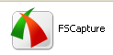
3 Make a shortcut of the FSCapture icon and put it on your Desktop or PIN IT to your START button.
Ask someone to help you with these steps if you’re not too sure.

This Version 5.3 of FastStone Capture is the last Freeware version and requires NO installation.

It’s also on TShare and Common drive (root directory – FastStone Capture53)

There are a number of other screen capture programs – but most require installation or aren’t free.

