Creating Animated Gifs in Fireworks
Open Fireworks
Click on the FILE menu and choose NEW
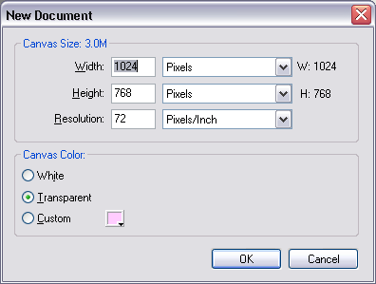
This window will pop up.
It usually has the size of your computer screen stored here.

You can leave it how it is and for the timebeing, just click OK.

The Fireworks Screen.
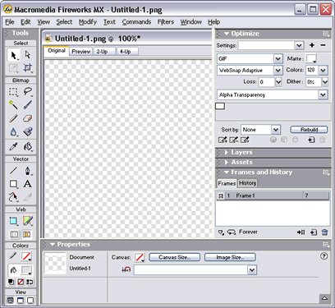
Tools palette
Canvas
Frames
Properties

Drawing a Circle.
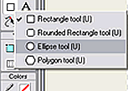
Click on the Shape Tool and hold until the menu appears. Choose the Elipse tool by clicking on it.

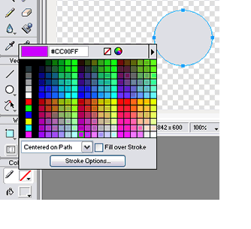

Draw a circle on the canvas by clicking and dragging a square shape.

Choose the line colour by clicking and choosing a colour

Choose the Fill colour by clicking here and choosing a colour like above.

Making it appear 3D

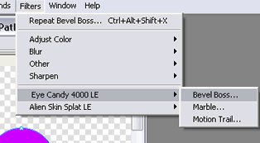
Click on the FILTERS menu and choose EYE CANDY and then BEVEL BOSS…

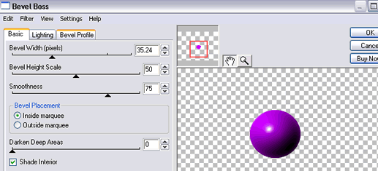
Play with the Bevel Width slider until you get a sphere shape.

You can also play with the lighting too but for now, this should be enough.

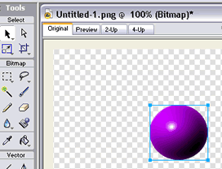
Use the Pointer Tool to click on your graphic.

You will get a blue box around your graphic.

Copy the graphic by either going to the EDIT menu and choosing COPY or you could use the keys Ctrl Alt Del to copy.

Add a new Frame
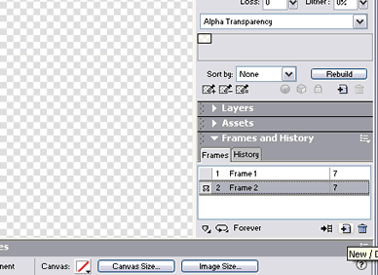

Click the New Frame button.

You will see a new, blank canvas in front of you and in the frames window, you will see that you now have 2 frames and frame 2 is highlighted.

Paste your graphic on to the blank canvas (frame 2). You will see that it pastes your object in exactly the same position as the object in the previous frame.

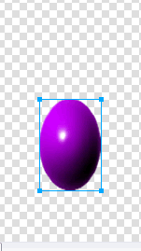
Next you need to change the shape of your object and move it down slightly.

Click and drag your object a little further down the canvas.

Stretch it and make it narrower using the handles on the blue box. (If you can’t see the blue box, just click on your graphic.)

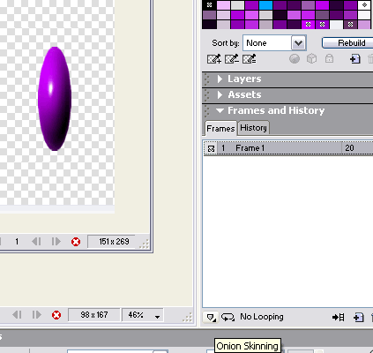
So that you can see where you’re moving your graphic, you can click on the Onion Skinning button and choose ALL FRAMES from the menu that pops up.

Copy and paste this new graphic into a new frame. Move it down a little more, stretch it and make it narrower a little more. Keep doing this until ‘it gets closer to the floor’ then you need to start squashing it and making it fatter in each new frame until it reaches the bottom of the canvas.

It should now look something similar to this:
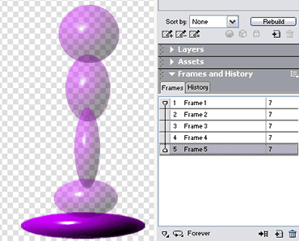

Here you can see all the frames in the animation.

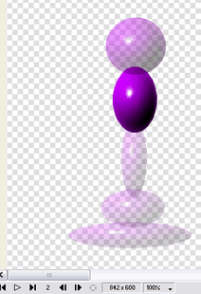

To see your graphic animated, click the PLAY button

To save the animated graphic

Click on the FILE menu
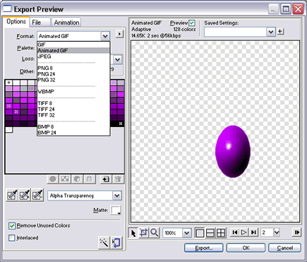
Choose EXPORT PREVIEW

Change the Format of your file to ANIMATED GIF by pulling down the menu and selecting it.

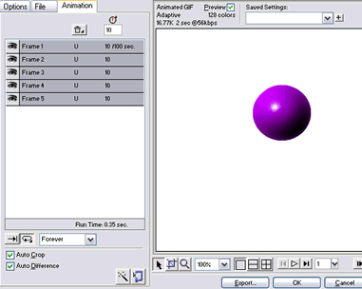
Then click the ANIMATION TAB

You can change the speed of your animation by holding the SHIFT key and clicking on each frame, then in the TIME box, click and type in a different number.
Experiment with different times and click the play button to see what happens

When you are happy with your animation, Click the EXPORT button

