VCE Information Technology
Project Management – Gantt Charts

By using Excel and the drawing tools, it is possible to create a reasonable GANTT chart that will you to develop a good understanding of what the various elements of the chart represent.

Setting up the Worksheet

Column A needs to be made wide enough to enter the names of the tasks, all the other cells in the worksheet should be set to a uniform size. (A quick tip – set all the cells to a width of 2 or 3 characters, and then change the size of column A) Set up the first 3 rows with the Month, Day of the week and date respectively. The Merge and centre button comes in useful for making it all look pretty! Don’t forget to split and freeze the panes (with the b4 cell as the axis).

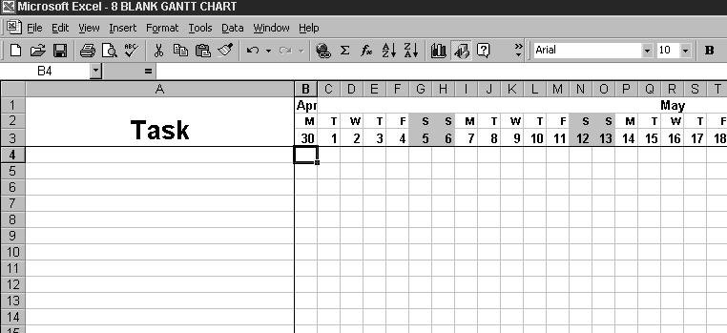

Entering in tasks

The entering in of tasks is a simple process – enter the name of the task into the A column, and then use the paint fill to colour in the cells corresponding to the days that the task will be carried out.
Tasks to be completed by different people can be shaded using different colours.

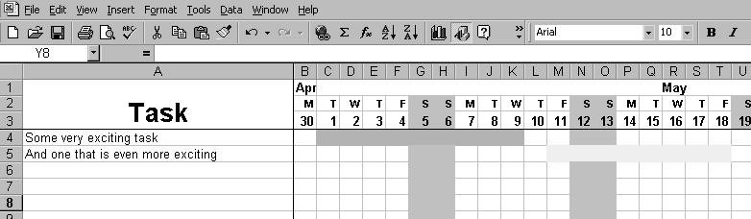

Predecessors

Predecessors can be shown by using the drawing tools to insert lines and arrows. Unfortunately, you will find it is almost impossible to get the lines to match up in the way a standard GANTT chart would, so some liberties may need to be taken with the designs.

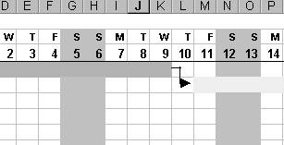

Milestones

Milestones need to be put into the chart by using a diamond from the Windings font. Having said that, there is nothing wrong with using any other symbol instead – so long as you understand what a diamond means if you see one without a key. (W in Windings will produce a small diamond that will then need to be made 2 or 3 points bigger than the default font size you are using.)

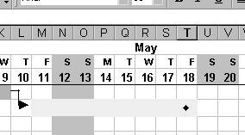

Sample Projects.

You will find 3 projects for your students to make into GANTT charts, and the solutions using Excel as described in this article on the Year 12 network.

PERT Charts

This article has focused on GANTT charts, but it is equally as likely that you will be given or asked to construct a PERT diagram in the exam. The study design does not specifically include or exclude either of them, so it is important that you are familiar with both of them. It is a useful exercise to take a GANTT chart and convert it into a PERT chart.

