Unit 4 IT Applications 2007 - Outcome 2 SAC
Task Outline

Evaluate the effectiveness of the strategies used by an organisation to manage the storage, communication and disposal of data and information, and recommend improvements.

Superior Auto Pty Ltd

Question One
Superior Auto Pty Ltd was established in 1999 in order to fulfil the car servicing requirements of the owners of prestige vehicles in the South Yarra/Toorak areas.

The service provided by Superior Auto is quite unique, in that they provide owners with a replacement vehicle for the day of the service, wash, wax and vacuum vehicles they have finished servicing, and ensure that each vehicle is only fitted with original branded replacement parts.

Business has been booming, and the owners of Superior Auto are looking at expanding their business, and opening another two outlets to service the Brighton/Elwood and Hawthorn/Camberwell areas. They are hoping to win customers who would otherwise take their cars to the local dealerships to be serviced, by providing the same quality car service with higher levels of customer service and reduced prices.

Superior Auto mission is to passionately commit to providing outstanding products and services.

Superior Auto use a transaction processing system (TPS) to keep track of customer details, service details, part prices and stock-on-hand. When customers call and book a service, their details are entered onto the system: name, address, phone, registration, car type and model, kilometres travelled, service type required and replacement vehicle preference. On the day of the service, the customer receives a printout of their details and simply needs to sign a confirmation slip and they can be on their way.

Customer’s details are retained so that if they call to book in another service, their details can be retrieved, and only the kilometres travelled, service type and replacement vehicle preference needs to be updated.

Question 1

- Identify the current organisational goal of Superior Auto

by providing the same quality car service with higher levels of customer service and reduced prices.

B) Explain how the information system used by Superior Auto assists the organisation in achieving its organisation goals.

Efficient management of stock – keeping good stock records

Prices low – using efficient systems
- Personalised care- by keeping records
- Fast drop off of vehicle – pre form fill out…

Question Two

The information used by the transaction processing system is stored on the company’s central server (computer). The service manager goes to the central server every Friday morning at 6.30am (the business opens at 7.00am) and copies all files from the server onto DVD. At first, after the business just started, only one DVD was required, but currently this process requires two DVDs, and it seems that this will shortly be three.
The service manager places the DVDs (unlabelled) into an envelope, writes the date onto the envelope, and places the envelope in a lockable filing cabinet located in the server room.

A) Identify the type of process described above.

Backup system

B) Discuss one strength and weakness of the above strategy.
Strength

It’s done outside of office hours
- Backups are stored in a lockable cabinet

Weakness

Only done once a week
- DVDs are not labelled
- Stored in an envelope not a protective case
- Not stored in a fire/water proof safe
- Not stored off site
- Slow
- Done in the morning 30min may not be enough time. What if something goes wrong the work day may be effected.

(c) Identify and describe in detail ways in which Superior Auto could improve on the above strategy.

Automate the system with scripts
Use a more appropriate media eg tape or removable hard drive
Perform the backup daily and over night
Store the backed up files off site or at least in a fire/water proof safe.

Question Three
The management of Superior Auto recognise the importance of their transaction processing system and, in particular, the information stored on it.

The office area at Superior Auto is set-up as follows:

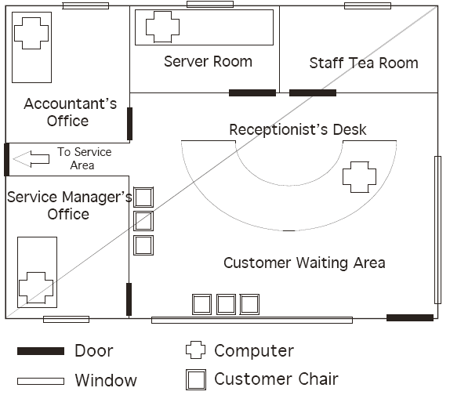
- Each of the doors within the office area is lockable, and each employee has a key that enables them to open all doors.
- All windows are lockable.
- The receptionist has a lunch break of 30 minutes at midday every day, the quietest time of the day. Whilst the receptionist is out, the accountant watches the reception desk from his office.
- Staff must log onto the system in order to gain access to the information stored on the transaction processing system. Staff are allocated a user name and password by the service manager when they commence working at Superior Auto that they do not have to change and does not have to meet a complexity rule.
- Once staff have logged onto the system they are able to access all information stored on the transaction processing system.
- All computers are loaded with the latest virus protection and this is updated fortnightly.
- A firewall is installed between the information system (TPS) and the Internet to prevent unauthorised access.
- The receptionist’s computer is locked down using a cable to the underside of the desk

A) Explain a consequence for the organisation or individuals if the security measures are violated or if the staff purposely ignores them?

- Staff loose their keys – all staff open all doors
- Windows are not locked
- Accountant gets busy and does not watch the front desk carefully
- They are not carefully while in the TPS. – all staff have all access. Some staff could delete or change data intentionally or unintentionally
- Virus software is not updated or used

B) Comment on the appropriateness of the physical security measures used by Superior Auto.

- Window in the server room may be an issue
- Customer waiting area is only partly supervised during receptionists lunch break
- All staff have keys to all areas – including server room.

C) Comment on the appropriateness of the software security measures used by Superior Auto.

- Antivirus is only updated fortnightly not weekly
- Firewall is a good thing if set up correctly
- Staff have usernames and passwords
- Staff do not have forced password change or structure

D) Identify three improvements that could be made to either physical or software security measures used by Superior Auto in order to ensure that data stored on the information system is adequately protected.
  - Forced password change with complexity rules
  - Update antivirus weekly
  - Restrict access to TPS or at least restrict access to functions or parts of the TPS by some staff. Staff should only have appropriate access to do their job.
  - Board up the window in the server room
  - Put server room on a different key

Question Four
Superior Auto has been approached by Magnificent Mags Pty Ltd, a company that provides mag wheels for prestige vehicles. They would like to purchase a copy of Superior Auto’s customer database so they can send marketing materials direct to prestige vehicle owners who would be interested in their products.

A) Identify the Act being infringed.
/1

Question Five

When a customer calls to book their car in for a service, the receptionist requests information about how they intend to pay, and records this information on the customer file. If the customer indicates they will be paying by credit card, the receptionist asks for the credit card number and enters it into the customer file, so that this information can be processed prior to the customer returning to pick up their vehicle on the day of the service, to save time on the day.

On the morning of the service, customer files are printed and each file is placed on the counter ready for the customer to come in and sign their confirmation slip for their vehicle to be serviced. All of the customer information held on file, including personal details and credit card numbers (if entered) appears on the front of the file.

A) Explain any reservations/concerns you would have about this particular practice in terms of any ethical issues.

- All the customer details or on public view
- Other customers could see service records/issues with cars other than their own

B) How should Superior Auto ensure this issue will not arise in future instances?

- They would need to change their procedures
Question Six
Once a month, one of the receptionist’s tasks is to identify the customer files that have not been utilized in the past twelve months. These files are copied across to a CD and then deleted from the system, in order to ensure that there is sufficient room on the system for new customer files. The CD is labelled with the month and date, and stored in a filing cabinet in the accountant’s office.
Once the CDs are three years old, the accountant disposes of the CDs to make room for the new files being stored.

A) Identify the type of process described above.

- Archiving

B) Comment on one strength and/or weakness of the above strategy.

Strength –
- clears old files and makes more data space
- Data files are stored in another room in a cabinet
- Kept for 3 years

Weakness –
- Accountants filing cabinet may not be secure enough
- 3 years may not be long enough

C) Propose a more suitable strategy for Superior Auto to implement.
/2

Question Seven
The service manager regularly receives updates (via email) from car manufacturers informing service centres about service requirements, availability of replacement parts, complying with manufacturer car warranties and safety concerns. These emails usually comprise of a short text message, with an attachment (usually a .pdf or .doc file) that outlines specifications and further details.

Due to the important nature of this information, the service manager likes to save the attachments, and has a folder structure on his computer as follows:

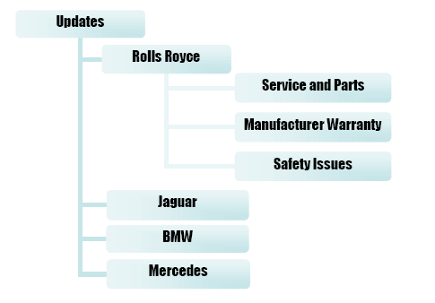

- Each car manufacturer has its own folder, and within each manufacturer folder are folders for service and parts, manufacturer warranty information, and safety issues.
- When each attachment comes in, the service manager saves the attachment in the appropriate manufacturer and area folder, with a name that is defined as follows:

Month_Year received_topic.extension
Eg. March_06_tyres.pdf
November_06_airfilters.doc

A) Comment on the strengths and weaknesses of the above strategy.

Strengths

Very logical
- Easy to find if search by date

Weakness
- It is on his local computer and not on the server where it can be backed up etc
- If it is only on his local machine then others can not access it

Question 8

Superior Auto management has just become aware of the need of Disaster Recovery Strategies after a worm called Code Red infected their information system and the news of floods in NSW.

A) For each part of the Disaster Recovery describe why it is important and what it would contain.

Emergency plan – explains specific steps to be taken in the event of a natural disaster.
- Types of disaster
- Contact names ph etc
- Procedure for shut down, and file removal
- Evac procedures for staff including removal of bk up tapes etc
- Procedure for re-entry of the building etc

Backup plan – the plan used to restore backed up files to the system
- Location of alternate hardware/software in case the original system has been destroyed
- The location of the back up files and equipment
- Personnel who are responsible for the above
- Schedule for the order and approx time each application will be back up and running

Recovery plan – includes the specific procedures for restoring the full information processing capacity of the organization.
- ID of mission critical IT services
- Use of a back up site until the original site is rebuilt

Test plan – will contain info about simulating a variety of disasters.
- Staff responsibilities
- Criterion to evaluate the test
- Procedures to follow up after the test and make required changes to procedures and systems

Question 9

One year on Superior Auto pride themselves on their disaster recovery plan and data security measures. How can they evaluate the effectiveness of security measures of both data and information and ensure both are safe and recoverable.

A) From the following list choose two to discuss how Superior Auto can evaluate how effective their strategies have been.

Integrity of Data, Security, Ease of Retrieval, Currency of Files

Strategy One - /1
Strategy Two - /1

Question 10

If you were asked to evaluate the effectiveness of data security management strategies of Superior Auto, describe 2 different potential threats you would test for?
Threat One - /1 Threat Two - /1

