ITA Monty SC Adapt to local conditions!!!!!

A strategy for doing real well in the EoY Exam!

There is NO escaping some hard work!
If you adopt a ‘that’s easy – I know that’ approach you are only fooling yourself. You MUST come to grips with a large body of knowledge that you can apply to a wide variety of situations.

As a MINIMUM you need to read the What you should know for each chapter. When you meet a concept you don’t understand (don’t fool yourself) look back in the chapter and master the concept.

It would be BETTER if you read the chapter – making notes or highlighting as you went then

Do as many as possible of the Test your knowledge questions – ESPECIALLY if you haven’t done so yet.

Try the Apply your knowledge questions as practice of case study problems.

- I have answers to all text questions!!

Next term I will use resources from the text, Checkpoints and ITA Study Guide. Copyright restrictions mean I CANNOT photocopy very much – so you should buy one of these!
You could share both books with a group of four and then sell them after the exam.

- I will give a list of Year 11 students you can approach to buy your 2ndhand texts.

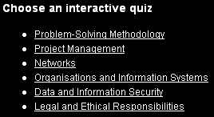
Next term I will have available two practice EoY Exams – we will do one in class near the end of the year.

Revision books info:
Cambridge Checkpoints 2007 VCE IT Applications Potts $26 ISBN 978-0-52169-710-1

This has interactive online tests – needs a password – available from text.
Past paper questions with suggested responses + some ‘cheat sheet’ cards at the end.

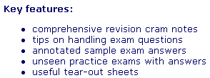
The Leading Edge VCE Units 3&4 Study Guide IT Applications
Kelly $29.95 ISBN 978-1-74081-560-4

30 page Unit summary + a few review questions + Getting the edge sample answers at various levels (points) + 2 sample practice papers with answers.

I believe there is a study cards pack available from North of the Yarra – publisher, cost and suitability unknown. Make sure it is for ITA not IPM!

Generic help (and well worth a visit):http://www.vcehelp.com.au/vce-study-skills

You have only weeks left to learn a lot. There are NO questions on the exam about specific software! There may be generic ones [like: How could Michael avoid re-entering data? (Pirelli Tyres Unit 4 Prac SAC 2) – Answer: use a RELATIONAL database (like MS Access).
but NOT a question like: How do you create a relational database in MS Access?]

Colin Sutton Monty SC September 2007 oz.sutton@gmail.com
(Nelson – Potts - page references and sections)

