Mount St. Joseph Girls’ College
Parent Forum – 16th May 2007
MS-Word 2003 : Creating a Mail Merge

- Start a new document.
- Got to the Tools menu and select, Letter and Mailings, Mail Merge.

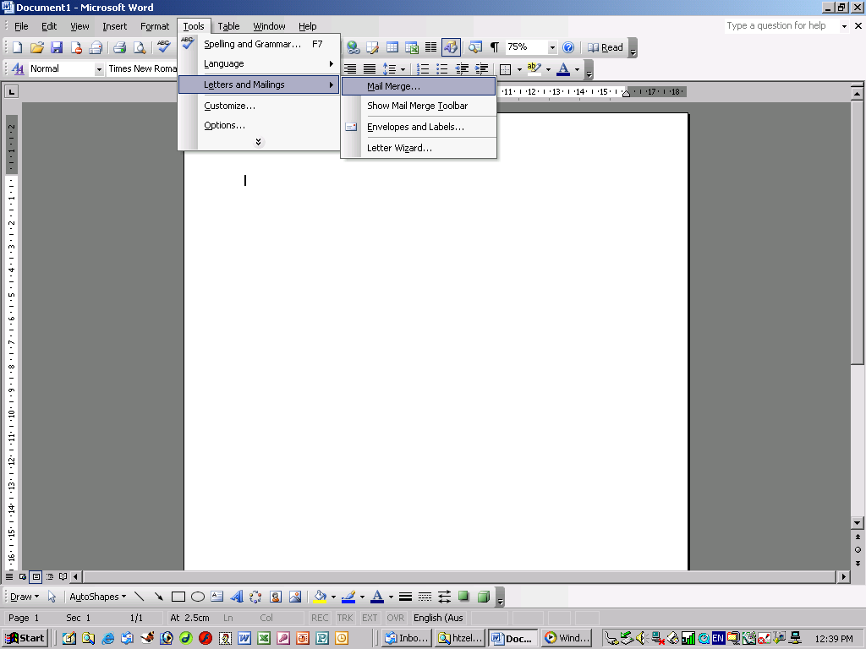

Step 1 of 6  Select document type – Letters  Click “Next: Starting document” | Step 2 of 6  Select starting document –  Use the current document  Click “Next: Select recipients” | Step 3 of 6  Select recipients –  Type a new list  Type a new list – Create
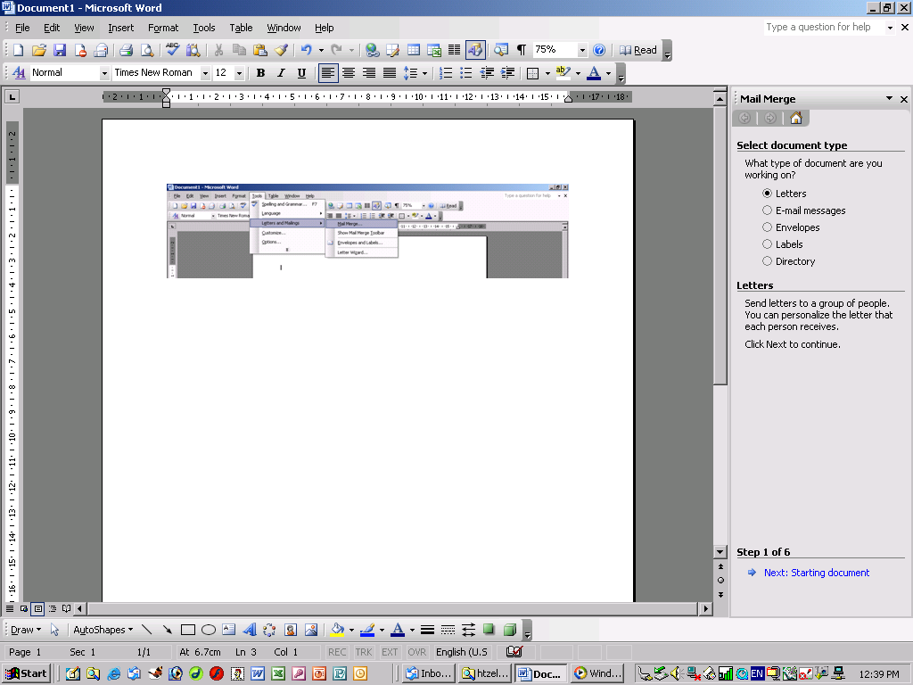 | 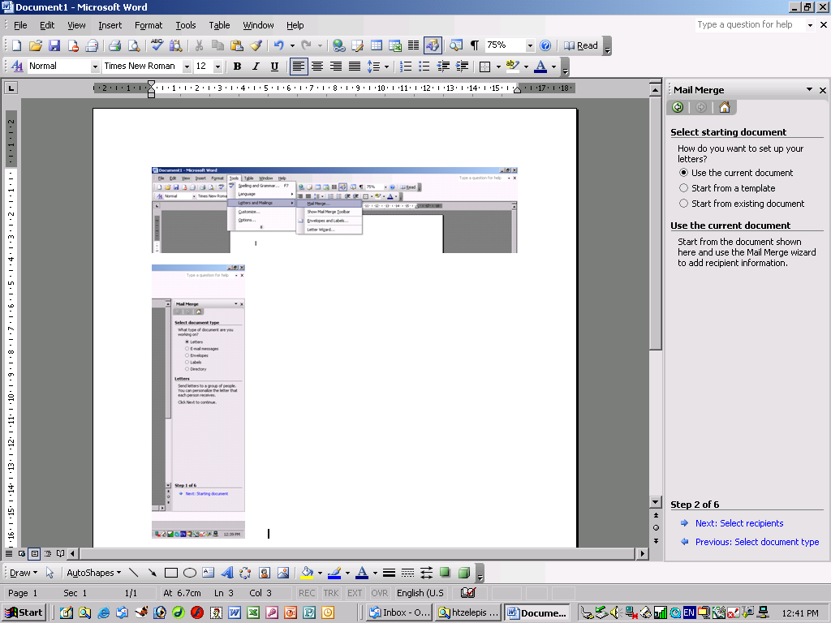 | 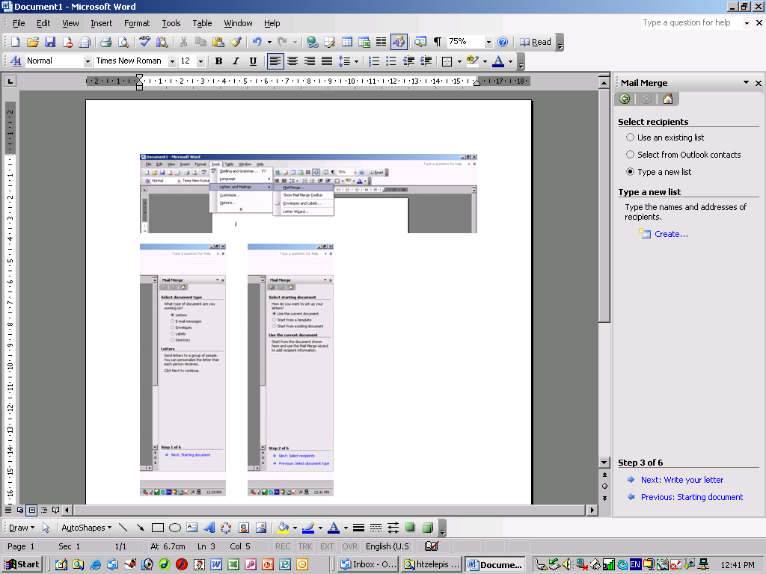

Step 3 of 6 continued…

The “New Address List” appears.
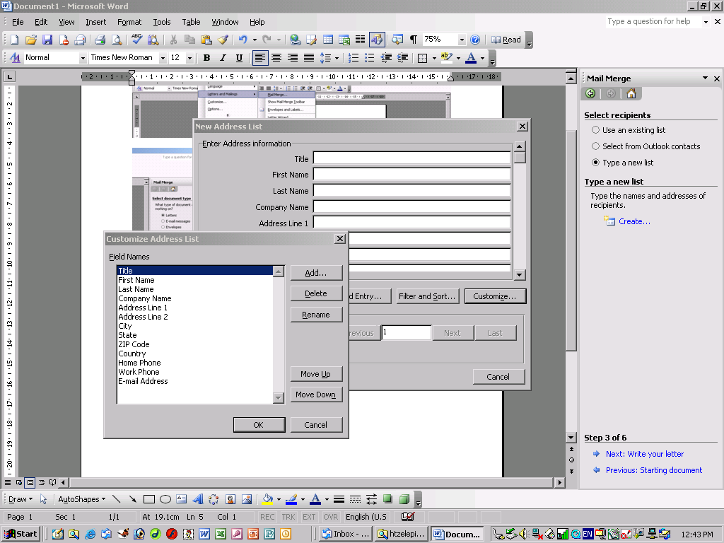
- Structure the database – Click Customise

- Define the fields you need and click OK.

- Here you can add / edit data by clicking New Entry, Delete Entry, etc.

- Once you are finished, click Close and Save your new database.

- Organise your data, Select recipients and Click OK.

- Type your letter and Save.

- Click “Write your letter”

Step 4 of 6

- Under Write your letter, click “More items”.

- Double click the fields to insert them into the letter and click OK.

- Cut and paste the fields into their correct area in your letter.

- Click “Next: Preview your letters” and scan through them.

- Click “Next: Complete the merge”

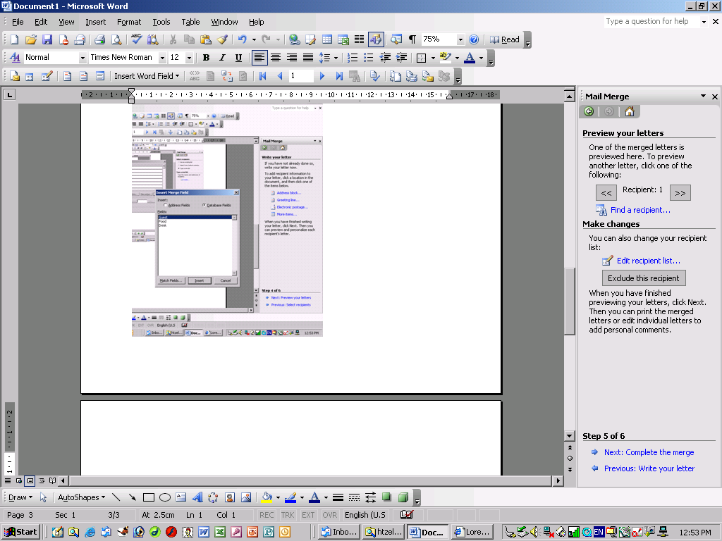
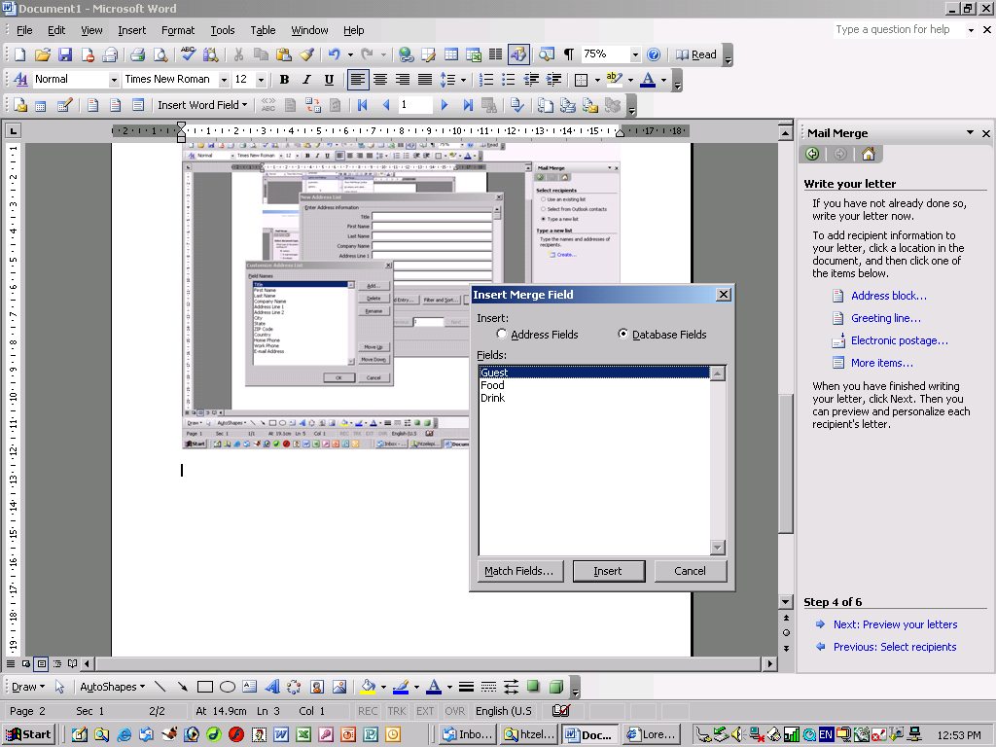

Step 5 of 6

- Either “Print” or “Edit Individual Letters” (you can save the entire group of letters here)

