- Visual record of decision-making
Decision making is an important component of solving problems and achieving organisational or personal goals. The information recorded includes the decision or action, date and personnel involved. Retracing and analysis of decisions and actions will mean that difficulties or errors have occurred can be identified and addressed.
Concept-mapping software e.g. Inspiration can be used to show the key decisions made and actions taken e.g. what form of user documentation. Make it look visually appealing!!
To show your ideas you may want to display them in either one of the following ways;
1. Flow charts sequence ideas, procedures or events. They can be used for preliminary planning or, with appropriate annotations; they can represent a timeline or final action plan. To read a flow chart you read the arrows from shape to shape. Each shape represents a step taken. For further help go to (http://www.rff.com/how_to_draw_a_flowchart.htm)
Decision
Data-
Input/ Output
Terminator-
Start/ Finish
Save
- Spider Map is used as a brainstorming and planning tool. To use this map, you place the central theme or idea in the middle circle and then list a main idea along one of the spider's legs. This idea is then further teased out in the section at the end of the appropriate leg.
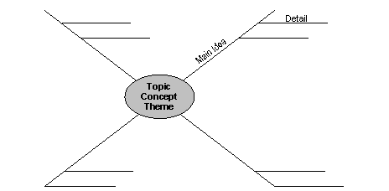

- Tree diagram

In your diagrams you may choose to colour code or have different shapes (like in a flow chart) to show different actions taken or decisions made. E.g. Clouds for decisions, thin or thick arrows for different components and green for ‘yes’ or red for ‘no’
After showing your decisions in a diagram, you must evaluate by annotating your visual representation of the decisions made and actions taken
Annotations must include;
- The positive and negative aspects of the processes used to create the solution – for the negative aspects, identify how they could be improved to ensure this mistake is easy identifiable and not repeated
- How the solution has solved the information problem identified in the Analysis phase
- How your solution and output will lead to improved efficiency (effects upon time, cost or effort), improved effectiveness (effects upon quality of output, accuracy, presentation and comprehensiveness) and/or improved decision-making (sufficient information that is communicated well and presented in a timely manner)

Decision

Options (record available options)

Action (Indicate action taken)

Impact of decision/action (Evaluation component)

