Mind Map

How to do a Mind Map

Mind mapping (or concept mapping) involves writing down a central idea and thinking up new and related ideas which radiate out from the centre. By focussing on key ideas written down in your own words, and then looking for branches out and connections between the ideas, you are mapping knowledge in a manner which will help you understand and remember new information.

Look for relationships

Use lines, colours, arrows, branches or some other way of showing connections between the ideas generated on your mind map. These relationships may be important in you understanding new information or in constructing a structured essay plan. By personalising the map with your own symbols and designs you will be constructing visual and meaningful relationships between ideas which will assist in your recall and understanding.

Draw quickly on unlined paper without pausing, judging or editing

All of these things promote linear thinking and the idea of mind mapping is to think creatively and in a non-linear manner. There will be plenty of time for modifying the information later on but at this stage it is important to get every possibility into the mind map. Sometimes it is one of those obscure possibilities that may become the key to your knowledge of a topic.

Write down key ideas

Some students find that using capital letters encourages them to get down only the key points. Capitals are also easier to read in a diagram. You may, however, wish to write down some explanatory notes in lower case. Some students do this when they revisit the mind map at a later date while others write in such things as assessment criteria in this way.

Put main idea in the centre

Most students find it useful to turn their page on the side and do a mind map in "landscape" style. With the main idea or topic in the middle of the page this gives the maximum space for other ideas to radiate out from the centre.

Leave lots of space

Some of the most useful mind maps are those which are added to over a period of time. After the initial drawing of the mind map you may wish to highlight things, add information or add questions for the duration of a subject right up until exam time. For this reason it is a good idea to leave lots of space.

These hints on how to construct a mind map have been adapted from the work of Tony Buzan and others who have promoted mind mapping as a learning and thinking tool. For a full explanation of the mind mapping technique see Buzan, T. (1991). The mind map book . New York: Penguin. [http://www.jcu.edu.au/studying/services/studyskills/mindmap/howto.html]

Use the following Mind Map template to analyse the problem to be solved as stated in the case study (5-10 mins)

Fishbone Diagram: A Problem-Analysis Tool

What is a Fishbone diagram?
Dr. Kaoru Ishikawa, a Japanese quality control statistician, invented the fishbone diagram. Therefore, it may be referred to as the Ishikawa diagram. The fishbone diagram is an analysis tool that provides a systematic way of looking at effects and the causes that create or contribute to those effects. Because of the function of the fishbone diagram, it may be referred to as a cause-and-effect diagram. The design of the diagram looks much like the skeleton of a fish. Therefore, it is often referred to as the fishbone diagram.
Whatever name you choose, remember that the value of the fishbone diagram is to assist teams in categorizing the many potential causes of problems or issues in an orderly way and in identifying root causes.

When should a fishbone diagram be used?
Does the team...
Need to study a problem/issue to determine the root cause?
Want to study all the possible reasons why a process is beginning to have difficulties, problems, or breakdowns?
Need to identify areas for data collection?
Want to study why a process is not performing properly or producing the desired results?

How is a fishbone diagram constructed?
Basic Steps:
- Draw the fishbone diagram....
- List the problem/issue to be studied in the "head of the fish".
- Label each ""bone" of the "fish". The major categories typically utilized are:
The 4 M’s:
Methods, Machines, Materials, Manpower
The 4 P’s:
Place, Procedure, People, Policies
The 4 S’s:
Surroundings, Suppliers, Systems, Skills
Note: You may use one of the four categories suggested, combine them in any fashion or make up your own. The categories are to help you organize your ideas.
- Use an idea-generating technique (e.g., brainstorming) to identify the factors within each category that may be affecting the problem/issue and/or effect being studied. The team should ask... "What are the machine issues affecting/causing..."
- Repeat this procedure with each factor under the category to produce sub-factors. Continue asking, "Why is this happening?" and put additional segments each factor and subsequently under each sub-factor.
- Continue until you no longer get useful information as you ask, "Why is that happening?"
- Analyze the results of the fishbone after team members agree that an adequate amount of detail has been provided under each major category. Do this by looking for those items that appear in more than one category. These become the 'most likely causes".
- For those items identified as the "most likely causes", the team should reach consensus on listing those items in priority order with the first item being the most probable" cause.

Use the following Fishbone diagram to analyse the problem to be solved as stated in the case study (5-10 mins)
Use four of the strongest arguments for a new solution, and then work through the causes of these problems.
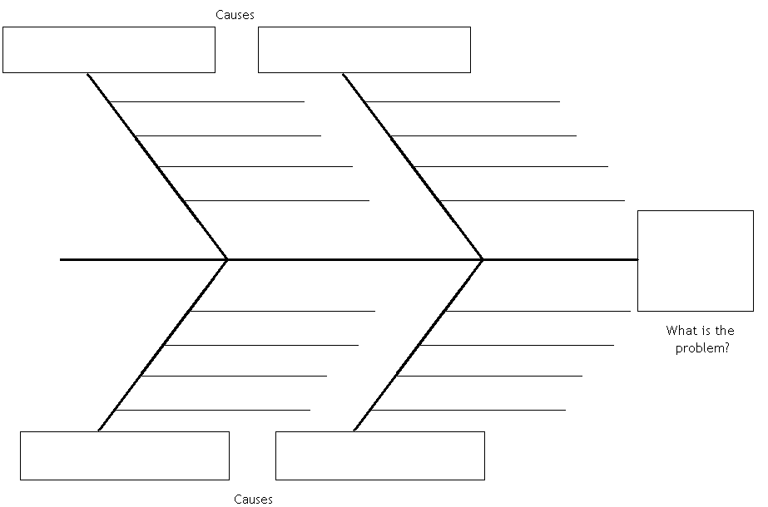
Use the following Decision/Action Tool to Analyse the Problem
Decision/Actions

Decision
(List all the Decisions that you have to make)

Solutions/Options
(record available options)

Action
Outcome/Actions
(Indicate action taken and colour code option selected)
Impact of Decision/Action
(Evaluation)

