Graphic Organisers

Flow diagram
Flow diagrams sequence ideas, procedures or events. They can be used for preliminary planning or, with appropriate annotations, they can represent a timeline or final action plan.
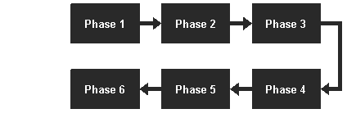
Spider Map
The Spider Map can be used as a planning or brainstorming tool. Students place the central theme or idea in the middle circle and then list a main idea along one of the spider's legs. This idea is then further teased out in the section at the end of the appropriate leg.
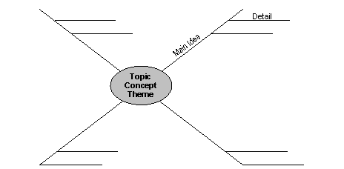

http://vels.vcaa.vic.edu.au/support/teaching.html#graphic

Flowcharts
Why a Flowchart? | Flowcharts are helpful in understanding a complicated process. This is especially true if you have to make decisions and do different steps depending on those decisions. By looking at a flowchart you can visually follow different paths through the chart. For each step on a flowchart you can ask yourself "Why is this done?"
Terminator | All flowcharts start and end with the terminator or terminal shape. This is a rounded rectangle and is shown below. You use this same shape for both the start and the end. You will see some charts with slightly different terminal shapes. This is because there is no golden standard for flowcharting..  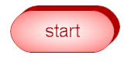
 | To read a flowchart, you follow the arrows from shape to shape. 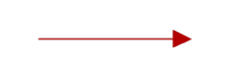
Decision | The decision shape asks a question. "Are you under 65 years of age?" If you are less than 65 years old, you follow the arrow going down out of the decision shape. If you are 65 or older, you follow the arrow to the right.  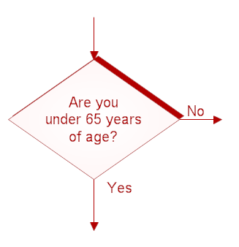
Process | The rectangle is used for activities or action steps. These are things that must be done.  
Putting it all together | The chart shown below could be part of the 2006 Federal Income Tax return instructions. You start at the top and follow the arrows from shape to shape. Flowcharts usually go from top to bottom or left to right, but you can do whatever you want. The circle with the letter B refers to a chart on a different page. You would find that page and look for a B in a circle. Almost all flowchart can be done with only these four shapes.  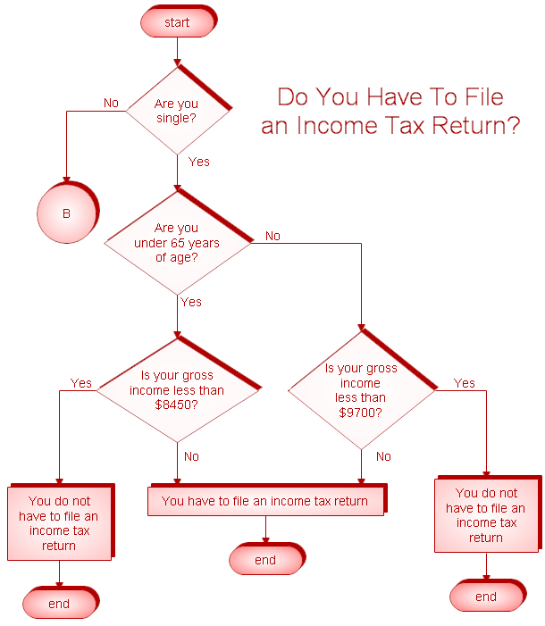
(http://www.rff.com/how_to_draw_a_flowchart.htm)

Tree

