VCE 1 – Information Technology
Skills Development Folio – MS-Excel

Macros: Automating tasks you perform frequently
If you perform a task repeatedly in Microsoft Excel, you can automate the task with a macro. A macro is a series of commands and functions that are stored in a Visual Basic module and can be run whenever you need to perform the task. When you record a macro, Excel stores information about each step you take as you perform a series of commands. You then run the macro to repeat, or "play back", the commands.

Record a macro to do a task in one step
Before you record or write a macro, plan the steps and commands you want the macro to perform. If you make a mistake when you record the macro, corrections you make are also recorded. When you record macros, Visual Basic stores each macro in a new module attached to a workbook.

1. How to record a NEW macro

TOOLS, MACRO, RECORD NEW MACRO
- Name the macro (& if you wish, allocate a CTRL key shortcut to access the macro via the keyboard), OK
- Carefully execute the steps you would like to record
- When you are finished, click the STOP RECORDING button on the macro icon

2. How to EXECUTE the macro

TOOLS, MACRO, MACROS
- Select the macro you want executed and click RUN

or

- Access the CTRL key you allocated during recording of the macro

Part B – Macros & Buttons

Rather than accessing your macros from the TOOLS menu, you can program a command button to do so.

Firstly, you will need to open up the Visual Basic and the Control Toolbox Toolbars.

VIEW, TOOLBARS, VISUAL BASIC

- VIEW, TOOLBARS, CONTROL TOOLBOX

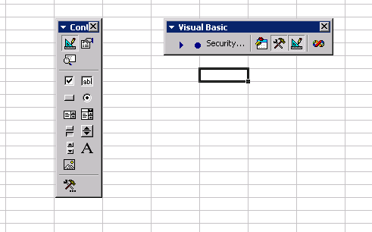

Command Button

Design Mode / Exit Design Mode

- Record all the macros you require.
- Click on the Command Button control.
- Draw out a button of a decent size.
- Access the macro – TOOLS, MACRO, MACROS
- Select the MACRO and click EDIT
- Copy all the code between SUB and END SUB
- Close the Visual Basic window (with more practice you can leave it open)
- Double click the button you created
- Paste the code in between the PRIVATE SUB and END SUB and close the Visual Basic window
- Name your button (right click on the button and click PROPERTIES, click on the CATEGORIZED tab and rename it under caption. Also, other button appearances can be modified under this tab). Close the PROPERTIES window.
- Click the EXIT DESIGN MODE button
- Check that your button works

Part C – Customizing the toolbar with your macros

For easier access to the macros you have created, you can dock them onto a new toolbar.

Open the Flash Macros V2 file

Creating a new toolbar

- Right-click on any toolbar
- Select CUSTOMIZE from the shortcut menu
- Click the TOOLBARS tab
- Click NEW
- Give the toolbar a NAME – eg. My Macros
- Click OK and then CLOSE
- Drag the new toolbar to the top of the screen next to the other toolbars

Adding buttons to your new toolbar

- Right click on any toolbar
- Select CUSTOMIZE from the menu
- Click the COMMANDS tab
- Scroll down the CATEGORIES list and select MACROS – the COMMANDS list will display only two items: Custom Menu Item and Custom Button
- Select CUSTOM BUTTON and drag it out into the new “My Macros” toolbar
- Right click on the new button to display its properties
- Change the name of the button – use a name that is representative of the macro that will be assigned to it.
- Select TEXT ONLY (ALWAYS) – whichever option you choose is fine, just be consistent
- Right click on the new button again to display its properties
- Select ASSIGN MACRO
- Highlight the name of the macro you wish to assign to the button click OK
- Close the CUSTOMISE dialog box

Attaching a new toolbar to your workbook
To ensure that your newly created toolbar is available in a specific workbook, you need to attach it.

- VIEW, TOOLBARS, CUSTOMISE
- In the TOOLBARS tab click ATTACH
- Under CUSTOM TOOLBARS select the toolbar you wish to attach
- Click COPY, OK and make sure you SAVE

