Excel Tutorial
This tutorial is based on the case study Point Pleasant Social Service Program from the Potts text book page 162-163. It has been slightly adapted. In the design step on page 166 two separate sheets for Teacher and Homeroom are proposed. In this tutorial this is combined into one sheet Homeroom_Details. All sections from the list of required software skills for spreadsheets are covered in this tutorial except for Macros. Formatting/Layout is not explicitly covered.

Open a new Excel workbook

A. RENAMING SHEETS
- Rename the worksheets to Main, Fundraising and Homeroom_Details by right clicking the sheet name and selecting Rename.
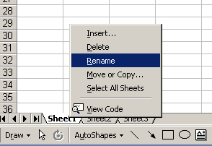

B. ENTERING DATA
- Fill in the following data in the Homeroom_Details sheet
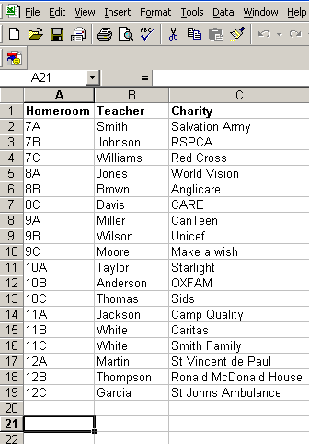

- Assuming a maximum of 30 (this can be adjusted if more events are expected) individual fundraising events, fill in the following data in the Fundraising sheet. Eventually this sheet will be filled in by a) selecting a Homeroom from a drop down list (Data-Validation), b) entering the fundraising Event, c) the Date the event took place and d) the Amount collected.
Note: Its important that the Homeroom is not entered manually as the homeroom totals on the Main sheet are dependent on this.
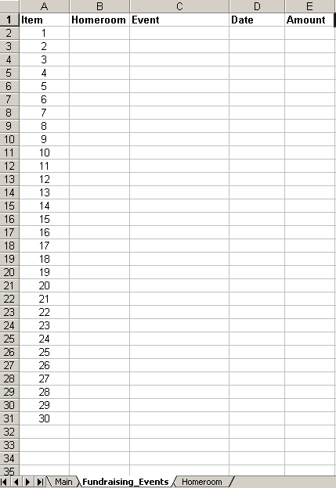
- Fill in the following data in the Main sheet. The Homerooms entered must match the list, which will eventually be used for the Fundraising sheet Homeroom Data-Validation List (see section H. DATA VALIDATION pg 9). There will be formulas entered for Teacher, Charity, Amount and Certificate.
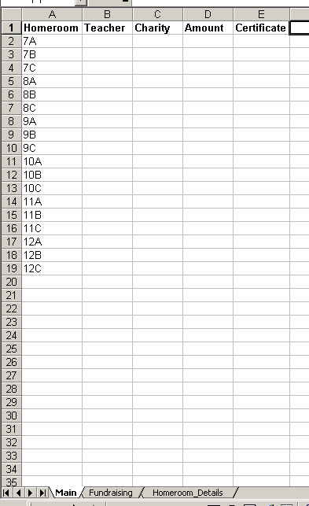

C. NAMING A DATA RANGE
- Highlight the Homeroom data as shown below on the Homeroom_Details sheet.
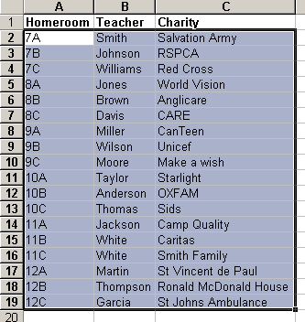
- Click Insert → Name→ Define… and name the data range Homeroom_Teacher_Charity. Click OK.
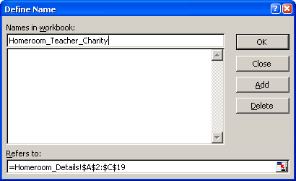

- Highlight B2 to B31 on the Fundraising sheet.
- Click Insert → Name → Define and name the data range Fundraising_Homeroom. Click OK.
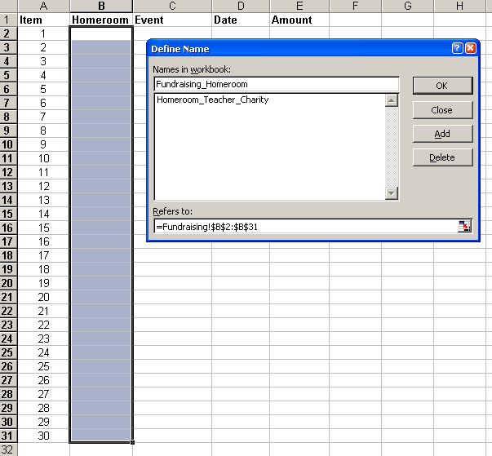
- Highlight E2 to E31 on the Fundraising sheet.
- Click Insert → Name → Define and name the data range Fundraising_Amount. Click OK.
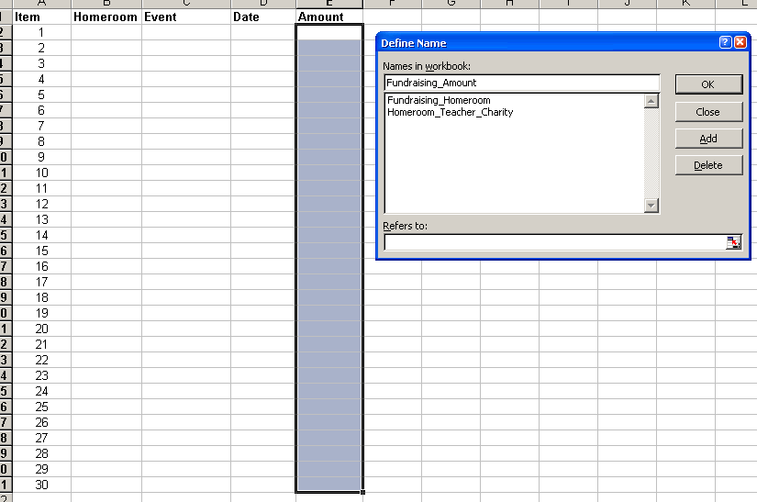

The ranges of data named above will be used as part of VLOOKUP formulas on the Main sheet.

D. USING VLOOKUP TO LOOK UP DATA ON ANOTHER SHEET
- Click B2 in the Main sheet and type in the formula =VLOOKUP(A2,Homeroom_Teacher_Charity,2,0)
The vlookup formula will lookup the value in A2 in the data range named Homeroom_Teacher_Charity. Once it finds the value (Homeroom) it will then return the value 2 places over (Teacher), counting the original value as the first place. The 0 means that the data range does not have to be in any particular order and that the value being looked up must be matched exactly.
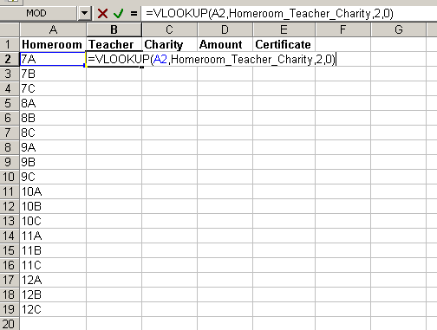
- Fill down the formula by highlighting from B2 down to B19 and clicking Edit → Fill → Down
- Click C3 in the Main sheet and type in the formula =VLOOKUP(A2,Homeroom_Teacher_Charity,3,0)
This formula will return the chosen Charity for the Homeroom. The 3 means the formula will return the value 3 places (Charity) over.
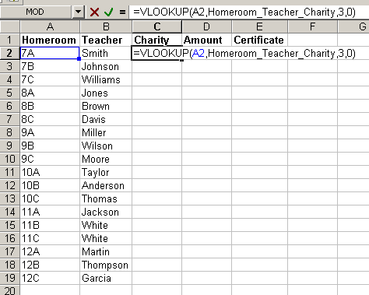
- Fill down the formula by highlighting from C2 down to C19 and clicking Edit → Fill → Down

E. USING SUMIF
- Click D2 in the Main sheet and type in the formula =SUMIF(Fundraising_Homeroom,"7A",Fundraising_Amount)
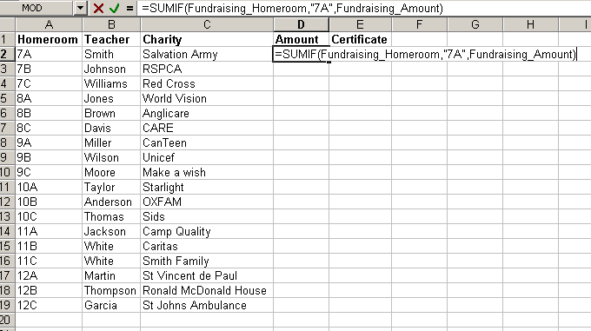
This formula will look for any instance of the Homeroom in the quotation marks in the Fundraising sheet and add up its corresponding Amounts raised.
- Copy and paste the formula down to D19 changing the Homeroom in the quotation marks to be looked up.

F. IF STATEMENT
This formula checks the Amount raised by each Homeroom. The totals used is slightly different from the Text book (as I did not have the book with me at the time).
- Click E2 and type in the formula =IF(D2>=2000,"Gold",IF(D2>=1000,"Silver",IF(D2>=500,"Bronze","")))
The If(test condition,do this if true,do this if false) formula used above will do the following. It checks whether the total amount raised is over $2000,
if so the Homeroom receives a Gold certificate
if not then the value is checked if it is over $1000
if so then the Homeroom receives a Silver certificate
if not then the value is checked if it is over $500
if so then the Homeroom receives a Bronze certificate
if not then no certificate is issued

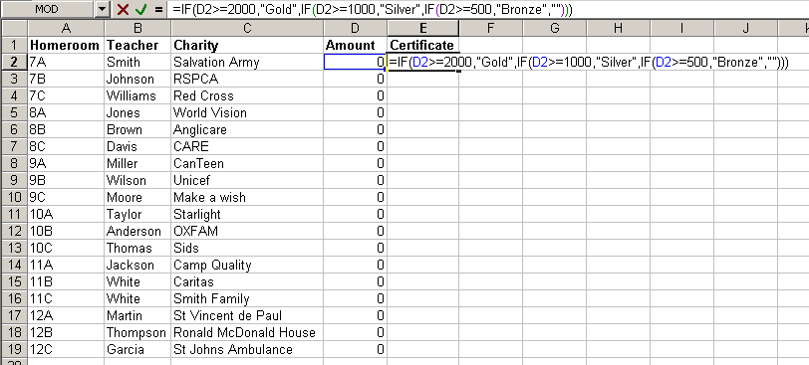
- Fill → Down the formula to D19

G. CONDITIONAL FORMATTING
- Highlight cells A2:E19.
- Click Format → Conditional Formatting.
- Select Formula Is from Condition 1. Enter the formula as shown. (ask teacher for clarification of this formula, re: use of absolute and relative cell referencing)
- Click Format and then click the Patterns tab. Select a colour. Click OK.
The formula checks if the Amount in column D is equal to the Maximum of all the values in the Amount column. If the maximum Amount is found the entire row is highlighted.
Note: When there are no data entered in the fundraising sheet then all amounts will be 0. This means all rows are the maximum and hence every row is highlighted.
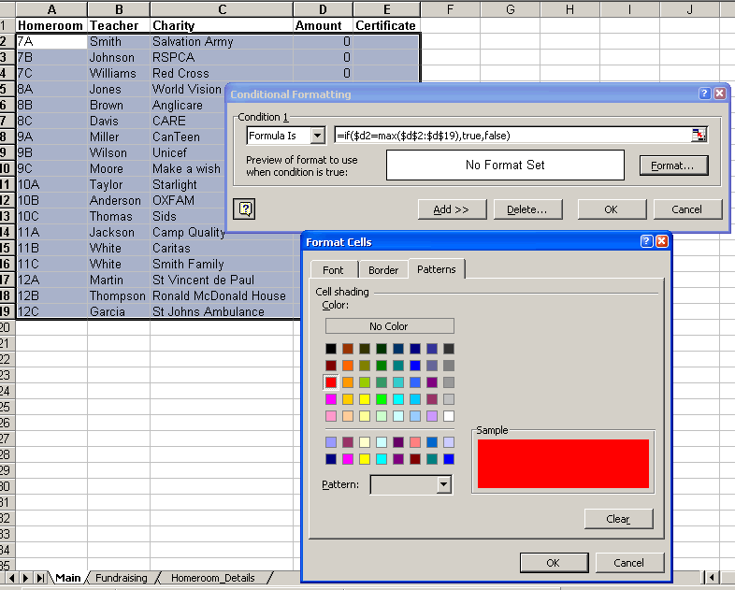

H. DATA VALIDATION
- Highlight B2:B31 in the Fundraising sheet.
- Click Data → Validation…
- Change Validation criteria to Allow from a List. Type in the Source: ,7A,7B,7C,8A,8B,8C,9A,9B,9C,10A,10B,10C,11A,11B,11C,12A,12B,12C
Note: there is a comma at the beginning in order for a blank entry to occur in the Homeroom column.
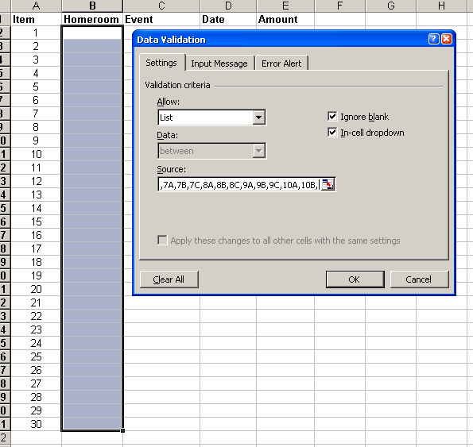
I. INSERTING COMMENTS
- Click B1 in the Fundraising sheet. Click Insert → Comment and type in the comment box as shown below. Click anywhere on the sheet to close the comment box.
Note: After entering the Comment a red triangle appears in the top right corner of the cell with the comment. Placing the mouse over the cell reveals the comment.
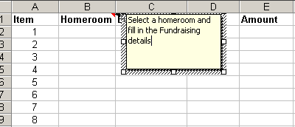
J. TESTING
- Enter the following data to test the formulas in the Main sheet.
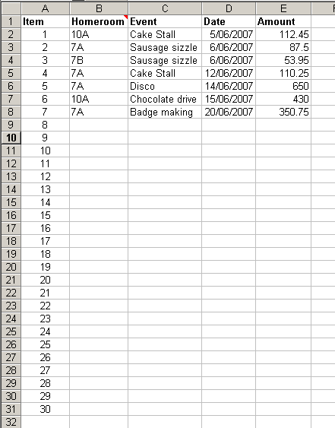

K. CELL PROTECTION
By default all cells are locked in Excel. Protecting cells is a 2-stage process. You first unlock the cells then you protect the sheet.
- Highlight A2:A19 in the Main sheet. Click Format → Cells…
- Click the Protection tab and unselect Locked.
- Select Tools→ Protection → Protect Sheet… Click OK.
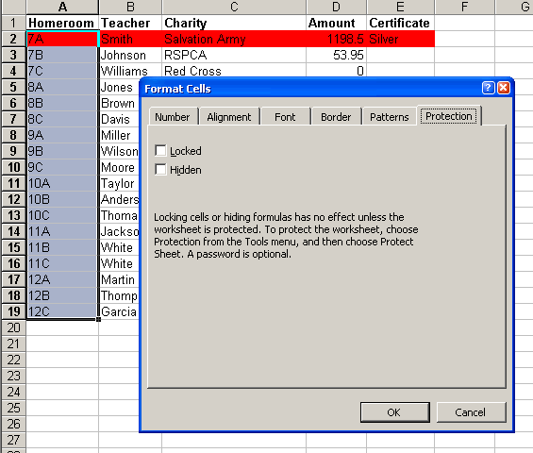

Note: It is a good idea to thoroughly test the spreadsheet before protecting parts of the spreadsheet. Ideally you would leave the formulas locked and unlock the data entry areas of the spreadsheet.

L. CREATING A CHART USING THE WIZARD

Note: Once the chart has been created, when any data is updated on any sheet the chart is automatically updated.
- Highlight A2:D19 in the Main sheet. Click the Chart Wizard button
- Select Column from the Chart type: Click Next
- Click the Series tab. Type in the Name: Amounts Raised. Click Next
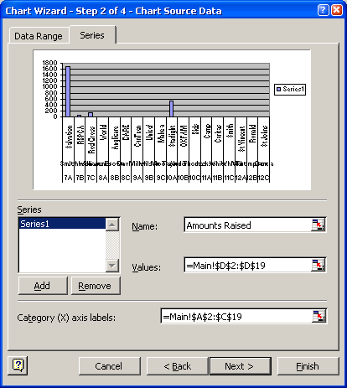
- Click the Title tab and enter $ for the Value (Y) axis:
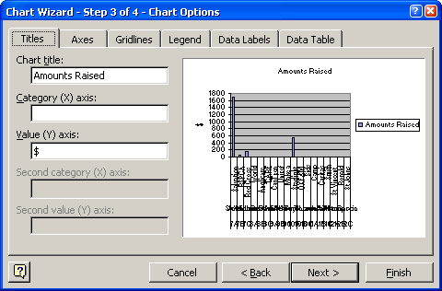

- Click the Gridlines tab and unselect the Major gridlines below Value (Y) axis.
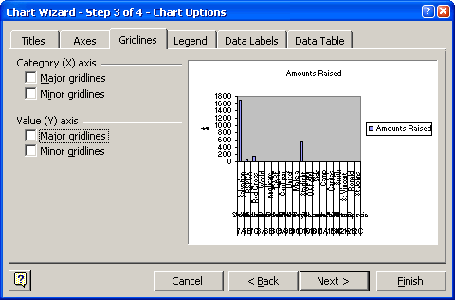
- Click the Legend tab and unselect Show legend. Click Next.
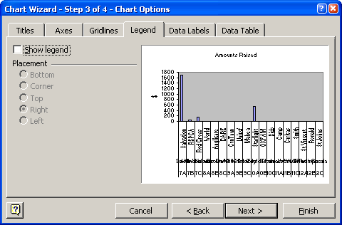
- Click As new sheet. Click Finish.
