Unit 4 Outcome 1
Part 1. Creating spreadsheet solutions
Part 2. Creating quality user documentation
Part 3. Visualising the thinking that went into decisions for parts 1 and 2.

Ex 1 The Project Manager for Ripple Pty Ltd needs to keep track of the team’s expenses. He wants you to set up a spreadsheet to be stored in the Project Team’s folder on the company network. Each team member will enter his/her expenses for each month onto their own worksheet. The Manager wants to know how much the team is spending on each expense category each month and the total expenses for the month. He wants to know who spends the most each month.

The expenses to be recorded are: Internet access, telephone, Heating, Light, Accommodation, Travel, and Food. The team member is to input his/her Heating and Light bills and the software will allow 15% of each bill as an expense for the project. The Project Manager has decided that the team will meet at the beginning of the project to get to know each other and then at the end to celebrate meeting all milestones and (hopefully) coming in under budget!

Planning the solution
1. Use MS Project to create a plan of action for solving this problem. Start with these tasks:
- Design user interface (shows what the user interacts with)
- Create an IPO chart (shows processing required)
- Write evaluation criteria (to check solution against – how well does my solution meet the organisation’s needs?)
- Develop spreadsheet
- Test and debug
- Brainstorm documentation required
- Choose documentation form and structure
- Write documentation
- Test and edit
- Submit for assessment

1.1 Identify milestones in your project and predecessors.
1.2 In the Notes box for each task, you will write an evaluation of how well you performed the task.
eg
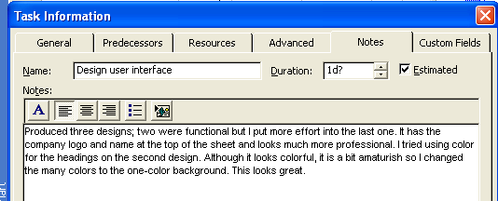

2. Draw up an IPO Chart for solving the problem
Annotate it to show where it meets the evaluation criteria and make any amendments needed eg

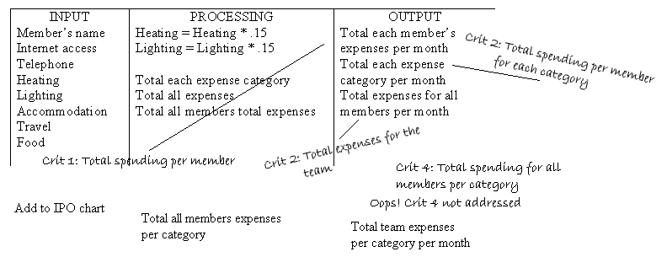

3. Use a blank sheet of paper to draw up 2-3 designs for the user interface. Do PMI for each design eg.

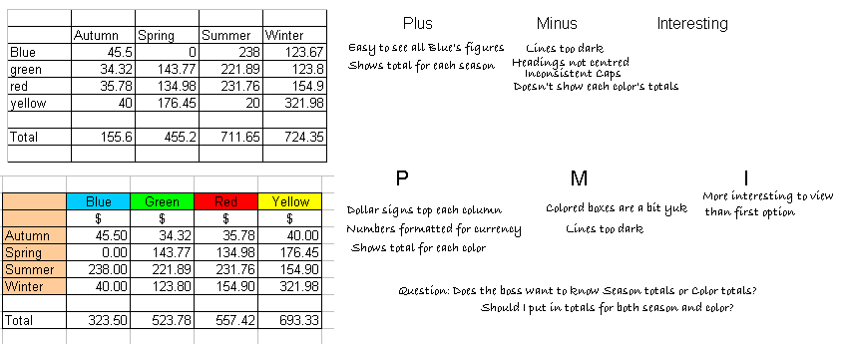

4. Create your spreadsheet, test and debug

5. Read the notes about good documentation design in the file named Designing_User_Doc

6. As a class, we will brainstorm the user documentation needed to support your solution

7. Open the file named Selecting_user_doc and follow the instructions to help you choose the best documentation types for your solution.

8. Create the user documentation, test and edit

9. Submit your final product (spreadsheet including doc, project plan, and planning docs)

Notes for teachers

1. I based this exercise on the Project Team I used for Unit 3 SAC 2 but it can be edited so that the work is done for any Project Manager for any organisation. The spreadsheet functions used are simple for two reasons:
i. this is the students’ first exercise since last year
ii. my focus is on the user documentation.

2. The visualising thinking aspects of the exercise (tasks 1.2, 2, 3 and 7) are not artificial. The research is showing that people better understand their thinking processes when they attempt to put them down on paper. Sometimes this involves drawing images, using libraries of images (as in Inspiration), or using words. I have included two of the three here. As I’ve mentioned before, I don’t use Inspiration because students spend too much time looking for images and not enough time thinking!

3. We undertook task 6 as a whole class activity. If you have a large class, you might do it in small groups of 4-6 students. I asked students to select one of the Project Team members (my SAC had 6 team members) and place his/her name in the middle of a plain sheet of paper. I then asked “What do we need to know about our target audience for this product so that the user documentation is appropriate for them?”
We developed a mind map like the one below. You could give the students a map with the questions on it and ask them to fill in the answers individually.

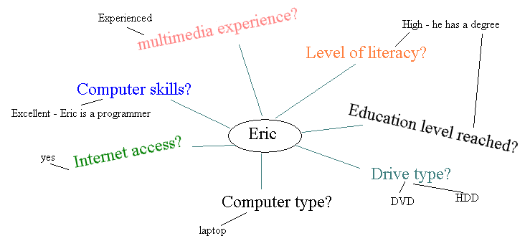

4. The application Selecting_user_doc is a little visualising thinking tool I created quickly. I can see possibilities with this tool and will improve it during the holidays.

Feel free to modify, improve, take bits you like. Please, however, do not use any of my work under another’s name. I always give credit to those whose work I use from the IT list and would appreciate the same courtesy.

