Creating and Applying Cascading Style Sheets

- Create a new Dreamweaver site name it CCS
- Open a new page and type the following

My Favorite Foods

One of my hobbies is eating. I love food. In particular I love visiting different restaurants

This is a bulleted list on my favorite foods

Item one- pizza

Item two - nachos

Item three - Greek salad

- Click on the Design panel
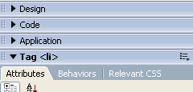

This open the CSS Styles panel

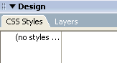

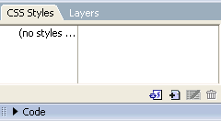
- Click on New Style Icon

The following dialog box appears

Change the name to .Heading

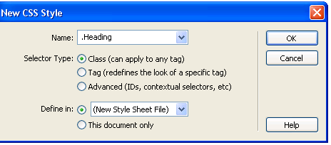

Ensure New Style Sheet File is selected – this ensures that we can use the style throughout our website

Ensure Class (Can apply to any tag) is selected –this creates a new custom style and places it in the CSS Styles Panel

- Click OK

The following dialog box opens – save into the website folder and give the style the filename Header.

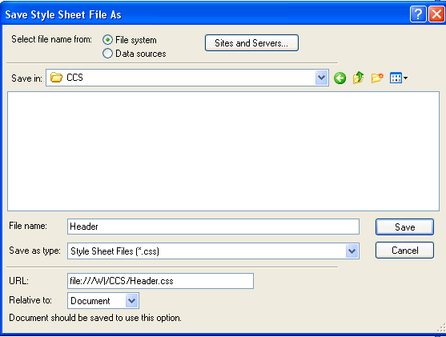

6. Click Save

The following dialog box will appear:

Change the definitions as suggested

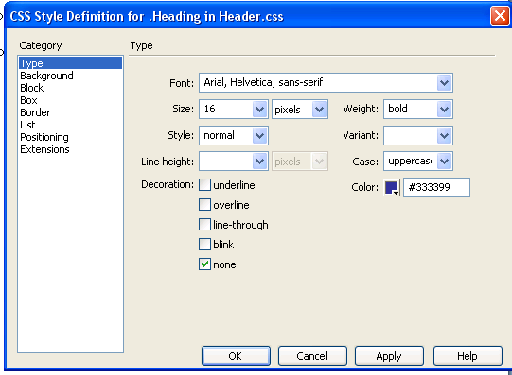

Then click OK

Refresh your files panel

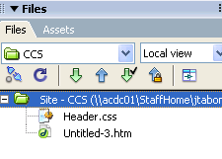

The Header cascading style should appear

We are now ready to apply our header style.

Click on Code view to view the HTML Code, your header ccs should appear

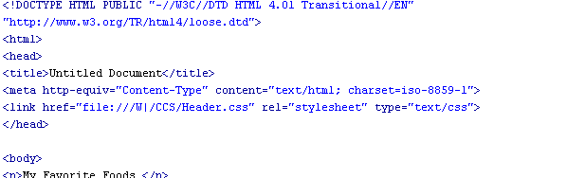

Click on Design view to return to design

- Select the words “My Favorite Foods”
- Right click and the following menu appears

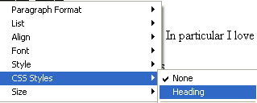

Click on CSS Styles – Heading

You can do this throughout your website

Your Turn:

Create a CSS for the paragraph style

To use the CSS throughout your website

1. Create a new page
2. Click on attach a CSS option

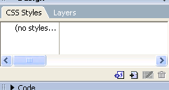

The attach style sheet dialog box appears.

Click the browse button and select the header style

The header style now appears and you can use this style throughout the page.

Creating a style for a tag

- Create a new style- this time make sure that the tag radio button is selected

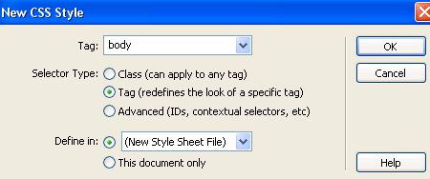

Click OK
And save

The definition dialog box appears

Click on background and change a style (I added an image as a background)

Click OK

