Styles in Dreamweaver

Cascading Style Sheets (CSS) enable the Web designer to apply page elements that affect the entire site and establish consistency throughout the site.
A Cascading Style Sheet is a set of formatting rules that can be applied to all pages in the Web site. For example, text, paragraphs, lists, positioning, background, borders, rollovers, HTML tags.
When a Cascading Style Sheet is modified, all the pages in the site that are linked to the style sheet can be updated by using a single command.

The CSS Styles can be imbedded into the <head> area at the top of the page using the <style> tag, or linked to an external style sheet. The external style sheet is a separate document that holds all the rules pertaining to the CSS Styles. This document is linked to all, or specific, pages in the Web site. It also enables the updating of all linked pages with ease.

Dreamweaver has three types of CSS style sheets:
- Custom CSS Styles – (called classes) applied to a block of text.
- HTML Tag Styles – redefine the formatting for a tag.
- CSS Selector Styles – redefine the formatting of a combination of tags.
For CSS Styles control to function correctly, all manual HTML formatting and HTML styles must be removed.

Creating an external style sheet
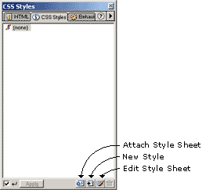
- Open your document
- Click Window > CSS Styles
- Click the "Edit Style Sheet" icon (3rd from left)
- Select "New"
- Make sure the "Define in" radio button is set to "New Style Sheet File" and not "This Document Only"
- Decide whether you're going create a style sheet class, redefine a html tag or use a css selector
- Select the item you're going to define and Dreamweaver will ask you to save your .css
- Save it in your web site - best in a folder called /styles/
- Edit your attributes and save.
- To add more style sheet attributes for classes, html tags and selectors, click the "Edit Style Sheet" icon again
- Select your new style sheet from the list
- Click Edit and continue
  - Be aware that Dreamweaver allows you to assign attributes which may not be supported by all browsers yet
  - You can remove the link to the style sheet by clicking the "Edit Style Sheet" icon and then clicking "Remove"

Creating an embedded style sheet
- Open your document
- Click Window > CSS Styles
- Click the "Edit Style Sheet" icon (3rd from left)
- Select "New"
- Make sure the "Define in" radio button is set to "This Document Only" and not "New Style Sheet File"
- Decide whether you're going create a style sheet class, redefine a html tag or use a css selector
- Select the item you're going to define
- Edit your attributes and click "Done"
Or
- Open your document
- Click Window > CSS Styles
- Click the "New Style" icon (2nd from left)
- Make sure the "Define in" radio button is set to "This Document Only" and not "New Style Sheet File"
- Decide whether you're going create a style sheet class, redefine a html tag or use a css selector
- Select the item you're going to define
- Edit your attributes and click "Done"

Link to an existing external style sheet
- Open your document
- Click Window > CSS Styles
- Click the "Attach Style Sheet" icon (1st on left)
- Browse for the existing style sheet
- Select correct style sheet

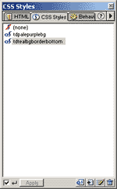
Using style sheets in dreamweaver
Whether you're using inline, embedded or external style sheets, Dreamweaver will display the html tags as defined in the style sheet (you'll need to define all the html tags you require) and the classes will be displayed in the CSS Style menu (Window > CSS Styles). Image to the right shows list of classes.

Applying a class
To apply a class, simply click once in the area you wish to define. The html tag you will be applying the style class to will be highlighted in bold at the bottom of your Dreamweaver window (see image below with pink highlighted tag). If the correct bit of html is not highlighted, simply click on the correct one in this bottom bar. This will highlight the whole html tag. Then click on the appropriate tag in the CSS Styles menu. The class will now be applied to the whole html tag. If you just wish to apply a style to part of an area, select the area using your mouse, then click the appropriate style class. This will apply the style to only the highlighted area.
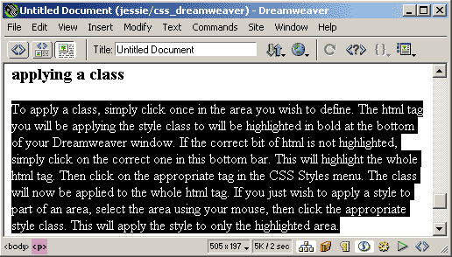

When you name your style sheet you must start with a ".".

