Year 8 Gamemaker Project
Assessment Task Marking Scheme
Use of tanks over the desert in the same way as planes over the sea as in the Wingman Sam exercise in class

Your Name : Class:

Your Task
- Log on to Moodle and download the sprites under the file – Gamemaker Assessment Project Sprites
- You will create a tank game similar to the Wingman Sam game with planes. Except you will have to make your game over the desert with tanks like the following :
Enemy Tank 1
Enemy Tank 2

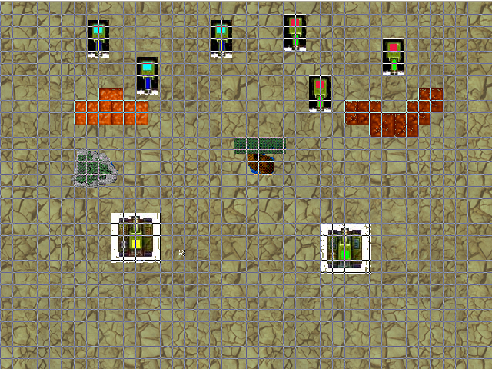
Tank1
Tank2
grass
rocksgrass
wall1
wall2

- Following the steps in the handout given and the steps below in the table, create a new game in J: DRIVE under Assessment , Mr Krozian and your class and Log in name.
- You can use any spare time you have to work on your project. You can also add any new sprites you like.
- However, the final marks will be given based on your work after 2 weeks and the marking rules in the table below.
- GOOD LUCK

 | Skill | Description | Resource | Marks
1 | Add sprite | Add available sprites to the game | p 173 | 5
2 | Add object | Add objects from the sprites | p 173 | 5
3 | Add Room | Add room to play the game | p 173 | 5
4 | Add background | Add background to room | p 173 | 5
5 | Configure background | Make background move to give illusion of motion | p 173 | 5
6 | Allow objects to fall off edge of room and reappear at the top randomly | Give illusion of new objects in random positions at top of screen | P 173 | 5
7 | Use of a parent object to save time | Use parent object to save recreating events and actions. | P 174 | 5
8 | Move objects left, right, up , down with keypress events | Use up, down, right, down for first and W, S , A, D for second object | P 175 – 176 | 10
9 | Destroy object once outside room | Bullets, shells to be destroyed if outside room | P 176 | 5
10 | Fire a missile or shell at reasonable frequency | Fire bullets or shells at reasonable regularity | P 177 | 10
11 | Cause explosion when missile or shell collides with target | Cause explosion on collision, then destroy explosion graphic | P 178 | 10
12 | Create damage control to allow many hits before an object is destroyed | Allow the game to keep running even if an object is hit | P 179 | 10
13 | Create graphical damage panel | Show progress of damage on the panel for both objects | P 180 | 15
14 | Add time lines | Show waves of attacking enemy tanks as a time line event | P 180 – 182 | 10
15 | Add enemies from left and right directions | Show attack from enemies from left and right directions and add to time lines | P 184 – 186 | 10
16 | Add enemy objects that can shoot | Allow enemy to shoot | P 184 – 186 | 10
17 | Add background music to the game | Allow music to play during the game | P 188 | 5
18 | Add walls or trees your tank cannot go through | Allow for obstruction in the room | Tutorial 1 | 10
19 | Allow for a loading image and game icon | Allow for an image and icon when starting the game | P 188 | 5
20 | Multiple waves on enemies to attack | Allow for multiple waves of enemy attack | P 183 | 5
 | TOTAL MARKS |  |  | 150

