VCE Units 3 and 4 Information Technology Applications

OBJECTIVE OF ITA COURSE Ms Diane Peat – dpeat@firbank.vic.edu.au
VCE Units 3-4 IT follows the new 2007 VCAA curriculum for VCE Unit 3-4 IT Applications. IT Applications is a good generalist introduction for students who are keen to understand more about computing but who do not necessarily want to make it a career.
Unit 3 focuses on how individuals and organisations use ICT in their daily lives and businesses. It also considers the ways in which data is processed into information using web authoring and database management software. A problem solving methodology is used to produce solutions that assist in decision-making. The unit also explores how a networked information system can be used to support teams of workers engaged in problem solving or sharing knowledge. Project management strategies are developed to coordinate the creation of solutions and information products.
Unit 4 looks at how organisations use ICT to solve ongoing information problems, including the knowledge and skills required to create solutions and information products using spreadsheet software. Problem solving and decision-making strategies are used (ADDTDIE) for the solution. The storage, communication and disposal of data and information by organisations is explored. Steps to minimise security threats to data and information are also investigated.
The attached course outline is the ‘ideal scenario’ for completing the year’s work. However, emergencies and hiccups occur and these dates are very ‘fluid’. If you work through one topic more quickly than expected, you will have more time for revision at the end of each semester.
I hope you are inspired, develop new skills, work hard, have fun and learn lots!

Requirements for semester
- Textbook: IT applications: VCE Information Technology Units 3 &4, Second edition
Colin Potts (Series Editor), 2007 Nelson Australia Pty Ltd
- Two CDs to backup student work
- USB (minimum 256 Mb) stick for easy transportation of photos, websites, etc

Recommended additional resources
- ITA Checkpoints (available later this year)
- Old textbooks for additional explanations of certain topics
- Heinemann CDs – Units 1/2 and Units 3/4 – on Firbank CD Drive – for information
- McKinnon Secondary College website http://www.mckinnonsc.vic.edu.au/la/it/ipmnotes/exam/2006exam/index.htm and
http://www.mckinnonsc.vic.edu.au/la/it/ipmnotes/index.htm great resource for everything!
- Wikipedia (used cautiously) http://www.wikipedia.org/ for definitions and explanations
- How stuff works http://www.howstuffworks.com/ for explanations
- VCAA website http://www.vcaa.vic.edu.au/vet/programs/Infotech/infotech.html for previous exams

Hardware / Software requirements
- Computers, digital cameras, scanners, IWBs, digital projectors
- Macromedia Dreamweaver web authoring software
- Macromedia Flash animation software
- Microsoft Word (word processing), Access (database), Excel (spreadsheet) and PowerPoint (presentation) software
- Photoshop image editing application

Summary of assessment tasks

Unit 3 Outcome 1: Term 1, Weeks 8 and 9
Students are to identify a problem and propose a
solution that uses database management software to
create an information product. Project management
principles are to be used in managing tasks and
timelines. A problem-solving methodology is to be used to
produce the solution. Techniques and procedures are to
be used to efficiently process data and manage the
production and handling of data and information.
Students are also to develop criteria for evaluating
their solutions. 40 / 10 marks

Software: MS Access database software

Unit 3 Outcome 2: Term 2, Weeks 6 to 8
The focus of this outcome is on how a prototype website
can be used to meet an organisations’ needs of sharing
knowledge and collaborative problem solving within a
virtual team environment. This will require students to
design, create and evaluate a website. An overview of
the types, capabilities and characteristics of networks
will be used to show how a networked information
system can support the use of the website. 30 / 20 marks

Software: Macromedia Dreamweaver

Unit 4 Outcome 1: Term 3, Weeks 4 to 6
Students are to use spreadsheet software to produce a
solution to an information product that can be reused in
the future with new sets of data. A problem-solving
methodology must be used that takes into account the
information needs of the organisation. The effectiveness
of the decisions made and actions taken during the
problem-solving steps are to be evaluated. 35 / 15 / 10 marks
Software: Microsoft Excel, Inspiration

Unit 4 Outcome 2: Term 4, Week 2
The focus of this outcome is the legal and ethical reasons
why organisations need to monitor and control the storage,
communication and disposal of information. Procedures and
equipment required to prevent unauthorised access or
accidental actions that threaten the security of data are
to be described. Criteria that can be used to evaluate the
effectiveness of data security management strategies are
to be recorded. 40 marks
Class test (closed book)

The combined marks from all four outcomes make up 50% of the marks available for this subject.
The remaining 50% of marks is derived from the final ITA Exam, to be held on Tuesday, 13 November 2007 from 3:00 to 5:15 pm.

TEXTBOOK CHAPTER SUMMARIES – ongoing tasks
You will be required to complete a written summary of each of the eight chapters in the textbook. When you complete the summary of each chapter, you need to upload it to the Moodle Unit 3/4 ITA area – you may revise and resubmit as often as you wish. Summaries are to be uploaded at the end of each chapter as chap??_summary_your-initials.doc.
At the end of each chapter you need to review the “What you should know” section for new terms you have not encountered before. Keep an ongoing glossary of any terms that you do not know throughout the year and save as ita_glossary.doc.
PLEASE NOTE: ONLY your ITA Glossary and your Chapter Summaries may be taken into SAC tasks – these will be checked to ensure they are your own work. Only your own notes may be used.

CLASS RULES
These rules are developed to enable all students to work in a friendly, safe and secure environment. Failure to adhere to these rules may incur a Friday afternoon detention.
- Chapter pages listed for reading and related activities listed are to be completed before each class. There is insufficient time during class to read entire chapters so it is essential for you to read these in your own time and to come to class prepared to review and discuss the content of each chapter and your answers to the questions set.
- Please check your Firbank email account daily - I communicate a great deal via email and I will not accept the excuse that you did not know you had to complete something because you didn’t check your email.
- Everyone’s input is important so everyone must be given the chance to explain their ideas, give suggestions or ask questions without interruption. Different people may express creativity in a variety of ways and all students must respect this.
- Being more than five minutes late without a note of explanation.
- Internet or Email use during class is NOT permitted unless it is a required part of the class work currently being undertaken.
- Playing computer games in class time is NEVER permitted.
- If you use headphones, be careful with them and put them back in their correct position before you leave.
- Log off, put your chairs back neatly and take any mess with you when you leave the room.

ASKING FOR HELP and GIVING HELP TO OTHERS
- Before asking for the teachers’ assistance, you should seek help from at least two other sources (eg. software online help, tutorials, fellow students, books, internet, emails, etc) before asking the teacher.
- If, after trying two sources, you still require help, put your hand up and wait. Please do not call out - you are probably not the only person in the room needing assistance!
- If you are giving help to another student, make sure it is in such a way that they learn. Don’t just do it for them. Guide them so that they understand and learn from you and then let them do it themselves.

SEMESTER OUTLINE (Otherwise known as “We live in hope”)
PLEASE NOTE: If you are absent for any reason, you are still expected to complete all reading, and tasks listed in this outline, together with any other work distributed in class.

Textbook: IT applications: VCE Information Technology Units 3 &4, Second edition
Colin Potts (Series Editor), 2007 Nelson Australia Pty Ltd

TERM 1 – WEEK 1 31 Jan to 02 Feb
Outline and requirements of Unit 3 ITA
Explanation of School Assessed Coursework – Outcome tasks:
- 50% of subject marks come from outcome tasks and 50% of marks from final exam
Moodle site orientation – all work to be uploaded to ITA area of Moodle

UNIT 3 - Topics to be covered:
Introduction to Unit 3 – collaborative problem solving in organisations

Prepare for T1 Week 2:
- Complete any exercises distributed in class.
- Read Chapter 1 of textbook – pages 2 to 18.
- Complete Glossary and Chapter Summary (see note on page 3).
- Complete “Think about IT” questions 1-10 and 1-11 on page 14. Save your answers as chap1_think__your-initials.doc.
- Select any seven questions from “Test your Knowledge” on page 34; save your answers as chap1_test_your-initials.doc.

WEEK 2 05 to 09 Feb
Topics to be covered:
Problem solving in organisations (Cont)

Chapter 1 – Problem Solving: pages 2 to 18:
What is an information system? (p 3)
Elements of an information system (p 4)
Characteristics of data and information (p 7)
Information processing steps (p 11)
Information characteristics in organisations (p 16)

Prepare for T1 Week 3:
- Complete Access exercises distributed in class (saved as prac1, prac2, etc).
- Read Chapter 1 of textbook – pages 18 to 31.
- Complete Glossary and Chapter Summary (see note on page 3).
- Complete “Think about IT” questions 1-12 on page 20 and 1-13 on page 21. REsave as chap1_think__your-initials.doc and upload to Moodle.
- Select five more questions from “Test your Knowledge” on pages 34 or 35; REsave your answers as chap1_test_your-initials.doc and upload to Moodle.

WEEK 3 12 to 16 Feb
Topics to be covered:
Introduction to database management software – MS Access 2000:
Access database exercises (available from Moodle) to be saved as access_prac1_your-initials.mdb and uploaded to the Moodle Unit 3/4 ITA area.

Chapter 1 (Cont): pages 18 to 31
Decision making in organisations (p 18)
Identifying information problems (p 20)
The problem solving methodology – Analyse, Design (p 21)

Prepare for T1 Week 4:
- Complete Access exercises distributed in class.
- Read Chapter 2 of textbook – pages 38 to 59
- Complete Glossary and Chapter Summary (see note on page 3).
- Complete “Think about IT” questions 2-1 on page 41, 2-4 and 2-5 on page 45. Save your answers as chap2_think__your-initials.doc.
- Answer the five Problem-solving methodology questions from “Test your Knowledge” on page 74; save your answers as chap2_test_your-initials.doc.
- Complete the “Apply your knowledge” questions on page 36. Save and upload your answers as chap2_apply_your-initials.doc.

WEEK 4 19 to 23 Feb
Topics to be covered:
Database exercises – tables, queries, forms, reports

Chapter 2 – Developing a solution using database software: pages 38 to 59
Developing a solution using database software (p 38)
Procedures to effectively manage the production and handling of data and information (p 50)

Prepare for T1 Week 5:
- Complete Access exercises distributed in class.
- Read Chapter 2 of textbook – pages 60 to 71.
- Complete Glossary and Chapter Summary (see note on page 3).
- Complete “Think about IT” question 2-8 on page 70. REsave your answer as chap2_think__your-initials.doc and upload to Moodle.
- Answer five new questions from “Test your Knowledge” on page 74 and 75; REsave your answers as chap2_test_your-initials.doc and upload to Moodle.

Source:
http://www.generalcomics.com/funny-computer-jokes-cartoons-cartoon-pics/2.php

WEEK 5 26 to 02 Mar
Topics to be covered:
Database exercises – tables, queries, forms, reports

Chapter 2 (Cont): pages 60 to 71
Testing the solution and output (p 60)
Documentation to support solutions (p 66)
Implementation strategies (68)
Criteria for evaluation (p 70)

Prepare for T1 Week 6:
- Complete Access exercises distributed in class.
- Revise Chapters 1 and 2.
- Complete the “Apply your knowledge” questions on page 75. Save and upload as chap2_apply_your-initials.doc.
- Read the Preparing for Unit 3 Outcome 1 notes on pages 76 and 77.

WEEK 6 05 to 08 Mar
Preparation for Unit 3 Outcome 1 –
Practice SAC using MS Access database software and creating a project management report.

Prepare for T1 Week 7:
- Revise all database knowledge.
- Revise Chapters 1 and 2, ensuring Glossary and Chapter Summaries are uploaded to Moodle.
- Make sure you have completed the required “Test your knowledge” and “Apply your knowledge” questions are up to date.

WEEK 7 13 to 16 Mar
Preparation for Unit 3 Outcome 1 –
Practice SAC using MS Access database software and creating a project management report.

Prepare for T1 Week 8:
- Revise all database knowledge.
- Ensure ITA Glossary and Chapter Summaries are up to date (these are the only notes you may bring to the Outcome task). To be used, they must be uploaded to Moodle.

WEEK 8 19 to 23 Mar

Unit 3 Outcome 1 – 6 x 1 hour lessons: 40/10 = 50 marks
Propose and apply project management and problem-solving strategies to produce a solution and an information product, using database management software, which meets the decision-making needs of a specific audience.

WEEK 9 26 to 30 Mar

Unit 3 Outcome 1 (Cont)

TERM HOLIDAYS 06 to 16 April
    - Read and summarise Chapter 3, pages 78-94.
    - Update your IT Glossary.
    - Complete Think about IT question 3-4 on page 84, 3-5 on page 85 and 3-8 on page 94.
    - Answer five questions from the left column of “Test your knowledge” on page 116. Save your answers as chap3_test_your-initials.doc.

(Oh … and if you’re going away, I hope it’s somewhere with an Internet café a bit more modern than this one. Have a rest too!!)


Source: http://www.generalcomics.com/funny-computer-jokes-cartoons-cartoon-pics/25.php

TERM 2 – WEEK 1 17 to 20 Apr

Topics to be covered:
Review of Unit 3 Outcome 1 SAC task

ClickView video “Networks” – what a network consists of: central processors, network procedures and architecture in a case study of a modern computer network (2005, 28 minutes).

Chapter 3 – Networked information systems: pages 79 to 94
Types of information systems (p 79)
Networks (p 81)
Types of networks (p 86)

Prepare for T2 Week 2:
- Read Chapter 3 of textbook – pages 94 to 112.
- Complete Glossary and Chapter Summary (see note on page 3).
- Answer ten more questions from “Test your Knowledge” questions on pages 116 and 117. Save your answers as chap3_test_your-initials.doc. REsave your answers as chap3_test_your-initials.doc and upload to Moodle.
- Complete four of the “Apply your knowledge” questions on page 118. Save and upload as chap3_apply_your-initials.doc.

WEEK 2 23 to 27 Apr
Topics to be covered:

ClickView video “Network Security” – examines human and environmental threats to computer network security and measures that should be implemented to protect an organisation’s network (2002, 27 minutes).

Chapter 3 (Cont): pages 94 to 112
Network communication standards (p 94)
Network hardware and software (p 98)
Transmission media (p 104)
Network security (p 108)
The logical design of a network (p 110)
Physical design of networks (p 110)

Prepare for T2 Week 3:
- Read and summarise Chapter 4 – pages 120 to 134.
- Update your IT Glossary as required.
- Complete “Think about IT” questions 4-1 and 4-2 on page 120, 4-7 on page 126 and 4-10 on page 131. Save your answers as chap4_think_your-initials.doc.
- Answer five questions from the left panel of “Test your knowledge” on page 143. Save your answers as chap4_test_your-initials.doc.

WEEK 3 30 Apr to 04 May
Topics to be covered:
Introduction to Dreamweaver web authoring software

ClickView video “Website Design” – investigates the various elements used to design effective websites (2004, 25 minutes).

Chapter 4 – Using networks: pages 120 to 134
Characteristics of collaborative problem-solving practices (p 120)
Problem-solving methodology (p 123)
Analysis of the problem (p 123)
Design the solution (p 125)

Prepare for T2 Week 4:
- Read and summarise Chapter 4 – pages 134 to 141.
- Update your IT Glossary as required.
- Complete “Think about IT” questions 4-13 on page 134 and 4-14 on page 138. REsave your answers as chap4_think_your-initials.doc and upload to Moodle.
- Answer five questions from the right panel of “Test your knowledge” on page 143. REsave your answers as chap4_test_your-initials.doc and upload to Moodle.

WEEK 4 07 to 11 May
Topics to be covered:
Dreamweaver exercises
“Apply your knowledge” pages 144 to 145

Chapter 4 – (Cont): pages 134 to 141
Manipulating information to create a prototype website (p 134)
Testing a solution (p 136)
Evaluating the effectiveness of websites (p 137)
Managing and transmitting files (p 138)

Prepare for T2 Week 5:
- Complete Dreamweaver exercises distributed in class.
- Revise Chapters 3 and 4.
- Complete the “Apply your knowledge” questions on page 144 to 145. Save and upload as chap4_apply_your-initials.doc.
- Read the Preparing for Unit 3 Outcome 2 notes on pages 146 to 148.

WEEK 5 14 to 18 May
Preparation for Unit 3 Outcome 2 –
Practice SAC using Macromedia Dreamweaver software and written evaluation report.

Prepare for T2 Week 6:
- Revise all database knowledge.
- Revise all chapters, ensuring Glossary and Chapter Summaries are uploaded to Moodle.
- Make sure you have completed the required “Test your knowledge” and “Apply your knowledge” questions to date.

WEEK 6 21 to 25 May

Unit 3 Outcome 2 – 9 x 1 hour lessons: 30/20 = 50 marks
Design, create and evaluate a prototype website that meets an organisation’s needs of sharing knowledge and collaborative problem-solving within a virtual team environment.

WEEK 7 28 May to 01 Jun
Unit 3 Outcome 2 (Cont)

WEEK 8 04 to 08 Jun
Unit 3 Outcome 2 (Cont)

Prepare for T2 Week 9:
- Read and summarise Chapter 5 – pages 151 to 159.
- Update your IT Glossary as required.
- Complete “Think about IT” question 4-1 on page 151. Save your answer as chap4_think_your-initials.doc.
- Answer five questions from the left panel of “Test your knowledge” on page 172. Save your answers as chap5_test_your-initials.doc.

WEEK 9 12 to 15 Jun

UNIT 4 - Topics to be covered:
Review of Unit 3 Outcome 2 SAC task
Introduction to Excel spreadsheet software

Chapter 5 – Organisations and information needs: pages 151 to 159
Goals of information systems (p 151)
Role of hardware and software components of information systems (p 154)
Spreadsheet software (p 154)

Prepare for T2 Week 10:
- Read and summarise Chapter 5 – pages 160 to 170.
- Update your IT Glossary as required.
- Answer five questions from the right panel of “Test your knowledge” on page 172. REsave your answers as chap5_test_your-initials.doc.
- Complete your choice of two of the “Apply your knowledge” questions on page 173. Save and upload as chap5_apply_your-initials.doc.

WEEK 10 19 to 22 Jun
Topics to be covered:
Excel spreadsheet exercises

Chapter 5 (Cont) pages 160 to 170
Problem-solving (p 160)
Why information problems occur (p 161)
Creating an information product using a spreadsheet (p 162)

Prepare for T3 Week 1:
- Read and summarise Chapter 6 – pages 175 to 184.
- Update your IT Glossary as required.
- Answer Think about IT question 6-1 on page 175 and 6-3 on page 179.
- Answer five questions from the left panel of “Test your knowledge” on page 198. Save your answers as chap6_test_your-initials.doc.

SEMESTER HOLIDAYS 23 Jun to 16 Jul

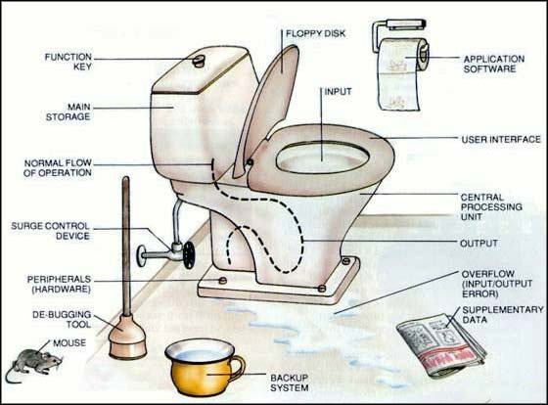
Source:
http://www.generalcomics.com/funny-computer-jokes-cartoons-cartoon-pics/1.php

TERM 3 – WEEK 1 17to 20 Jul
Topics to be covered:
Design elements
Visual representations of decisions

Chapter 6 – Supporting information products and reviewing decisions: pages 175 to 184
On-screen user documentation (p 175)
Elements of design for ons-screen information (p 180)

Prepare for T3 Week 2:
- Read and summarise Chapter 6 – pages 184 to 195.
- Update your IT Glossary as required.
- Complete Think about IT question 6-6 on page 188 and 6-7 on page 195.
- Answer five questions from the right panel of “Test your knowledge” on page 198 or any on page 199. REsave your answers as chap6_test_your-initials.doc.

WEEK 2 23 to 27 Jul
Topics to be covered:
Excel exercises
On-screen user documentation
Visual representations of decisions and actions

Chapter 6 (Cont): pages 184 to 195
Characteristics of on-screen information products (p 184)
Visually representing decisions and actions (p 188)
Evaluating the effectiveness of decisions and actions (p 192)

Prepare for T3 Week 3:
- Complete all exercises distributed in class.
- Revise Chapters 5 and 6.
- Complete the “Apply your knowledge” questions on page 200. Save and upload as chap6_apply_your-initials.doc.
- Read the Preparing for Unit 4 Outcome 1 notes on pages 201 to 202.

WEEK 3 30 Jul to 03 Aug
Preparation for Unit 4 Outcome 1 –
Practice SAC using Microsoft Excel software, onscreen user documentation and a visual presentation.

Prepare for T3 Week 4:
- Revise all spreadsheet knowledge.
- Revise all chapters, ensuring Glossary and Chapter Summaries are uploaded to Moodle.
- Make sure you have completed the required “Test your knowledge” and “Apply your knowledge” questions to date.

WEEK 4 06 to 10 Aug

Unit 4 Outcome 1 – 10 x 1 hour lessons: 35/15/10 = 60 marks
Use spreadsheet software to solve an ongoing information problem, taking into account the information needs of an organisation.

WEEK 5 13 to 17 Aug
Unit 4 Outcome 1 (Cont)

WEEK 6 20 to 24 Aug
Unit 4 Outcome 1 (Cont)

Prepare for T3 Week 7:
- Read Chapter 7 – pages 204 to 212.
- Update your IT Glossary as required.
- Complete “Think about IT” question 7-1 on page 204, 7-2 on page 207 and 7-4 on page 211. Save your answer as chap7_think_your-initials.doc.
- Answer five questions from the left panel of “Test your knowledge” on page 228. Save your answers as chap7_test_your-initials.doc.

WEEK 7 27 to 31 Aug
Topics to be covered:
Review of Unit 4 Outcome 1 SAC task
Legal requirements, ethics and security

Chapter 7 – Storage, communication and disposal of data and information: pages 204 to 212
Organisational goals and information systems (p 204)
Legal obligations of organisations and individuals (p 205)

Prepare for T3 Week 8:
- Read Chapter 7 – pages 213 to 226.
- Update your IT Glossary as required.
- Complete “Think about IT” question 7-5 on page 214, and 7-6 on page 217. REsave your answer as chap7_think_your-initials.doc and upload to Moodle.
- Answer five questions from the right panel of “Test your knowledge” on page 228. REsave your answers as chap7_test_your-initials.doc and upload to Moodle.
- Complete any five of the Apply your knowledge questions on page 229. Save and upload as chap7_apply_your-initials.doc.
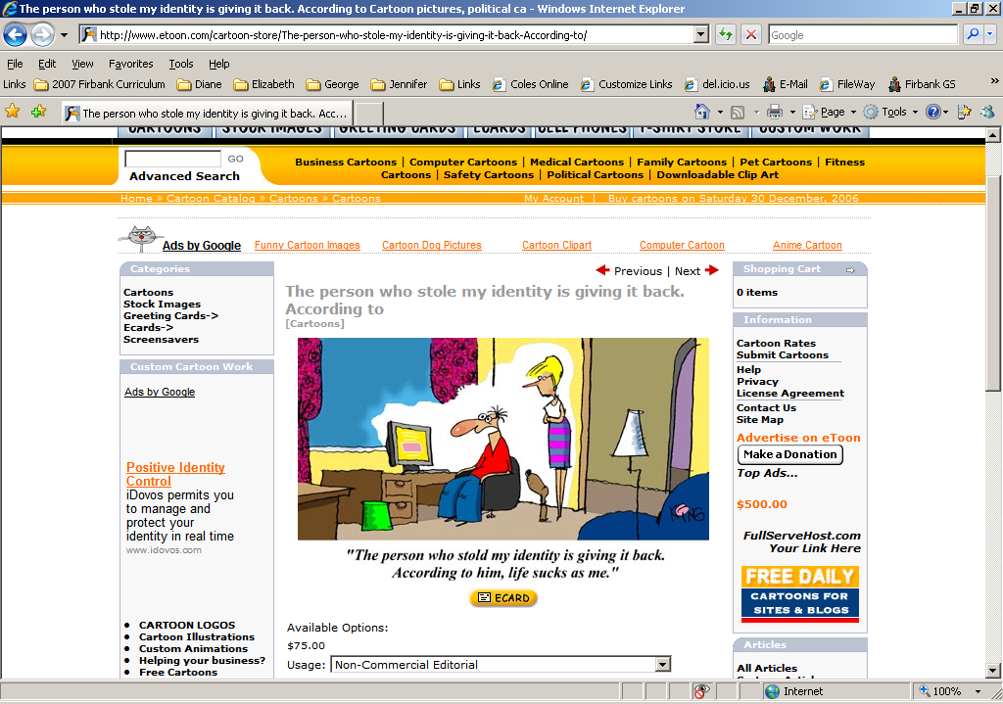
The person who stole my identity is giving it back. According to him, life sucks as me.

Source: http://www.etoon.com/cartoon-store/

WEEK 8 27 to 31 Aug
Topics to be covered:
ClickView video “Inside Story: Social and Ethical Issues in IT” – focuses on power and privacy, control and security, trust and accuracy. (2003, 31 minutes).

Chapter 7 (Cont): pages 213 to 226
Ethics and information systems (p 213)
Threats to data and information (p 218)
Consequences of violating security and privacy measures (p 225)

Prepare for T3 Week 9:
- Read Chapter 8 – pages 231 to 243.
- Update your IT Glossary as required.
- Complete “Think about IT” question 8-1 on page 231, 8-2 on page 232 and 8-3 on page 233. Save your answer as chap8_think_your-initials.doc.
- Answer five questions from the left panel of “Test your knowledge” on page 256. Save your answers as chap8_test_your-initials.doc.

WEEK 9 10 to 14 Sep
Topics to be covered:
Implementation of security
ClickView video “Keeping IT secret: Privacy and Security in IT Networks” – looks at the issue of electronic security in relation to medical databases and online shopping. (2001, 17 minutes).

Chapter 8 – Security measures: pages 231 to 243
Security equipment (p 231)

Prepare for T3 Week 10:
- Read Chapter 8 – pages 243 to 252.
- Update your IT Glossary as required.
- Complete “Think about IT” question 8-12 on page 251 and 8-13 on page 252. REsave your answer as chap8_think_your-initials.doc and upload to Moodle.
- Answer five questions from the right panel of “Test your knowledge” on page 256. REsave your answers as chap8_test_your-initials.doc and upload to Moodle.
- Complete all of the Apply your knowledge questions on page 257. Save and upload to Moodle as chap8_apply_your-initials.doc.

WEEK 10 17 to 21 Sep
Topics to be covered:
Security of data and equipment

Chapter 8 (Cont): pages 243 to 252
Security procedures (p 243)
Disaster recovery strategies (p 249)
Evaluating the effectiveness of data security measures (p 250)
Evaluating the effectiveness of data security management strategies (p 252)

TERM HOLIDAYS 22 Sep to 08 Oct

REVISE, REVISE, REVISE plus
LOTS of practice exams to complete
But look on the bright side – it’s nearly over


Source:
http://www.generalcomics.com/funny-computer-jokes-cartoons-cartoon-pics/10.php

TERM 4 – WEEK 1 09 to 12 Oct
Preparation for Unit 4 Outcome 2 –
Practice SAC – Handwritten class test

Prepare for T4 Week 2:
- Revise Chapters 7 and 8, ensuring Glossary and Chapter Summaries are uploaded to Moodle.
- Make sure you have completed the required “Test your knowledge” and “Apply your knowledge” questions to date.
- Read the Preparing for Unit 4 Outcome 2 notes on pages 258 to 259.

WEEK 2 15 to 19 Oct

Unit 4 Outcome 2 – 2 x 1 hour lessons: 40 marks
Evaluate the effectiveness of the strategies used by an organisation to manage the storage, communication and disposal of data and information, and recommend improvements.

WEEK 3 22 to 26 Oct
Review of Unit 4 Outcome 2 SAC task

Exam preparation

WEEK 4 29 Oct to 02 Nov

Exam preparation

WEEK 5 07 to 09 Nov

Exam preparation

WEEK 6

Tuesday 13 November – 3:00 to 5:15 pm – Firbank Exam Centre
2007 VCE Units 3 and 4 Information Technology Applications Exam

Ms Diane Peat dpeat@firbank.vic.edu.au
Computer Centre Telephone 9591 5119 (direct)

(Thanks to Keith Richardson, Head of ICT, Leibler Yavneh College,
Elsternwick for his assistance and advice.)

