To contact Sunsonline phone Jason on 0433893235

Lexmark T622 Network Laser Printer (Qty: 30)
No minim purchase amount required
Feature:
Speed: 40ppm
Condition: Tested and in Good Condition
Connection: Network (10/100 Ethernet Card installed) & USB Port
Paper Tray: Option1: 2 *500 paper trays
Option 2: 1* 500 paper tray + 1* 2000 sheet paper tray
Option 3: 2 * 500 sheet paper trays + 1* 2000 Paper tray

Toner: Yes, Included

Power Cord: Yes

Lexmark T622 is low ongoing cost laser printer and is widely used in corporation, banks and universities.
Price: $220 for Option 1 & 2
$250 for option 3

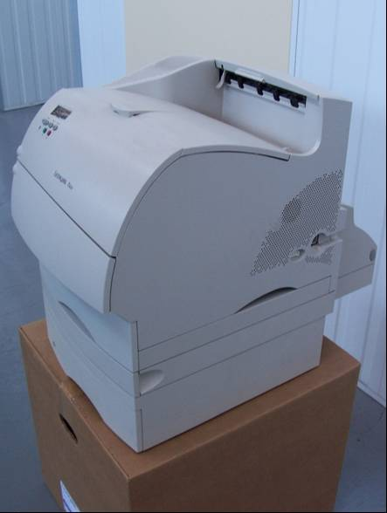
Option 1

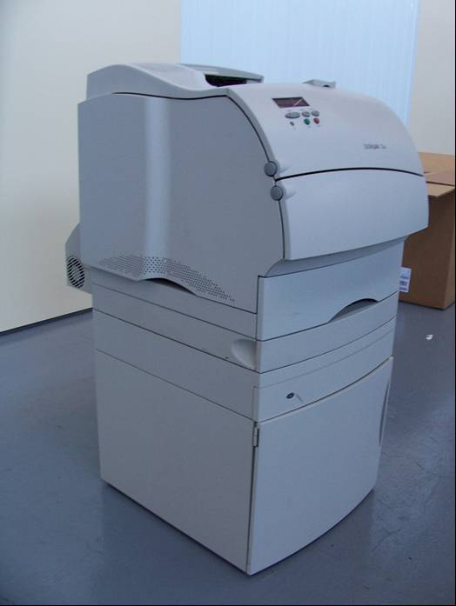 Option 2 with 2000 sheet paper tray

