NAME: .............................……… MARK: ........../60

There are two sections. Section A consists of 30 multiple-choice questions.
Section B consists of 9 short-answer questions.

SECTION A. For this section choose the BEST answer from those provided.
Indicate your answer by writing the letter corresponding to your choice on the dotted line.

1. An information system is best described as
A. something used to compile school sports results B. a wordprocessor and database
C. a set of related parts designed to process information D. a computerised database
…………
2. An information system consists of
A. people
B. procedures
C. equipment
D. all of the above
…………
3. The difference between data and information is that
A. data is usually quite disorganized whilst information is arranged or structured
B. computers only work with data not information
C. data is more useful than information
D. data can be processed by a computer, information can't
…………
4. Which of the following describes the correct sequence of phases of information processing
A. gathering, output, input, retrieval, validation, processing, storage, communication, disposal
B. input, storage, gathering, processing, retrieval, output, communication, disposal, validation
C .gathering, input, validation, storage, processing, retrieval, output, communication, disposal
D. gathering, input, retrieval, validation, processing, storage, communication, output, disposal
…………
5. A technology used to prevent unauthorized access to important data and secure communication between
computers by using codes is called
A. encryption B. encapsulation
C. a firewall D. copyrighting
…………
6. Hardware and software that only allows certain users to access a network is called
A. encryption B. encapsulation
C. a firewall D. copyrighting
…………
7. A study of the relationship between people and their working environment is called
A. encryption B. encapsulation
C. electronics D. ergonomics
…………
8. Working from home by using a computer and electronic communication technology is called
A. telecommuting B. Telstra
C. telecom D. the Internet
…………
9. A multi-tasking operating system
A. does different jobs for different users at the same time
B. is only used on personal computers
C. requires many users for it to operate properly
D. all of the above
…………

10. A check digit
A. prevents a computer accepting wrong numbers
B. is calculated from the other digits making up the number
C. is part of all bar codes
D. all of the above
…………
11. Which of the following is an ergonomic consideration
A. screen glare
B. room lighting
C. keyboard design
D. all of the above
…………
12. Which piece of software would a company use to keep track of customers
A. a graphics package B. a database
C. a spreadsheet D. electronic mail
…………
13. FrontPage is an example of
A. a spreadsheet program B. a web page authoring program
C. a database program D. a multimedia authoring program
…………
14. HTML is an acronym for
A. Hypertext Total Make-up Language B. Hypertext Mark-up Language
C. Hypertext Manipulation Language D. Home to Mum Late
…………
15. Which of the following pieces of equipment is the 'odd' one out
A. printer B. voice output
C. VDU D. scanner
…………
16. Which of the following pieces of equipment is the 'odd' one out
A. computer disk B. CD-ROM
C. keyboard D. magnetic tape
…………
17. If the capacity of storage devices is listed from least to greatest, the order would be
A. DVD, floppy disk, CD-ROM B. DVD, CD-ROM, floppy disk,
C. floppy disk, CD-ROM, DVD D. floppy disk, DVD, CD-ROM
…………
18. A set of data-handling rules that allow peripherals to work correctly are known as
A. protocols B. SCSI
C. USB D. LANs
…………
19. TCP/IP
A. is a protocol used for the transmission of data over the Internet
B. is a web browser
C. stands for total control protocol/internet protocol
D. is all of the above
…………
20. Plug-ins
A. are additional programs a browser might use
B. can be downloaded from a number of sites on the Web
C. allow multimedia applications to be played
D. all of the above
…………

21. The domain abbreviation .edu is used by
A. charitable organizations B. schools and universities
C. Australian government D. businesses
…………
22. A computer that is used as the centre of a network is called a
A. server B. supercomputer
C. workstation D. palmtop computer
…………
23. The Internet is
A. The Web B. A global collection of computer networks
C. File transfer and email D. Explorer and Netscape Navigator
…………
24. FTP stands for
A. File transfer programs B. File transfer protocol
C. Firewall transfer program D. Firewall transfer protocol
…………
25. One Gigabyte is
A. 1 000 000 000 bytes B. 1 000 bytes
C. 1 000 000 bytes D. 100 000 bytes
…………
26. The most common form of transmission media used in schools is
A. coaxial cable B. fibre-optic cable
C. CAT 5 cable D. microwave
…………
27. CAT 5 (Fast Ethernet) typically transfers data at a rate of
A. 1 Mbps B. 100 Mbps
C. 4 Mbps D. 56 Kbps
…………
28. A network that consists of a single central cable to which all devices are connected is a
A. star network B. a ring network
C. a bus network D. a mesh network
…………
29. A device that enables a packet of data to reach its destination faster is a
A. a switch B. a hub
C. a bridge D. a firewall
…………
30. Which of the following is not a network operating system
H
A. Unix B. Windows Me
C. Windows NT D. DOS
…………

END OF SECTION A

SECTION B 9 questions. Total 30 marks

Question 1
List a software tool (program) you have used this year and describe how a function of the software, other than copy and paste, allowed you to produce information efficiently.

Software tool:

Description:

3 marks

Question 2
Give two reasons why the size of file attachments sent by email should be limited.
Reason 1:

Reason 2:

2 marks

Question 3

Refer to the following diagram to answer the question that appears below it.

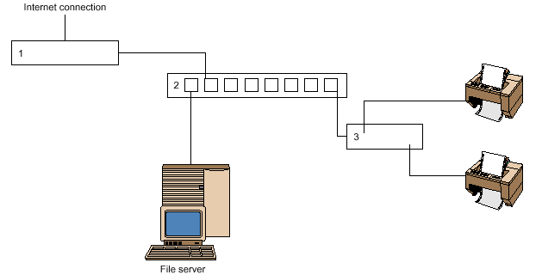

a. Indicate the correct answer by circling the appropriate letter. In the network diagram shown above, the numbered components (1, 2 and 3) are
A. modem, hub and printer.
B. firewall, hub and print server.
C. firewall, network and print server.
D. modem, network and printer.
1 mark
b. Describe the purpose of the empty connections on component 2.

1 mark
Question 4
Explain what test data is and why it is essential to create test data to enter into a database or spreadsheet solution.

3 marks

Question 5
Funky Mobile Phones is developing its own web site. Shown below is their homepage which is being tested with staff. The developer has received several negative comments from staff about the appropriateness of the conventions used.

Colours: All text will be blue and the background of each page will be red.

Recommend how a web designer could correct any four generally accepted web conventions not followed by Funky Mobile Phones.

Recommendation 1.

Recommendation 2

Recommendation 3

Recommendation 4

4 marks

Question 6
Valley View Secondary College has recently upgraded their information system. The new system has the potential to allow students, parents and staff to access the school network from home.
The Student Representative Council has requested that the new system allow students and parents to
access school files, assignments and homework outside school hours. Discuss this proposal (ie. advantages/disadvantages) for each user group identified.

Students:

Parents

4 marks
Question 7
Select either a hand-held scanner or a digital camera and describe one capability and one limitation of this component in producing electronic output.

hardware component:

capability:

limitation:

2 marks
Question 8
Susan uses her home-office computer to purchase books from an Internet company, Bookeze, in Canada. She enters her details and credit card number on line and the books arrive on her doorstep in Australia four days later. Susan tells friends she has a ‘cable connection’ to the Internet.

a. Outline two benefits of a cable connection.

Benefit 1:

Benefit 2:

Susan has been told she should upgrade from version 4 to the latest version of her browser.

- Explain one reason why she should consider upgrading.

Question 8 continued

- Explain one reason why Bookeze’s web developer designed their web pages at 800 by 600 pixels instead of 640 by 480 pixels.

e. Explain two risks if Susan uses her credit card for on line transactions.

Risk 1:

Risk 2:

6 marks

Question 9
Bendarit College is about to install a new multimedia laboratory of computers for student use. The computers
are connected to the server via a hub as shown in the diagram below.

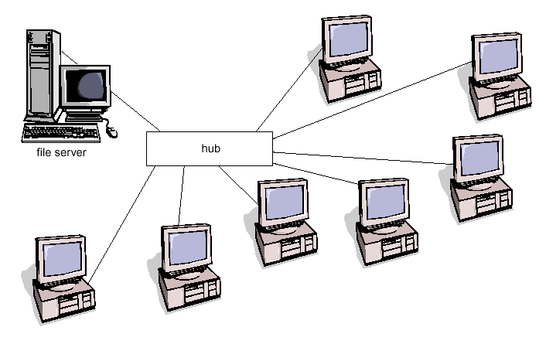
- What type of network topology is represented in the diagram?
1 mark
b. Identify one network operating system Bendarit could use.
1 mark
- What hardware component could be used in place of the hub, and what would be the advantage in using this component?

Component:

Advantage:

2 marks

END OF PAPER

