SECTION B 9 questions worth 30 marks

Question 1
List a software tool (program) you have used this year and describe how a function of the software, other than copy and paste, allowed you to produce information efficiently.

Software tool:

Description:

3 marks

Question 2
Give two reasons why the size of file attachments sent by email should be limited.
Reason 1:

Reason 2:

2 marks

Question 3

Refer to the following diagram to answer the question that appears below it.

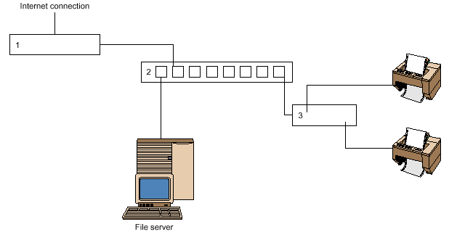

a. Indicate the correct answer by circling the appropriate letter. In the network diagram shown above, the numbered components (1, 2 and 3) are
A. modem, hub and printer.
B. firewall, hub and print server.
C. firewall, network and print server.
D. modem, network and printer.
1 mark
b. Describe the purpose of the empty connections on component 2.

1 mark
Question 4
Explain what test data is and why it is essential to create test data to enter into a database or spreadsheet solution.

3 marks

Question 5
Funky Mobile Phones is developing its own web site. Shown below is their homepage which is being tested with staff. The developer has received several negative comments from staff about the appropriateness of the conventions used.
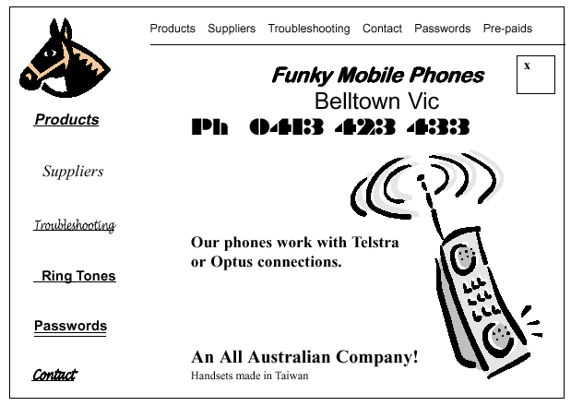
Colours: All text will be blue and the background of each page will be red.

Recommend how a web designer could correct any four generally accepted web conventions not followed by Funky Mobile Phones.

Recommendation 1.

Recommendation 2

Recommendation 3

Recommendation 4

4 marks

Question 6
Valley View Secondary College has recently upgraded their information system. The new system has the potential to allow students, parents and staff to access the school network from home.
The Student Representative Council has requested that the new system allow students and parents to
access school files, assignments and homework outside school hours. Discuss this proposal (ie. advantages/disadvantages) for each user group identified.

Students:

Parents

4 marks
Question 7
Select either a hand-held scanner or a digital camera and describe one capability and one limitation of this component in producing electronic output.

hardware component:

capability:

limitation:

2 marks
Question 8
Susan uses her home-office computer to purchase books from an Internet company, Bookeze, in Canada. She enters her details and credit card number on line and the books arrive on her doorstep in Australia four days later. Susan tells friends she has a ‘cable connection’ to the Internet.

a. Outline two benefits of a cable connection.

Benefit 1:

Benefit 2:

Question 8 continued
Susan has been told she should upgrade from version 4 to the latest version of her browser.

- Explain one reason why she should consider upgrading.

- Explain one reason why Bookeze’s web developer designed their web pages at 800 by 600 pixels instead of 640 by 480 pixels.

e. Explain two risks if Susan uses her credit card for on line transactions.

Risk 1:

Risk 2:

6 marks

Question 9
Bendarit College is about to install a new multimedia laboratory of computers for student use. The computers
are connected to the server via a hub as shown in the diagram below.

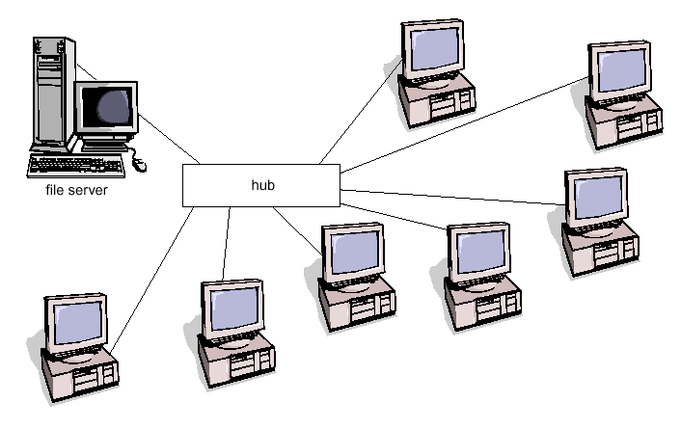

- What type of network topology is represented in the diagram?

1 mark
b. Identify one network operating system Bendarit could use.
1 mark

Question 9 continued
- What hardware component could be used in place of the hub, and what would be the advantage in using this component?

Component:

Advantage:

2 marks

END OF PAPER

