

The Geelong College

VCE INFORMATION TECHNOLOGY

Unit 2 Examination

Tuesday 8th November 2005 1:45 – 3:30 PM

Name: _________________________

Teacher: Mr. Hartley / Mr. Pike (circle one)

Reading Time: 15 minutes
Writing Time: 90 minutes

Instructions to students
- All questions should be attempted
- Answer all questions in the spaces provided. If the space is insufficient, you may continue your answer on a separate sheet of lined paper
- Use blue or black pen only
- Calculators may be used

SECTION A Multiple Choice: /20
SECTION B Short Answer Questions: /60
SECTION C Case Study Questions: /20
TOTAL: /100
Grade:

STUDENT NAME: ___________________________________

Multiple Choice Answer Sheet

Instructions to students:
Students should draw a single line within the box corresponding to the correct answer for each question. The line should be entirely within the box, and only ONE box per question should have a line through it.

Example:

Correct Incorrect

Question | A | B | C | D
Question 1
Question 2
Question 3
Question 4
Question 5
Question 6
Question 7
Question 8
Question 9
Question 10
Question 11
Question 12
Question 13
Question 14
Question 15
Question 16
Question 17
Question 18
Question 19
Question 20

If you make a mistake, put a cross through the incorrect answer and a single line through the correct answer.

SECTION A Multiple Choice 20 marks

Mark the letter of the most appropriate answer on the multiple choice answer sheet provided.

Q1 The most suitable device to connect 20 computers to a server would be a
- hub
- switch
- Firewall
- router

Q2 A Gantt chart is used in which of the following processes?
- Web page construction
- Spreadsheets
- Project Management
- All of the above

Q3 A combo drop down box used in a spreadsheet is a method of
- Data acquisition
- Data manipulation
- Data output
- Data validation

Q4 The appearance of ######### in a spreadsheet indicates
- The incorrect formula has been used
- The formula was too long
- The cell is incorrectly formatted
- The column needs to be widened

Q 5 The most common protocol used in modern networks is
- TCP/IP
- TCP
- Windows XP
- Ethernet

Q6 An ISP does which of the following
- Connect you to the internet
- Give you an email box
- Charge you for bytes used on the internet.
- All of the above

Q 7 Which of the following is not an example of back up media?
- Floppy disks.
- CDRW.
- Hard drives.
- RAM.
Q 8 Reliable information is most likely to be obtained when:

- The information is free of copyright restrictions.
- The information is current.
- The source of information is accurate and trustworthy.
- All of the above

Q9 An example of a workstation operating system is
a) Windows 2000
b) Novell
c) Windows NT
d) Microsoft Office 2003

Q 10 A classroom of 20 computers accessing a network through wireless, would be an example of what type of network topology
- bus
- star
- ring
- hybrid

Q 11 The evaluation of a website would be best described as
- checking to see that the links work
- checking to see that the pictures load quickly
- checking to see if the customers can navigate the site easily
- all of the above

Q 12 In the development phase of problem solving, the main task is to:
- produce the solution
- make sure the solution works
- make sure the customer is happy with the solution
- produce a Gantt chart

Q 13 The primary function of a firewall on a network is to
a) block incoming viruses
b) Stop hackers accessing your network
c) Block spam emails
d) Prevent you accessing blocked sites

Q 14 The main advantage of a workstation over a server would be
- the amount of RAM
- the size of the hard disc
- the speed of the processor
- the cost of the computer

Q 15 Which of the following is NOT part of the problem solving methodology?
- Analysis
- Design
- Validation
- Development

Q 16 Transaction processing, expert and decision support are types of
- Business procedures
- Information systems
- Organisational goals
- Computer systems

Q 17 The main advantage of the use of CAT 5 UTP cable in a LAN compared to coaxial cable is
- The speed of data transfer
- The reliability of the cable
- The length of cable that can be used
- The cost of the cable

Q 18 The five components of an Information System are
- People, procedures, hardware, software and data
- Software, data, hardware, computers and people
- Software, people, equipment, hardware and information
- Data, procedures, computers, people and information

Q 19 Microsoft FrontPage is most likely to be used at which stage
- Analysis
- Design
- Develop
- Documentation

Q 20 Which of the following is NOT one of the Information Processing Steps?
- Input
- Manipulation
- Storage
- Evaluation

SECTION B: Short Answer Questions 60 marks

Answer all questions in the space provided.

Q1 Give an example of a piece of communications hardware and explain its use. (2)

Q2 Passwords are commonly used to authenticate a user when accessing a network. (3)
- identify two features of a good password

1. ………………………………………………………………………………………….

2. ………………………………………………………………………………………….

- Describe a procedure that should be followed to make passwords more secure.

Q 3 Explain the role of each of the following components in the creation of a web site (4)
i) frames

ii) site structure chart

iii) hyperlink

iv) hit counter

(4)

Q 4. a) Draw a schematic (layout) diagram of a peer to peer network connecting 3 computers. Show all connections and label all components. (3)

b) What type of network topology have you used in the above diagram? _________
1 mark

Q 5. An organisation has 5 staff with laptops and they need access to email and the internet. They are considering putting in a network, but are undecided whether to put in cable connections or use a wireless network.

a) What factors need to be considered before making the final decision?

1.

2.

2 marks

b) You have been asked to set up the laptops on the network. The settings on the first laptop are as followings

Computer Name: laptop 1
Workgroup: Office 1

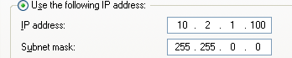

Complete the settings and fill in the numbers you would use for the second laptop

Computer Name: __________________
Workgroup: ____________________

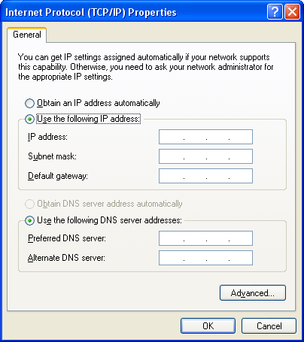
4 Marks

c) Describe how you would set up the laptops to allow files to be shared.

2 Marks

Q 6 A Gantt chart is shown for the completion of a mathematics web site.

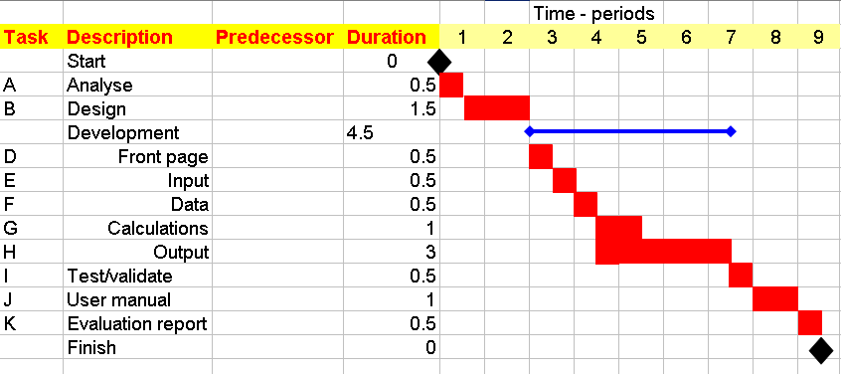
a) Fill in the column of Predecessors ( 2)

b) What is the total length of the project? ……………………………. (1)

c) The calculations are taking longer than anticipated. How long can they take before the completion date of the project is effected? (1)

- Is task G on the critical path? Explain your answer. (2)

f) What are the diamond shapes called? ………………………………….. (1)

Q 7 I have set up a spreadsheet to assist a furniture store to produce invoices for clients.
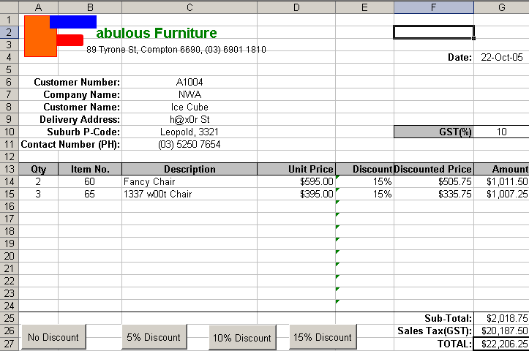

a) What is the purpose of the Macro buttons shown above (2)

b) What is the formula in each of the following cells (2)

- G14……………………………………..
- G25 …………………………………….
c) There is an error in the formula used in G26. Identify the problem and suggest how the problem can be fixed (2)

d) Identify an item on the spreadsheet which will enhance the efficiency of using the spreadsheet. (1)

e) Identify an item on the spreadsheet which will enhance the effectiveness of the spreadsheet. (1)

f) Describe a method of making the description of the furniture item come up automatically after typing in the item No in B14 (2)

g) What could be done to this spreadsheet to ensure that people who use it don’t type over a formula. (1)

h) Describe one other macro button that could be added to the above spreadsheet.(1)

i) Instead of using the discount macros it has been decided that all customers who order over $2000 will receive a 10% discount. (2)
a) What cell would you place the formula in?

b) Write a formula to do this.

- Select three items of test data that could be used to fully test the formula, and show the expected result for each item of test data. (3)
Test data | Expected Result
j) What is an advantage of using a customer number as in C6 (1)

k) The solution has the following worksheets.
Identify another worksheet that you could use and describe what you would put on it. (2)

Q 8 The careers advisor at Geelong College records information about year 10 work experience, so as to have a bank of possible contacts for work experience placements next year. The information is recorded on forms that the year 10’s fill out, and the forms are stored in a filing cabinet in the advisor’s office. They are stored alphabetically under the student’s surname. To help meet specific work experience requests next year, the advisor goes through the information to identify businesses with particular occupations or skills (such as hairdressing, graphic design, computer programming and travel) that the year 10s can apply to for work experience.
a) Briefly explain an information problem in this situation: (2)

.

b) Describe a computer based solution to this problem: (2)

c) Identify the hardware and software needed to implement your information system (2)

.

d) After the new system is installed, how could you evaluate the efficiency and effectiveness of the system (2)

Efficiency

Effectiveness

.

Q 9. The “Dogs Life” pet shop franchise has a plan to microchip all dogs they sell. They plan to create and maintain a database of puppy sales, the buyers’ names and addresses, and the microchip numbers. As a service to customers, they plan to provide this information on their website in case the pet is lost, so that the person who finds the pet can return it to its owner.
Because of space limitations in the Dogs Life main office, the computer needed to run this system will be set up on top of a filing cabinet in the back store room. The storeroom has a large window and a roller door leading to a back driveway and is used to store the dog food and straw for bedding.
Discuss this proposal with respect to two of the following issues: Identify a problem and suggest a solution. (4)
(i) Information privacy (ii) data security
(iii) Occupational health and safety (iv) ergonomics

1.

2.

Part C Case Study – 20 Marks
CASE STUDY
“Cyber Court Book”
Court 13 in the sandstone splendour of the Victorian Supreme Court building on William St is tastefully ornate and colourful in its Victorian elegance, but as modern as the millennium. Behind glowing panels of cedar and Brazilian oak and beneath the rich burgundy carpet of the courtroom is hidden technology that has been judged the best of its kind. Miles of fibre optic and copper cabling have been laid under a false floor and carried up through panels and behind benches to allow the judge, court officials, barristers and their associates access to information almost anywhere in the world.

The IT concept developed by Ringtail solutions working with the Supreme Court staff is drawn from the Internet. In its present form the system is an intranet set up within the court building, and an extranet through which lawyers and others with passwords and permission may get information. The system is Internet browser-based and compatible with any computer platform and any operating system or software. It allows barristers to plug their laptops into the courtroom network and see documents that the judge is viewing on his computer terminal. At the same time, they and the judge can consult the Supreme Court library’s electronic database, see evidential documents scanned in by a technician in the court, read the case transcript as it is typed in by court reporters, or send messages to their offices, wherever they are located. Cameras around the room transmit video images of judge, witnesses and barristers so that, by videoconferencing, the court is capable of reaching anywhere in the world.

“Ultimately”, said Mr Chris Priestley, the barrister-turned-technician who founded Ringtail Solutions, “audio and video feeds will become commonplace and the full record of a case, in digital multimedia form, will be kept on compact disk or DVD such as are now being used for commercial movies.”
The Ringtail system began at the Estate Mortgage trial, the biggest in Australian legal history. It has now made Ringtail an international company and Melbourne’s Supreme Court a centre of world’s best practice in electronic court technology.
While access to court proceedings is strictly controlled by judges, it is possible (court officials suggest) that the public will ultimately have access to the network through the public Internet, as was done with the Longford Royal Commission earlier this year. The potential of the “Cyber Court Book” (as the system is called), is huge. It could be used by thousands of courts around the world.
“That’s one of the points of using Internet technology,” Mr Priestley said. “It is universal. That is all very exciting for us.”

Ultimately, the system could dramatically cut the cost of litigation by reducing the time spent by judges and lawyers retrieving transcripts of evidence, legal documents and case law. Justice Tim Smith, who sat for more that 80 days on the Estate Mortgage trial, estimated that the computer system halved document search and retrieval time and reduced court costs by several million dollars.
By Garry Barker The Sunday AGE, 10 October 1999

Question 1
Information systems can have both positive and negative effects. For the system described in the Case Study, give one possible positive effect and one possible negative effect of the system. Include in your answer some description of the people who will be affected.

(2)

Question 2
Explain the benefits of keeping the record of a case in “ full multimedia form.”

(2)

Question 3
Explain how an Internet browser-based system such as the one described in the case Study is “……compatible with any computer platform and any operating system….”.

(1)

Question 4
In the Case Study, it is stated that “…the system could dramatically cut the cost of litigation…”. Explain how the new IT system will cut costs:

(1)

Question 5
a) Discuss the suitability of the storage media suggested in the case study

(2)

b) Describe two types of data used in the court system described in the Case Study, and give an example of each:

(4)

Question 6
Describe the capabilities of each of the following pieces of IT equipment, and explain its use in the court setting:
a) fibre optic cable

b) Internet browser

d) document scanner

(2 + 2 +2 = 6 marks)

Question 7
For data to be useful, it needs to be accurate, complete, relevant, unbiased and timely. Select any two of these attributes of quality data, and describe how they are met by the system described in the Case Study.
1.

2.

(2)
******************************* End of Examination ********************

