Technology for Country Folk
LOG ON:  Making a wood stove hot | 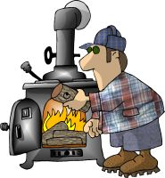 | LOG OFF:  Too much wood on fire | 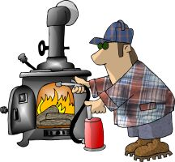
MONITOR:  Keep'n an eye on the wood stove | 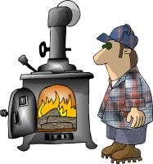 | DOWN LOAD:  Getting the firewood off'n the truck | 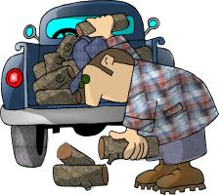
MEGA HERTZ:  When your not careful getting the firewood | 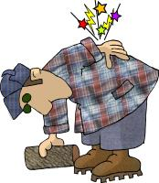 | FLOPPY DISC:  Whatcha get from tryin’ to tote too much firewood | 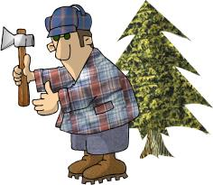
RAM (1):  That thar thang what splits the firewood | 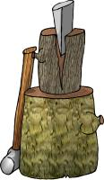 | RAM (2):  A sheep with horns
HARD DRIVE:  Getting home in the winter time | 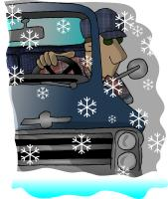 | WINDOWS:  What to shut when its cold outside | 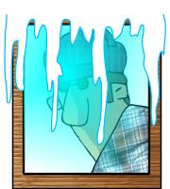
SCREEN:  What to shut in summer to keep flies out | 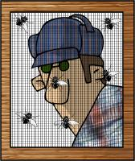 | BYTE:  What dem dang flys and mossies do | 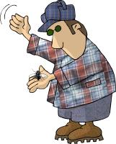
CHIP:  Munchies fer the TV  Sometimes choc-chip | 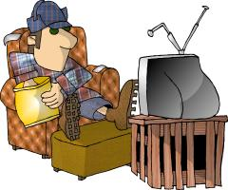 | MICRO CHIP:  What's in the bottom of the munchie bag | 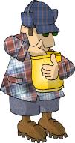
MODEM:  Whatcha do to the hay fields  What I do to the lawn | 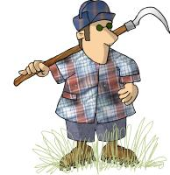 | DOT MATRIX:  Ole Dan Matrix's wife | 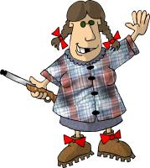
LAP TOP:  Whar the kitty sleeps | 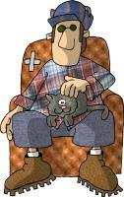 | KEYBOARD:  Whar you hang the dang truck keys | 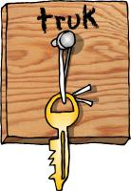
SOFTWARE:  Dem dang plastic forks and knifes | 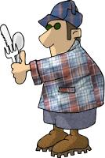 | MOUSE:  What eats the grain in the barn | 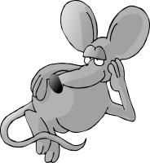
MOUSE PAD:  That's hippie talk fer where the mouse lives | 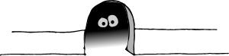 | MAINFRAME:  Holds up the barn roof | 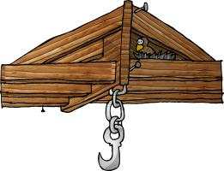
PORT:  Fancy flatlander wine | 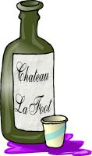 | ENTER:  Notherner talk fer "C'Mon in y'all" | 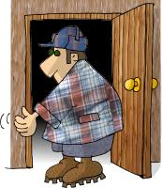
CLICK:  Whut you hear when you cock yer gun | 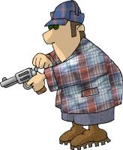 | DOUBLE CLICK:  When you cock the double barrel | 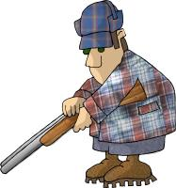
REBOOT:  Whut you have to do right before bedtime, when you have to go to the outhouse | 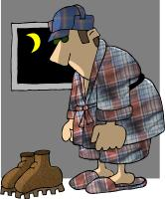 | TROJAN HORSE  What was used to trick the people in Troy
WORM  What one sometimes finds in an apple |  | VIRUS  What one has when they have a cold
INTERNET  What one tries to get the butterfly to do |  | EXCEL  What one says you do when you do well in something
ACCESS  Access to buildings is gained by using keys |  | WORD  Moses went up the mount to get the Word
POWERPOINT  Making a strong point |  | HARDWARE  Denim jeans are made for hard wearing
DOS  What we do when we crash at a friends – we dos down | 

