Recruitment Online Help
– Stephen Digby Monday, 8 August 2005

Warning: In the finest tradition of DE&T IT.
The site is
- very slow,
- will sometimes freeze for long periods
- may take up to 10 min to submit your resume when you click the last submit button

Warning: If you don’t use it you won’t get a job !!

Hint: When creating a resume. Put in a little bit of info ONLY and go right to the end so that it saves successfully. THEN go back and add some more. If you add it all the first time and it “crashes”, you will lose all your efforts !!

If you are reading this document on a computer screen, you can “jump to” the sites on the internet by holding the ctrl key down while you click on the links…… Try it !

Before you start: Ensure you know you edumail ID and your password are working.

Run all the way through once, giving minimum information. Some staff have entered reams of data and the system went offline before they finished. They had to type it all in again !!

Log out and return again now you know what you need: i.e. your full employment history, qualification dates etc

Before you apply for a job you need the personal details of specific referees you want to use for that job.

After you apply for a job you have until the final submission date to fill in the Responses to Selection Criteria

Ctrl + click to go to ………….
http://www.eduweb.vic.gov.au/hrweb/careers/vacs/advacs.htm

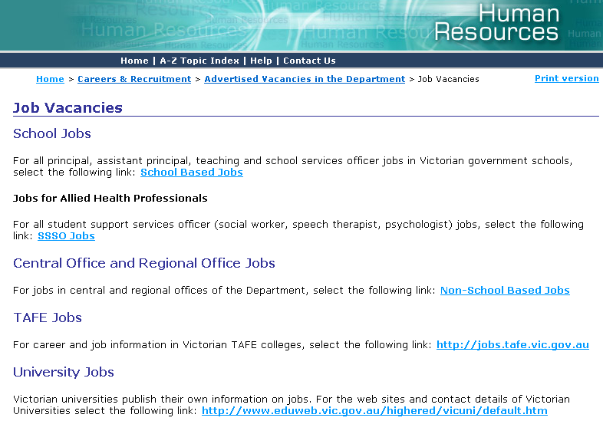

Ctrl + click to go to ………….
http://www.edumail.vic.gov.au/hrweb/careers/vacs/recruit.htm

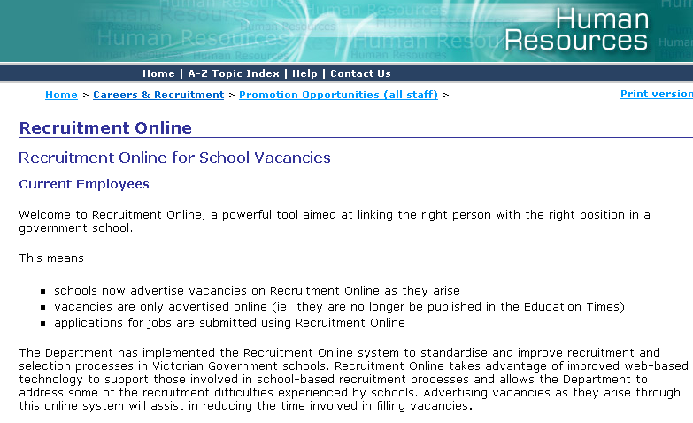

Ctrl + click to go to ………….
https://hrms.education.vic.gov.au/psp/HR8PRD/EMPLOYEE/HRMS/c/ROLE_EMPLOYEE.ER_EMPLOYEE_HOME.GBL?NAVSTACK=Clear

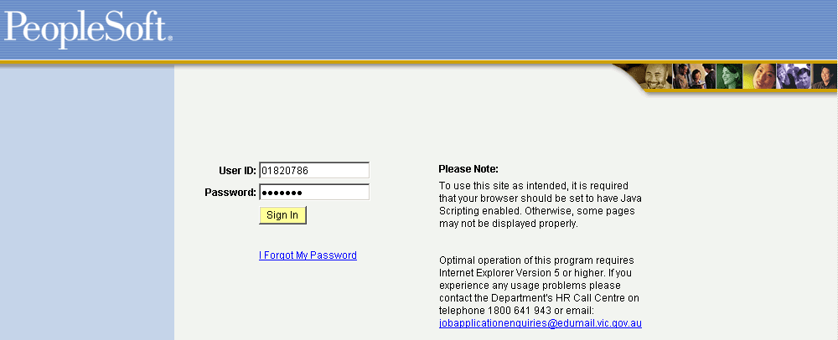

- DE&T Employee Number (i.e. Edumail Username)
- First Time User: Password is date of birth
dd/MMM/yy (e.g.: 1/1/1959 MUST be entered as 01/JAN/59)

- You will be FORCED to change your password on first use and every 90 days thereafter.
- Passwords must be 6 characters long with at least one number
- Passwords are case-sensitive – suggest you don’t use capitals (if you do, remember where !)
- Make sure that you click on the ‘Save’ button after password (and many other) changes !
[ Good practice would be to change your edumail pasword to match every 90 days as well ! ]
Your on the right track to that wonder job…..
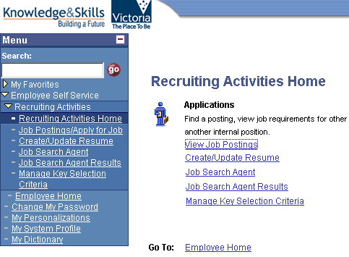

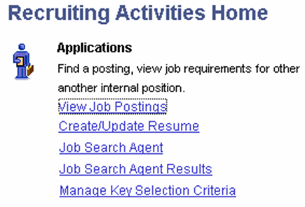

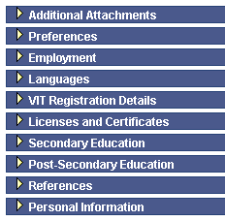
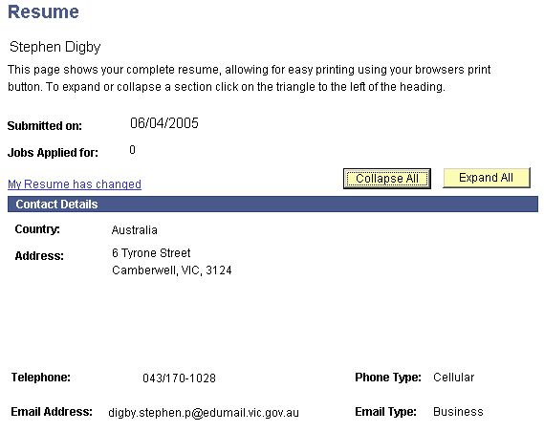

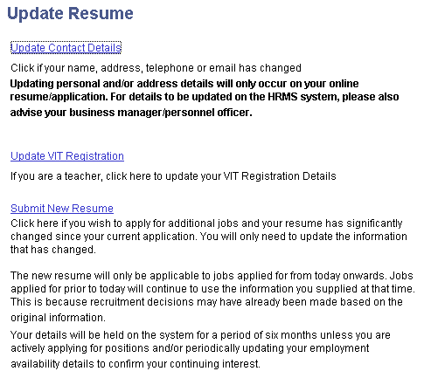
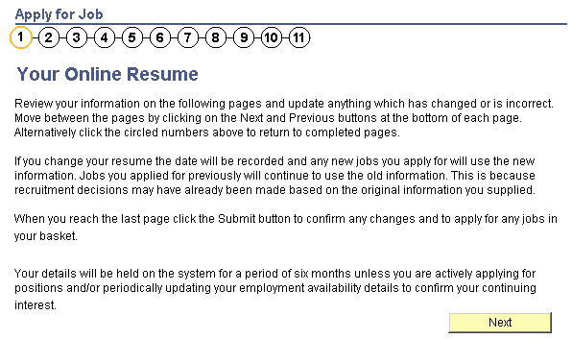

Have your details: personal, career dates, employment history, quals and referee details with you before proceeding….

Hint: When creating a resume. Put in a little bit of info ONLY and go right to the end so that it saves successfully. THEN go back and add some more. If you add it all the first time and it “crashes”, you will lose all your efforts !!

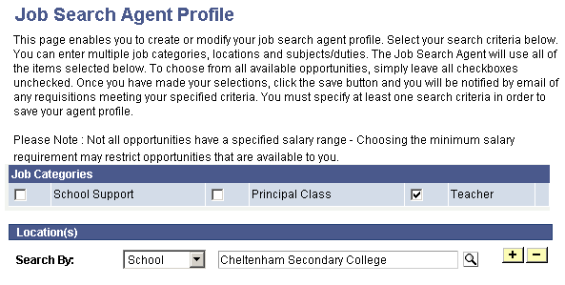

Add as many schools or regions as you want !!!!

Non DEET Applicants: Go to :
https://hrms1.education.vic.gov.au/psp/HR8PRD_EA/EMPLOYEE/HRMS/c/ROLE_APPLICANT.ER_APPLICANT_HOME.GBL

NOTE:

