Can anyone help with how to unlock this database?

My student has worked hard on U401 and on completion of the db has accidently set it so that it will no longer open.
He has done is the following.

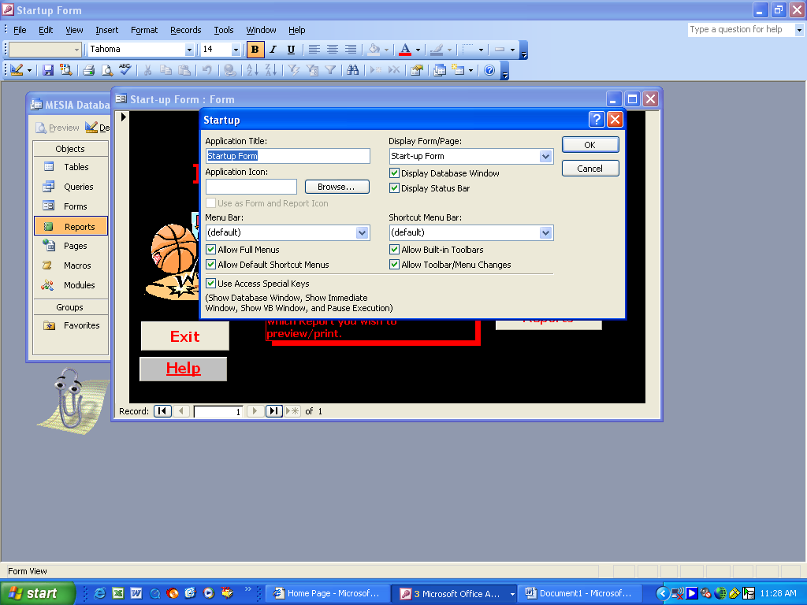
In the attempt to set their start up form to start up they have removed this tick (which is what I asked them to do) to remove db structure options.

The problem is that they have not put the ‘startup command’ in this box so now when the file is opened nothing loads. And I mean nothing!

This is all done through --- ‘Tools’ ------ ‘Startup’ and I can’t even access this anymore as it is now greyed out.

Does anyone out there have any ideas that can help pleeeeeeeeeeeeeeease?

