Mail Merge

For Word for Windows XP

1. Sit down comfortably and start Word XP.

2. Tuck your shirt in.

3. Go to the TOOLS menu and select LETTERS AND MAILINGS > SHOW MAIL MERGE TOOLBAR.

You’ll see this toolbar appear.

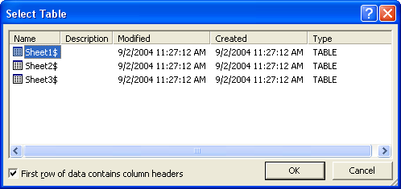
4. Click the second button, OPEN DATA SOURCE.

5. Select R:\IT\MAILMERGE\MERGE.XLS

6. Select SHEET1 as the data source

7. Type in the following letter, replacing the text in BOLD with appropriate fields from the data file using the field list button. E.g. the first line uses the fields GNAME and SNAME. Make sure you type spaces and <ENTER> where necessary between text and codes. Save the form file as U:\FORM.DOC.

GNAME SNAME
ADDRESS
SUBURB POSTCODE

Dear GNAME

As you may realise, your account is overdrawn by $DEBT. You will need to make the necessary payment by or further action may be taken against you.

We have branches in every suburb, including SUBURB so you may make the payment conveniently. If payment is not received, we will send our bruisers around to ADDRESS and ruffle a few feathers in the SNAME family.

Yours sincerely,

U.O. Mee

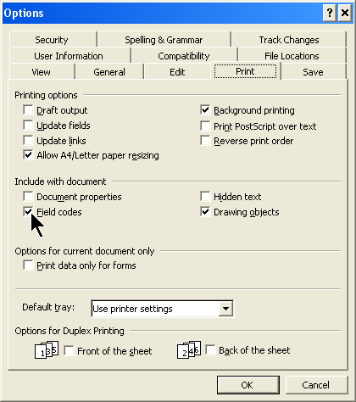
8. To see what the letters will look like with data inserted, use the preview button
9. To see the hidden field codes, press ALT+F9.
This makes codes appear in curly brackets like this… {MERGEFIELD sname}. Press ALT+F9 again to return to normal.

10. To actually carry out the merge and produce the letters, click the MERGE TO NEW DOCUMENT button
You should have a multi-page document with a different letter on each page. That’s your “letters” file.

11. Save the form file and data file and merge file. Print TWO sample letters.

- To print the form file with the merge codes visible, go to TOOLS > OPTIONS > PRINT and make sure FIELD CODES is ticked. After printing, be sure to return to TOOLS > OPTIONS > PRINT and turn off FIELD CODES!

ADVANCED MERGE STUFF

When inserting numbers from an Excel data source, even if Excel shows (say) 2 decimal places, the merged document may show (say) 8 decimal places (e.g. $8.5677887678). How can you format the number properly?

1. Display merge codes with ALT+F9
2. Right-click the field code you want to format.
3. Select EDIT FIELD
4. Select =FORMULA( ) from the FIELD NAMES box
5. Click the FORMULA button

You’ll see this…
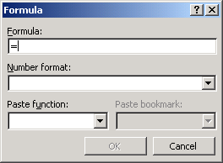

6. After the = sign, type the name of the data field (e.g. =payrate). Type it EXACTLY! Spaces must be entered as underlines (e.g. PAY_RATE)
7. Choose a number format from the drop down menu, shown below...

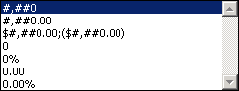

Alternatively, you can type the formatting manually if you know the right expression. e.g. {=number \# “0.000”} would display 3.333

If you end up with a mixed up field code like this… {MERGEFIELD {=age \# “0.0”} age}
select the inner set of curly brackets, cut them, delete the remaining mergefield, then paste the new one.

Nested fields … {MERGEFIELD {=age \# “0.0”} age}
Select the inner field … {MERGEFIELD {=age \# “0.0”} age}
Cut it with Ctrl+X … {MERGEFIELD age}
Delete it and paste… {=age \# “0.0”}

IF…THEN…ELSE

You can make the merge behave differently depending on each person’s data. Go to INSERT WORD FIELD (in the Mail Merge tool bar) and make your merge insert an extra warning if the person’s debt is over $100. Carry out the merge and see if it has worked out properly.

Find out what the other “Insert Word Fields” do – e.g. SKIP IF. When might they be useful?

NOW
Create your own letter and datafile.
Do some calculations in the Excel file that can be imported into the form file.
Use IF..THEN..ELSE to make your merge intelligent, and format numbers appropriately in Word.

