Year 7 Information Technology – Semester 1 – 2005

Assessment Task

Create a Digital Portfolio using Star Office Presentation software
(N.B.This project must be completed using Star Office software)

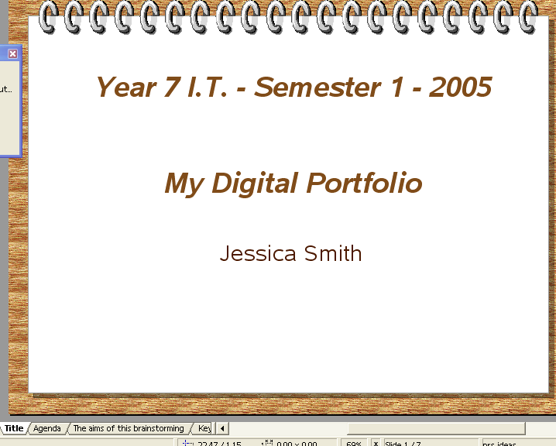
- Keyboarding / Typing Tutor:
- Create a slide or two explaining some features of good keyboarding techniques that you have learned

- Word Processing skills developed:
- Create a hyperlink to Word Processing documents you have created this semester that demonstrate the WP skills you have acquired. e.g.
- Saving a Star Office file as a MS Word Document
- Changing the Line spacing
- Lists / bullet points
- Wrapping text around a picture
- Justification / alignment
- Inserting a table
- Changing margins
- Inserting headers and footers

- Using the Internet and email:
- Create a slide that lists some of the problems that can be encountered when surfing the net
- Create a slide that lists appropriate precautions to be taken for Safe Surfing
- Notify your teacher by email when your project is completed. Include in the message the name and location of the file.

- Digital Images:
- Insert two or three slides that have examples of the digital images you have taken. e.g. Different shots – wide angle, close up etc.

- Spreadsheet skills acquired:
- Create a hyperlink to a spreadsheet that you have created which uses basic formulas and has a graph.

- Presentation:
- Within your presentation include pictures, hyperlinks, transitions etc.

Due Date:

 | VH | H | M | L | NYE
Evidence of a range of WP skills developed | 8 skills | 5 – 7 skills | 4 – 5 skills | 1 – 3 skills
Can use formulas for basic operations (+-*/) in a spreadsheet
Can produce an appropriately labelled graph using SS software
Has attractive design and layout in presentation of work
Can insert and format text and pictures in presentation software
Uses transitions and backgounds in presentation software

