IPM Unit 3 Outcome 1
Spreadsheet software study - Sample 4
Spreadsheet skills required
- Use of the Data Validation function as an alternative form of data validation
- Use of a Horizontal lookup OR Vertical lookup list
- Use of Absolute referencing within a lookup list
- Insert an object such as a Picture, AutoShape or Word Art
- Drawing charts
- Worksheet cell protection
Required
On the same spreadsheet used before, complete each of the following steps. Once you have finished this prac you must type in a few incorrect/unusual test figures to see what happens (see example below).
1. | Copy and paste the whole of your Sample 3 solution to "Sample 4" worksheet.
2. | We are going to try an alternative form of data validation so delete the whole of the "Data Validation in input" table.
3. | Use the "Data Validation" function found under the "Data" menu for all cells yellow/straw in colour (see below example). Remember, to add data validation for a cell or group of cells; Select the cell or cells where data validation is to occur, pull down the "Data" menu and select the "Validation" option and then modify the options available within the "Setting" and "Error Alert" tab options. Add the following validation tests;
 | a. | For all cells in the Student name column: Test for a text length between 5 (minimum) and 30 (Maximum).
 | b. | For all cells in the Siblings validation column: The number of siblings cannot not be less than zero and not to high (eg 12).
 | c. | For all cells in the Fees paid column: Fees paid cannot not be less than zero, nor should they be larger than what they are required to pay (school fee less sibling discount).
 | d. | For the cell containing the Date of the last update: It is to reject any date before the start of this year or after what is the current (today’s) date.
 | e. | For the cell containing the School fee amount: The number cannot be a negative amount.
4. | We are going to use an alternative way of determining the discount entitled based on the number of siblings at the school, a vertical lookup list will be used. Within the "Raw Data" section (at the top of the worksheet,) remove the item (label) "Siblings discount rate" and value for item.
5. | Add another table to the worksheet with 3 columns and 8 rows (see example below). This new table will be your Vertical lookup list table;
Rather than use a flat rate of 20% discount per sibling, on the school fee owing, you are required to have a sliding scale.
Column 1: to record the number of siblings,
Column 2: to record the sliding scale discount rate to be used and
Column 3: to calculate and display the discount amount entitled.
Use the VLOOKUP command in each cell within the Discount Entitled column to "fetch" the appropriate data from this table (see example below - formula bar). The following steps may help you;
 | a. | Use a scale from zero to six siblings.
 | b. | An increasing larger percent discount rate is to be given with every additional sibling, starting at zero percent for no siblings and 100% for 6 siblings. Choose whatever you feel is realistic.
 | c. | The discount amount entitled is simply calculated by multiplying the "school fee amount to charge each student" by the "sliding scale discount rate".
 | The usual shortcut is to set-up the formula in first cell of a column and then fill down. However, with lookup list commands first make sure you use ABSOLUTE referencing to some areas of the formula before you fill down. If your not sure, see your teacher.
6. | Sort the main table by name into ascending order.
7. | Insert a word art heading at the very top of the spreadsheet describing what information this spreadsheet is displaying.
8. | Draw a Line (or Column) and a Pie chart based on any of the data in the worksheet.
9. | "Protect" the whole of the worksheet, except those cells yellow/straw in colour, from any form of alteration. That is, the user is unable to change anything except the yellow/straw coloured cells
10. | Save this Spreadsheet to your home drive and to your backup floppy.
Your solution should now look something like this:
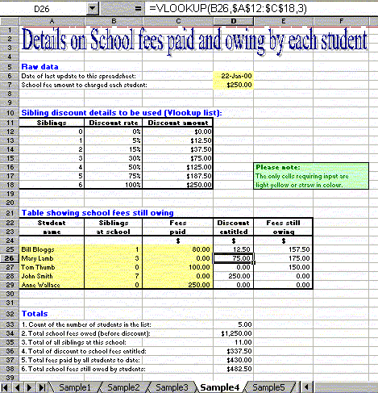
You have 2 periods to complete this exercise. Email your work to your teacher. Use an email subject name of IPM3 SS SAMPLE 4. To see student generated example of this samples click here.

