IPM Unit 2 Outcome 1
Spreadsheet software study - Sample 2
Additional spreadsheet features/ skills
- Use/naming of worksheets
- Inserting or deleting a column or row
- Use of borders and/or shading
- Use of the Date format function
- Use of Format Painter function
- Use of at least 2 different fonts or font sizes
- Use of spreadsheet header to list raw data to be used
- Use of spreadsheet footer to show summary of details
- Use of Page margins or other set-up functions
- Use of Landscape printing function
- Use of the Print Preview function
- Use of "formulas only" print out function
- Correct use of presentation conventions
Required
Modify your existing solution in the manner described below. Once you have finished this prac you must type in a few incorrect/unusual test figures to see what happens (see example below).
1. | Copy and paste the whole of your Sample 1 solution into "Sheet 2" of the same spreadsheet used for sample 1.
2. | In the bottom left corner of the screen, rename the tabs "Sheet 1", "Sheet 2" and "Sheet 3" to something more meaningful like "Sample 1", "Sample 2" and "Sample 3" by double clicking on the tab label you wish to rename, then type in the replacement name. Add additional tabs as required with appropriate names (see example below).
3. | Add borders and others features to improve presentation.
4. | Add the following "header" items to your solution. Modify your solution so that all the appropriate cells obtain their data from the items in this header (see example below - Raw data).
 | a. | Date.  Include a date that this spreadsheet was created on or was last modified (using a formula)
 | b. | School fee amount to charged each student.  Instead of having the figure 250 in each cell of the School Fees column, you have a formula (=D6) that obtains the data from one central location. This way you need only change the one figure in the header and the rest is automatically updated.
 | c. | Sibling discount rate to be used.  Instead of having the figure .2 being used in each cell of the Discount entitled column, use the cell name (D7).This way you need only change the one figure in the header and the rest is automatically updated.
5. | Add the following "footer" notes to your solution (see example below - Totals);
 | a. | Via the use of a formula, a count of the number of students in the list
 | b. | Instead of all the totals at the bottom of the table, place them here as individuals items
6. | Remove the "School fees" column. It is not required as it is the same value for every student and the amount is now shown in the "Raw data" header section.
7. | Set up the page so that your solution is in the centre of a landscape page.
8. | Save this Spreadsheet to your home drive and to your backup floppy.
Your solution should look something like this:

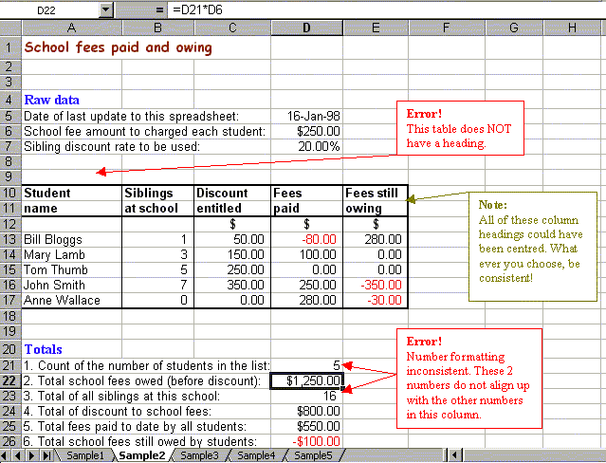

This sample should not take any more than 2 periods to complete. Email your work to your teacher. Use an email subject name of IPM3 SS SAMPLE 2. To see student generated examples of this sample click here.

