IPM Unit 2 Outcome 1
Spreadsheet software study - Sample 1
Spreadsheet features/skills covered (Revision of year 11 material)
- Creating a new Spreadsheet
- Use of labels
- Use of heading(s)
- Use of values
- Editing a cell’s contents
- Changing a column’s width
- Use of a calculation formula function eg SUM()
- Number formatting such as Fixed, Currency, Comma, Percentage, etc function
- Number formatting where negatives shown with negative symbol and in red
- Use of style formatting functions in cells eg bold
- Use of justification functions in cells eg right justified
- Use of the cut, copy and paste functions
- Use of Fill-down or Fill-right function
- Calculations using percentages
- Use of the Save or Save As functions
- Use of the Print function
- Use of "formulas only" print out function
- Correct use of presentation conventions
Description of the organization, current practices and technology
The school has 3 campuses; 2 junior and one senior campus. You are involved with the senior campus administration staff. Currently there are 3 office workers managing all of the day to day administration and financial record keeping of the campus. Currently the staff use a mixture of computer generated student lists that are then written on "by hand" recording all full or part payments of schools fees. As payments are made by students at the front counter the written entries are made on the computer generated lists. Each office staff member have their own computer and share one powerful laser printer. Each computer is connected to the school's network as is the laser printer they share. For security reasons the administration department has its own fileserver where all school, student and financial records are kept. Security is two fold, only those computer terminals in the administration offices can access the administration fileserver and each administration staff member has their own ID and password giving them access to particular area data on the administration fileserver. They use "high end" Pentiums.
The administration/office staff of our school have hired you to help them. Staff require a "new" information system were no paper is involved and all entries are made directly into the computer. this new system will record all school fees receipts for all students of the senior campus. The information system will provide information to the office staff answering queries as to who still owes school fees money and by how much. The information system will provide information to the principals and school council in the form of totals. The system MUST be easy to use by "non computer literate" people and will help as far as possible in automatically catching all possible errors.
Required
- Describe at least two possible organisational goals for this organisation.
- In your own words describe the information problem needing your attention.
- List the information required from your solution.
- List the goals your information system (solution) has.
- How do the information system goals relate to the organisational goals?
- Complete the following exercise;
Once you have finished this prac you must type in a few incorrect test figures to see what happens (see example below). The table is to include appropriate headings, labels and formulas. Have 6 columns;
- First column: a small number of student names (5 or 6 will do).
- Second column: a made up (but realistic) amount for school fees owed by each student. This figure will be the same for each student. At the bottom of this column, show via the use of a formula, the total fees owed by all students.
- Third column: a made up (but realistic) number of brothers or sisters (siblings) attending any of our 3 campuses. A zero indicates no siblings. At the bottom of this column, show via the use of a formula, the total number of siblings.
- Fourth column: displays, via the use of a formula, the amount of discount to school fees the student is entitled to because he/she has siblings at the school. At the bottom of this column, show via the use of a formula, the total of all discount entitlements. Current policy is a 20% discount is made for each sibling attending any campus.
- Fifth column: a made up (but realistic) amount of school fees so far paid by each student (all different). At the bottom of this column, show via the use of a formula, the total fees paid by all students.
- Sixth column: shows via the use of a formula, that amount of school fees still owing (if any). At the bottom of this column, show via the use of a formula, the total fees still owing by all students.
- Save this Spreadsheet by the name of Outcome1 to your home drive and to your backup.
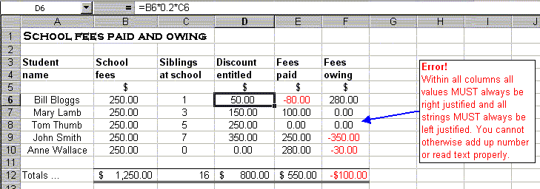
Your solution should look something like this:
You have 1 period to complete this exercise. Email your work to your teacher. Use an email subject name of IPM3 SS SAMPLE 1. To see student generated examples of this sample click here.

