
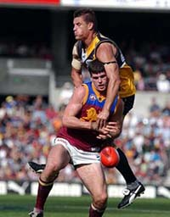
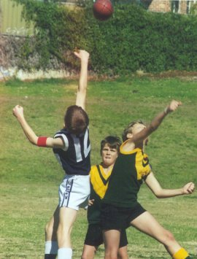
















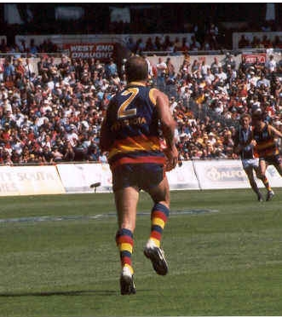



The AFL Footy Espionage Game
- We all know how highly competitive our great AFL game is on the field, but what about the rarely seen, hidden war, the silent cloak-and-dagger stuff that happens in the dead of night?
- What can happen to your club’s SECRET INFORMATION?
- You know, the stuff that other clubs would ****** to know!
- Who are our unsung heroes – the INFORMATION PROTECTION OFFICERS who work behind locked doors?
- What risks do they face daily? Who wants to discover the secret information they keep safe? What really happens?
The Information Espionage War Game:
- Identify the AFL club you support and sit in a group for that club. This is now your team for this activity.
- Type a word document with the names of three players you would like to trade from your club, and three players from other clubs you would like to gain in their place.
- At the top of your page type HIGHLY CONFIDENTIAL and your club name, and the names of the people in your group. Email it to yourselves, print it out and each person hold a copy.
- ATTACK – work out ways you could obtain the valuable secret information from the other AFL clubs.
- DEFENCE – work out ways to protect your club’s information while still sharing it with a 9-person club recruiting committee.
Note
All copyright materials are hereby used for educational purposes.
The Footy Espionage Game devised and created by Keith Richardson for IP&M U3O3 preparation.

