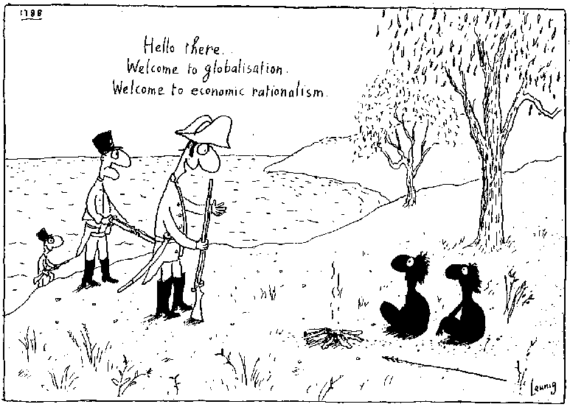

LITERAL
- There are three people in this scene.
- There are three groups of people in this scene.
- The soldiers are walking down from the mountains.
- The black people are building a hut.
- All of the people in the scene are unarmed.
- The date in the top left hand corner tells us that this is about English settlement in India.

INFERENTIAL
- The soldiers arrived on horseback.
- The soldier speaking to the indigenous people is the leader of his group.
- This soldier is very fearful of the indigenous people.
- The indigenous people are very war-like.
- The two groups are equal.
- The soldier has doubts about what he is doing.
- The soldier thinks that his culture is superior to indigenous culture.
- The indigenous people are very excited about what the soldier is saying to them.
- It would have been easy for indigenous people to resist being colonized.
- Indigenous people were able to negotiate a good deal with colonizers.
- The people in this scene would have understood terms like globalisation and economic rationalism.
- The people in this scene would have understood long term implications of European settlement.
- The people in this scene would have thought through and endorsed all the implications of European settlement.
CONCEPTUAL

- European exploration and colonization was part of a process that continues today.
- Just as the indigenous people were unable to avoid being colonized, no society today can resist globalization and economic rationalism.
- Globalisation and economic rationalism is the modern version of colonization.

