What do we need to implement e-texts in Australian schools? Kerrie Smith, Education Services Australia
Despite a very willing advance guard of principals who think they have seen the potential in particular of the iPad and dedicated e-reading devices, e-text books won’t be reality in Australian schools in 2011. The principals have frequently only experienced the personal benefits of technology, and not understood the real hurdles.

It is taking Australian education its usual lag time to get its collective head around the potential of new technologies. But this time, it is not our fault. We are very conscious that decisions taken before a technology has matured can come back to bite us. We’ve had plenty of examples of that in the past – PC vs Mac, laptop vs desktop, ink-jet vs laser, mouse vs track ball and so on. There are costs associated with being the first cab off the rank, particularly if you get it wrong.

And of course, before teachers can implement a new technology, they need not only to recognise the potential, gain some experience in using it, develop a vision of how extensively it might be used, flesh out the required pedagogical mind shifts, and then persuade reluctant colleagues. Then will come a “purchase and implement” phase, with the accompanying lesson plans and support materials. Many teachers will be unable to move forward without the latter, mainly because of their own lack of certainty.

It may be helpful to understand where we are in the hype cycle for emerging technologies. The diagram below is captured from Gartner in July 2009.

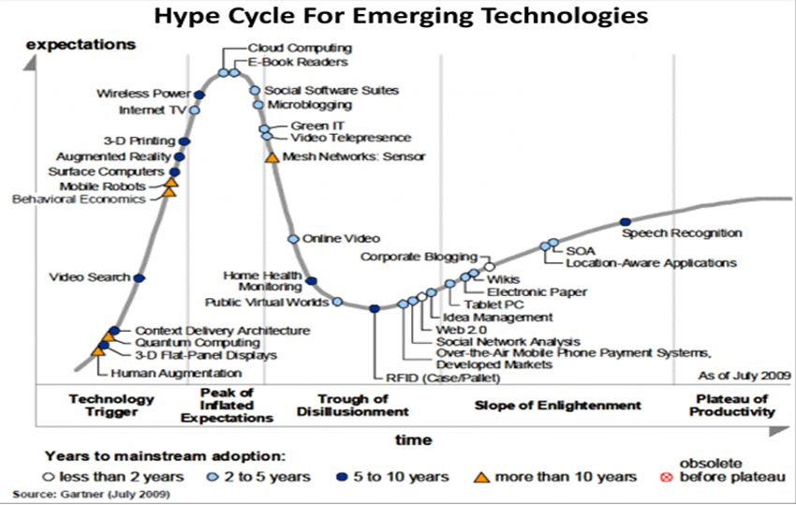

You can see that Gartner put e-book readers in the 2-5 year adoption cycle. I don’t actually think that we are as far up to the Peak of Inflated Expectations as they thought. The new devices being released in 2009 and 2010 has meant we are still somewhere on the up slope, and will probably remain there for some time yet.

One of the problems with the new e-book technology is that during 2010 it has gained a lot of momentum. In the first 6 months of the year Amazon’s Kindle got a head start, then on 28 May 2010 it was the turn of the iPad, and in the latter half of the year the waters were muddied with the release of other, cheaper than iPad, touchscreen and e-ink devices. Apple enthusiasts in Australia got app fever, proving the iPad won’t be a flash in the pan. And there is more on the horizon. In late October Barnes & Noble made a break-through in a colour 7” dedicated e-reader, the Nook Color, at a price only a little more than Amazon’s Kindle. This differed from Kindle and similar e-readers by being not only colour, but touchscreen.

A by-product of the momentum has been the penetration of the technology into ordinary households, and the understanding by the parent community that here is a technology that may have an unprecedented impact on literacy and reading. Parents and students are already purchasing Kindles, iPads, Sony, Kobo, and other e-readers. Even cheaper e-readers are now available through Dick Smith, BigW, and OfficeWorks, putting pressure on schools and teachers to make some sort of decision. Unfortunately the market penetration is already such that no single choice will suit all, and the school that decides to go with Kindles will find students who already have an iPad, and vice versa.

So what is holding us back from wholesale implementation in our schools and libraries?

Well, first of all, despite the fact that we’ve been getting ready for e-books for 40 years (that’s how long Project Gutenberg has been around), these devices are still immature. And, as in the case with most new technologies, we have choice.

The first choice is whether you are looking for a dedicated e-reader or you want your device to be multi-purpose.

Multi-functional device | Dedicated e-reader
iPad or similar tablet | Kindle
Netbook, laptop, | Kobo e-reader
iPhone, iPod Touch | Sony touch reader
etc etc | Quokka etc etc

Another difference heralded by the release of the Nook Color is that it is a device that is primarily an e-reader but will also have Apps, internet connectivity, and some games.
In the long run the choice may come down to whether you can afford to invest in a multi-functional device – they tend to be more expensive.
They have the advantage of
- being able to accommodate e-reading applications or software. These let the user choose the format of the e-book to be purchased.
- Rather obviously the multi-functional device also has the advantage of being a single device, not an extra to carry around, although you may already have more than one of them.
- They also have colour display available.

Within the dedicated e-reader range, the user also has to make a number of choices
- The price difference between these and the multi-purpose device is significant, and makes the potential buyer seriously question whether they just want to read a book or whether they will use all of the functionality of the multi-functional device.
- E-ink or touch screen: the former uses buttons, the latter fingertip or stylus manipulation
- The size of the device: they tend to be smaller than the multi-functional devices, ranging from 5 to 6 to 7 inches generally.
- Colour devices are only just beginning to emerge and are a little more expensive. (October 2010 Barnes & Noble Nookcolor $249 wifi, includes internet access and basic games)
- Most of the e-readers are linked to a distributor/provider and lock the user in to a particular format.

So the second choice (after choosing the device) isn’t really a choice at all. It is more the need to understand the consequences of selecting a device.

The dedicated e-readers are basically locked into a specific format.
There are basically 3 formats of e-books:
- Kindle friendly - .azw, .mobi, and pdf
- Non-Kindle e-reader – epub, pdf
- iPad, tablets etc - iBook on iPad takes epub, otherwise the user can download a Kindle App, or a Borders App.
You’ll notice that I have included pdf in the common formats but in reality the unenhanced pdf document offers very little more than a display of text. It often does not have the features that other formats have such as a linked table of contents and so on.
Adobe has produced an enhanced format for Adobe Digital Editions that allows readers to use epub and pdf formats. Books created in Adobe InDesign can be formatted as both epub and .mobi files.

It is beginning to look as if the epub format is emerging as a front runner and it may be best to go with an e-reader that can handle that. This may eventually force Amazon into selling their e-books in more than one format.

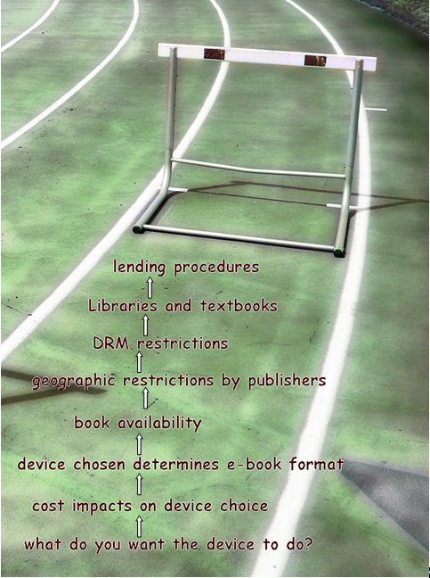

Once they have decided on a device to use for reading e-books most users want to read
- fiction (apparently the biggest group) and
- non-fiction
While that seems a pretty obvious thing to say, those converted to reading e-books are mainly either purchasing them online from sites like Amazon and Borders, or getting them free from places like Project Gutenberg. There are many thousands of fictional classics for example available free.

However readers are now seeing the potential of using an e-reading device for reading library books or text books. And that’s where the problems start. Where the books are purchased, either as an Amazon or Borders download, or an iPad App, the vendor has embedded some DRM code which prevents the e-book from being read on a device that did not buy it. This means that the e-book can’t be given freely to another or even sold second-hand.
It also raises the question of whether you have purchased the e-book or simply the right to read it.

Both Amazon and Borders allow a user to download an e-book to multiple devices (up to 6) that have been linked to a single account.
In late October Amazon announced that it will enable Kindle users to loan a Kindle book to other Kindle device or Kindle app users. The Kindle book can be loaned out for 14 days and during that time the “owner” will not be able to read the Kindle book in his own Kindle reader or any device using Kindle app.
However not all Kindle books will be lendable. The final decision if a Kindle book will be lendable still depends on the publisher. This move has been welcomed by libraries as a way of circulating a book. [However what do you make of this: Each book can be lent once for a loan period of 14-days]

So far there are a few things to think about with library e-books. Because of the DRM limitations many libraries are resorting to buying the e-readers themselves and lending them. (Digital Rights Management is a broad term used to describe a number of techniques for restricting the free use and transfer of digital content.)

For those libraries with serious cash, then there is a solution called Overdrive. This is American software in use in the US, the UK, and just recently Australia (Yarra Plenty /Brisbane library scheme). Basically the library pays a set up fee, and then is able to make a selection of e-books available in epub format to its readers. The e-books can be downloaded online and then transferred to an e-reader.
Recently however the UK Publishers Association has thrown a spanner in the works by announcing that ebooks would only be available for loan to borrowers who can not only prove residency, but also must physically present at the library for borrowing. At the same time they have required the UK’s biggest vendor of e-books to restrict their sales to UK and Northern Ireland residents.

In the matter of e-text books other factors coming into play include
- the availability of textbooks in an e-format. It does seem that some Australian publishers have envisaged the download of e-text books to laptops, by secure login, in pdf format
  - these will expire at the end of a specified period
  - they are often little more than an unenhanced pdf of the original digital version from which the book was presented
- recent moves by Adelaide University to use iPads and e-books for first year students in 2011 has revealed just how few of the text books were available in e-book format
- many publishers are claiming that the e-texts will be expensive to develop, and if users think they are going to get them cheaper and save money, they are wrong.
- In universities in particular where text books are regularly sold second-hand, there will be nothing to sell. Schools have quite an amount of money invested in their current text books holdings. They will not have anything to show for this investment, unless they can negotiate good terms with the publisher.
- “Research” in the US seems to indicate that when given the option students prefer the made-from-paper text book that they can scribble margin notes in, or sell after they’ve finished with, to the e-book. Trials were held with Kindles, both 6” and DX.
Students at Harvard said they
  - Found it difficult to keep track of where to find things: could not deal with the fact that Kindle does not use page numbers
  - Get used to the new technologies that let them make notes/highlight text etc.
  - Found the page turning slow
  - Could not zoom in on diagrams
  - Found the Kindle keyboard too small
  - Wanted colour particularly in diagrams and illustrations
  - Wanted some folder system
  - Thought Kindle was more suited to reading fiction that to academic study
  - One lecturer in particular criticised the linear style of reading that the Kindle forced on the reader.
  - There were accessibility issues for blind students in particular.
- Teachers who have little idea of how these (e-books) might differ from device to device, or that students might need different techniques for reading e-books. The use of e-books and e-readers in the classroom probably means a careful thinking about the pedagogy of their use if students are to gain maximum benefit. There will be problems if a variety of devices are used in the classroom. For example
  - Kindle does not use page numbering, but a system of locations. While locations remain consistent on the same devices, they may vary from Kindle 2 to KindleDX to Kindle for PC
  - Kobo e-reader uses page numbering, but when the size of the text in increased or decreased the number of pages changes (just as it does for large print books)
  - The edition of the book released for Kindle may differ from the edition released as an epub because of the different publishes involved.

What do we need teachers and TLs to do?
- Make a decision, bite the bullet and get some personal experience in using an e-reader. Alternatively enable someone else on their staff to get experience.
- Pro-actively engage colleagues (and students) in a project to assess which e-book reader, if any, is appropriate for their school. The project should use a
- Trial cheaper e-readers in their school or at least encourage students and staff to download e-reading software such as the Borders e-book software or Kindle for PC onto their laptops and computers.
- Locate relevant e-book resources and assist students and teachers and teachers in their download.
e.g.
  - download a selection of free .mobi or epub format e-books into an accessible spot on the school intranet.
  - Encourage a pilot where teachers and students read a Shakespearian play as an e-book. They should trial the note-taking and highlighting features, and use them to produce some written text
- Teachers could also trial creating e-books in their class and creating an internal e-book “library”.

